Active Volcanism & Continental Rifting
with special focus on the Kivu rift zone (AVCOR2013)
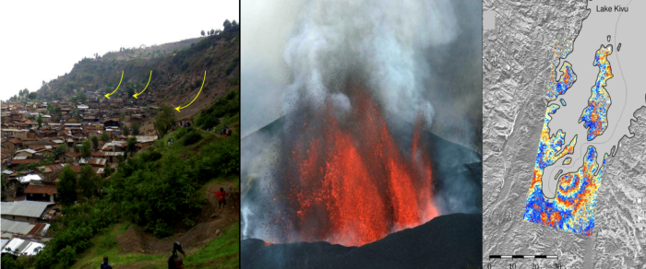
---- November 12-14, 2013 ----
Hotel Serena, Gisenyi, Rwanda.
- BOOK OF ABSTRACTS -

 | 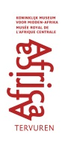 |  |  | 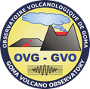

Table of contents

SESSION 1 3
Present-day kinematics of the East African Rift, D.S. Stamps et al. 4
Split Band Interferometry: Theory and potential applications, D. Derauw 1
Magma assisted extension in an immature continental rift, based on InSAR observations of Nyamuragira and Nyiragongo Volcanoes, V. Cayol et al. 1
Evidence of Rift-Parallel Deformation Along the Western Branch and Main Ethiopian Rift?, D.S. Stamps et al 1
Intérêt de l'approche sur la vulnérabilité des ouvrages face au glissement de terrain: cas du glissement de Funu à Bukavu, C.N. Balegamire et al. 1
Volcano instabilities and debris avalanche hazard in the East-African Rift, A. Delcamp et al. 1

SESSION 2 1
Lake Kivu Monitoring Program, A. Umutoni 2
Methane cycle and methane oxidation in Lake Kivu and Kabuno Bay, F. Roland et al. 1
The history of subaquatic volcanism recorded in the sediments of the main basin in Lake Kivu, K.A. Ross et al. 1
Petrogenesis of felsic peralkaline rocks at the Quaternary Kone Volcanic Complex, Main Ethiopian Rift, Y. Gezahegn 1
Geochemistry of continental rivers of the Virunga Volcanic Province, East Africa, C. Balagizi et al. 1
Impact de l'arsenic dans l'environnement de Nagarwa au Sud-Kivu, N. Buliba et al. 1
A detailed geochronology of the Rungwe volcanic province at the southern end of the East African Rift System, M. Maqway et al. 1
Lake Kivu a unique lake : a resource or a treat for the local population ?, D. Tedesco et al. 1
Gas geochemistry at the Nyiragongo volcano and surrounding areas, O. Vaselli et al. 1
Gas emission measurements of the active lava lake of Niyragongo, DR Congo, N. Bobrowski et al. 1
CO₂ dynamics in mofettes, A. Kies et al. 1
A geochemical constraint on the origin of melts using thermobarometry at Rungwe Volcanic Province, Tanzania, G. Mesko et al. 1
A single superplume source with multiple heads supplies melt along the East African Rift System, P. Castillo et al. 1
Preliminary data on trace element emissions from Niyragongo volcano (DR Congo), S. Calabrese et al. 1
The Rungwe Volcanic Province, Tanzania: Physical Volcanology of the Holocene explosive eruptions – and implications for hazard assessment, K. Fontijn et al. 1
A wider view on possible causes of observed BrO/SO2 – CO2/SO2 correlations – during volcanic degassing variations, G. Giuffrida et al. 1
Petrology and Geochemistry of lavas from the Walungu trough (South-Kivu, East African Rift System): geodynamic significance., C. Kakonkwe N’Konzi 1
L’enregistrement continu du CO2 et du radon dans un Mazuku, M. Kasereka Musosekania et al. 1
Caractérisation pétrographique des indices de fer dans le complexe anorogénique tertiaire de Bana (ligne vocanique du Cameroun), Y. Lemdjou 1
Pétrographie et Géochimie des gneiss kibariens de Miowe-Bulambika à Bunyakiri, Sud-kivu, RDCongo, T. Mugaruka Bibentyo et al. 1
Nouvelle approche sur la mise en place des coulées basaltiques cenozoiques du secteur Nord-Ouest de la Ville de Bukavu/RD Congo, E. Mugisho Birhenjira et al. 1
Contribution to the description of nitrogen cycle in the surface waters of Lake Kivu, F. Roland 1
Géochimie des roches métébasiques Kibariennes (Bunyakiri et Mitwaba/RDC , Mageyo/Burundi et Rwanda) et implications géodynamiques, M. Shubazi Kabemba 1
The “mazuku hazard” in the Goma region, D.R. Congo, B. Smets et al. 1

SESSION 3 1
Neotectonic setting of the Kivu rift segment within its intraplate Central African context, D. Delvaux et al. 2
Are magmatism and volcanism responsible for the structures and morphology of the Kivu Rift Basin?, B. Smets et al. 1
Contrôle structural de la géomorphologie du secteur de Katana (Sud-Kivu, RD Congo), G. Ganza et al. 1
Contribution to the understanding of the mechanisms controlling slope instabilities near Bujumbura-Burundi, S. Draidia et al. 1
Glissements de terrain et cause de leur déclenchement : Cas de la cité d’Uvira et sa partie méridionale (Sud Kivu, République Démocratique du Congo), S. Butara Mubane 1
Évaluation et cartographie par SIG du risque lié aux glissements de terrain à Bukavu (Sud Kivu, RD CONGO), P. Migombano Useni 1
Les risques que court la ville de Goma et la lithologie de la carriere MUGARA, B. Byamungu 1
Landslide hazard in the North Tanganyika - Kivu rift zones: current knowledge and research perspectives, O. Dewitte et al. 1
Paleomagnetic and Petrographic comparison of differently named basalts from the Omo-Turkana Depression, southwestern Ethiopia: implication for timing of volcanism, A.E Doelesso 1
Contribution à l'étude stratigraphique et structurale de Mulambi, chefferie de Kabiza, Sud-Kivu, RD Congo, C. Kalikone Buzera 1
L’alignement volcanique des cônes Nyarutsiru-Nyabyunyu-Buhimba-Kirunga: les dépôts phréatomagmatiques et magmatiques dans le secteur sud-ouesr du volcan Nyiragongo en bordure du Lac Kivu, R.D.C., R. Montfort Bagalwa et al. 1
Contribution à la caractérisation des événements dommageables du sol, ses problèmes et ses perspectives à Irhambi/Katana, H. Mushayuma 1
Sediment yields estimation and identification of their sources in Lake Tanganyika basin, S. Ongezo Muzaliwa 1
The Virunga Volcano Province: A new volcano-structural map based on morphological analysis of a high-resolution Digital Elevation Model, S. Poppe et al. 1
Basin history of the eastern graben of Lake Kivu from marine reflection seismic data, D. Wood et al. 1

SESSION 4 1
Recent seismicity of the Main Ethiopian and implication for earthquake and volcanic risks, A. Ayele 2
The Seismotectonic model of Southern Africa, B. Manzunzu et al. 1
Locating water ingress-induced micro-earthquake in the Central Rand Goldfields, South Africa, A. Mangongolo 1
Hypocenter determinations of volcanic earthquakes prior to the November 6, 2011 eruption at volcano Nyamuragira, Western Rift Valley of Africa, DR of Congo, B. Rusangiza et al. 1
Crustal structure beneath four seismic stations at the Southern flank of volcano Nyiragongo revealed from teleseismic P wave receiver function analysis, G.Mavonga Tuluka et al. 1
Aftershock sequences of February 3, 2008 earthquake in the Kivu Province, Western Rift Valley, J.P Lukindula Wilondja et al. 1
Les Sources Thermales et Séismicité du Bassin du Lac Kivu, S. Fiama Bondo 1
Analyse fréquentielle des essaims des séismes à longues période ayant précédé l'éruption du volcan Nyamulagira du 6 Novembre 2011, D. Birimwiragi Namogo et al. 1
Volcanic tremors and transients: 7 days of seismic recordings at Nyiragongo Volcano summit (Democratic Republic of Congo), G. de Gelder et al. 1
Compiling a homogenous Earthquake Catalogue for Southern Africa, T. Faith Mulabisana 1
Analyse de l'activité magmatique du volcan Nyamulagira par la mesure sismique des amplitudes à temps réel (RSAM) durant le période du 1 mars au 6 Novembre 2011, A. Kyambikwa Milungu et al. 1
Comparison of seismological, geodetic, and geological observations of rifting in East Africa: Diffuse vs localized deformation, N. Lindsey et al. 1
New Seismic Hazard Maps of Zimbabwe, V.P. Mapuranga 1
Impacts of tectonic earthquakes in the Western Rift Valley of Africa on the volcanic activity of Nyiragongo, Virunga region, D. Mifundu Wafula 1
Nouvelle Carte Sismique de la RDC et limplication tectonique des seismes majeurs du Rift de grands lacs, D. Ngindu Buabua 1
Seismic Hazards Assessment of Cameroon, A. Ngongang Wetie et al. 1
What are the hazards associated to a seismic sequence in the Kivu Rift Basin? The 2008 Bukavu/Cyangugu earthquake example., N. d'Oreye et al. 1
Tremors volcaniques associés à l’éruption du Nyamulagira du 6 Novembre 2011, E. Osodundu 1
Active fault systems of the Kivu rift and Virunga province, and implications for geohazards, H. Zal et al. 1

SESSION 5 1
The importance of multidisciplinary volcano monitoring: insights from the Nyamulagira 2010 eruption (RD Congo), N. d'Oreye et al. 2
Intensity, magnitude and impact of degassing activity of Nyiragongo volcano during 2004-2013, S. Arellano et al. 1
How used Tandem-X Radar Interferometry to detect magma transport and quantify eruptive volumes: the example of 2011 Nyamulagira eruption (D.R. Congo), F. Albino et al. 1
The Nyiragongo hazard: Is the literature misleading?, B. Smets et al. 1
Etude de la stratigraphie des dépôts volcaniques du Mont Goma (RD Congo) et ses implications pour l'aléa phréatomagmatique à Goma, A. Fikiri et al. 1
Calibration of a GIS-based combined thermo-rheological and probabilistic lava flow model for Nyamulagira volcano, M. Kervyn et al. 1
Geological constraints of volcanic hazard assessment, J. Marti 1
QVAST: a new Quantum GIS plugin for estimating volcanic susceptibility, S. Bartolini et al. 1
HASSET: A probability event tree tool to evaluate future volcanic scenarios using Bayesian inference. Presented as a plugin for QGIS, R. Sobradelo et al. 1
The magmatic system beneath Torfajökull volcano, Iceland: Combining radar and seismic interferometric observations, J. Martins et al. 1
The time discrepancy between the effective eruption and rock failure for the eruptions of Nyamulagira and Nyiragongo volcanoes in the Virunga region, D. Mifundu Wafula et al. 1
Reconstructing past eruptions at Mount Cameroon volcano (West-Central Africa) using Remote Sensing and GIS techniques: case of the 2000 eruption, M. Nechia Wantim et al. 1
A permanent geodetic GNSS network to monitor ground deformation in the Virunga Volcanic province., N. d'Oreye et al. 1
Hazard implications of phreatomagmatism along the urbanised Lake Kivu Northern shoreline, D.R.Congo, S. Poppe et al. 1
Development of a stereographic time-lapse camera system to study and monitor the lava lake activity at Nyiragongo volcano (North Kivu, D.R. Congo), B. Smets et al. 1

SESSION 6 1
How to understand and to reduce hazard-centered risk prevention policies limitations?, P. Pigeon 2
Inventory of institutions in charge of disasters management and risk prevention (Burundi, DRC, Rwanda), C. Michellier et al. 1
Présentation du Plan Provincial de Contingence Catastrophes Naturelles et Accidnts Majeurs, J.M. Bwishe Habari 1
La réduction des risques des catastrophes au Burundi, E. Nibigira 1
Science for Society in Central Africa: the geohazards contribution, F. Kervyn et al. 1
Assessing the vulnerability of sites in the East African Rift Valley to natural hazards: case study of Bujumbura, Burundi, L. Nibigira et al. 1
Use of remote sensing for population estimation number determination, K. Karume et al. 1
Precariousness and well-being in Goma: a personal narrative approach, T. Trefon 1
Characterising volcanic hazards and risks, C. Vye-Brown et al. 1
BADEMO: Bayesian Decision Model for Volcanic Crises, R. Sobradelo et al. 1
An attempted assessment of the human health impact of Nyiragongo and Nyamulagira volcanoes SO2-rich plume, C. Michellier et al. 1
Lava chemistry and dual eruption at Oldoinyo Lengai volcano: basis of environmental squalor in north-eastern Tanzania, F. Mangasini 1
Urban development of Goma city: increasing risk?, C. Michellier et al. 2

SESSION 1

Geodesy, ground deformation measurements and modeling of deformations associated to volcanic, tectonic or landslide activity

Géodésie, mesures des déformations du sol et modélisation des déformations associées à l’activité volcanique, tectonique ou aux glissements de terrain

Session 1 Geodesy, ground deformation measurements and modeling of deformations associated to volcanic, tectonic or landslide activity/Géodésie, mesures des déformations du sol et modélisation des déformations associées à l’activité volcanique, tectonique ou aux glissements de terrain
Talk / Oral

Present-day kinematics of the East African Rift

D.S. Stamps(1), E. Saria(2), E. Calais(3), G. Iaffaldano(4), L. Flesch(5).

(1) Massachusetts Institute of Technology, USA
(2) Ardhi University, Tanzania
(3) Ecole Normale Supérieure
(4) Australia National University
(5) Purdue University

ABSTRACT/RÉSUMÉ
Thanks to an increasing number of geodetic measurements across and along the East African Rift (EAR), the rates and directions of present-day extension in this modern archetype of continental rift are now starting to be quantified. In addition, the recent augmentation of continuously observing geodetic stations in Africa now allows us to define a Nubia-fixed frame for tectonic applications with an accuracy of a few millimeters per year. As a result, a quantitative model for the present-day kinematics of the EAR has emerged, with several microplates (Victoria, Rovuma, Lwandle) embedded in the extensional boundary between the major Nubian and Somalian plates. Much remains to be done, however, to determine the distribution of current deformation at the scale of individual rift basins and, in particular, contrast the behavior of the eastern and western rifts. This first quantified kinematics of the EAR is now serving to validate large-scale deformation models aimed at explaining the dynamics of continental rifting in Africa. Current results indicate that diverging mantle-flow at the base of the lithosphere, driven by the seismically-imaged African superplume, does not contribute significantly to the force balance that maintains rifting. Its contribution, in fact, over-predicts the rate at which Nubia and Somalia currently diverge. Models where buoyancy forces due to the anomalous elevation of East Africa are balanced by a passively-resisting mantle best match the present-day kinematic models. We also find that the tectonic forces available in the models are insufficient to rupture typical continental lithosphere, which implies a mechanism for early weakening in order for rifting to localize and initiate.

Session 1 Geodesy, ground deformation measurements and modeling of deformations associated to volcanic, tectonic or landslide activity/Géodésie, mesures des déformations du sol et modélisation des déformations associées à l’activité volcanique, tectonique ou aux glissements de terrain
Talk / Oral

Split Band Interferometry : Theory and potential applications

D. Derauw(1).

(1) Centre Spatial de Liège

ABSTRACT/RÉSUMÉ
Nowadays SAR sensors offer generally a metric resolution in both azimuth and range direction. While azimuth resolution is obtained through the synthesis aperture principle, high range resolution is achieved thanks to the large spectral bandwidth that is used to emit the radar signal.
This large bandwidth may also be considered as a new degree of freedom. Splitting this wide band into sub-bands allows generating several images at slightly different carrier frequencies from a single acquisition. The same principle can be used in interferometry splitting both images of an interferometric pair to generate interferograms at variable carrier frequency. This spectral diversity can then be used to alleviate phase unwrapping allowing to get an absolute phase measurement on some seed points. Having an absolute phase measurement on seed points allows connecting areas that, without such measurement, would be unwrapped independently, leading to partial DEM with unconnected plots of relative heights.
This technique was proposed in the frame of the Vi-X project specifically to allow connecting the platforms inside the Nyiragongo volcano crater, expecting to monitor its lava lake level.
The presentation will focus on SAR interferometry (InSAR) and differential interferometry (DInSAR) principle to derive to this new technique known as Split Band Interferometry (SBInSAR).
Some practical examples obtained on the Nyiragongo volcano are shown.

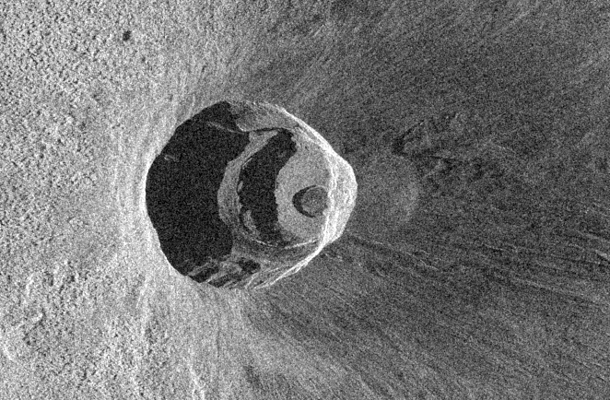
FIGURE 1: TerraSAR-X view of the Nyiragongo crater

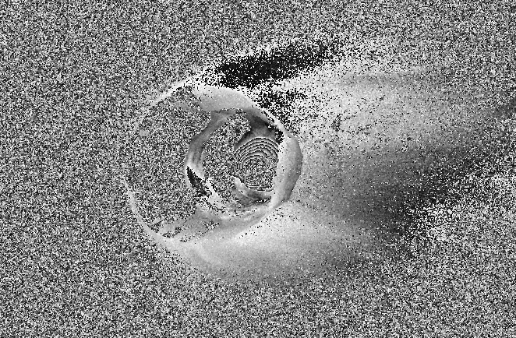
FIGURE 2: Nyiragongo crater differential interferogram

Session 1 Geodesy, ground deformation measurements and modeling of deformations associated to volcanic, tectonic or landslide activity/Géodésie, mesures des déformations du sol et modélisation des déformations associées à l’activité volcanique, tectonique ou aux glissements de terrain
Talk / Oral

Magma assisted extension in an immature continental rift, based on InSAR observations of Nyamuragira and Nyiragongo Volcanoes

V. Cayol(1)&(1'), C. Wauthier(2), F. Kervyn(3), N. d'Oreye(4)&(4').

(1) Université de Lyon, Université Jean Monnet, Laboratoire Magmas et Volcans, St Etienne, France
(1') CNRS, UMR 6524, LMV, F-63038 Clermont-Ferrand
(2) Department of Terrestrial Magnetism, Carnegie Institution of Washington, Washington, DC, USA
(3) Earth Sciences Dept., Royal Museum for Central Africa, Tervuren, Belgium
(4) Department of Geophysics/Astrophysics, National Museum of Natural History, Luxembourg
(4') European Center for Geodynamics and Seismology, Luxembourg

ABSTRACT/RÉSUMÉ
Magma assisted extension in an immature continental rift, based on InSAR observations of Nyamuragira and Nyiragongo Volcanoes
The active Nyamuragira and Nyiragongo volcanoes belong to the western branch of the east African rift. Both volcanoes are characterized by different preferencial diking directions associated with different eruptive behavior, suggesting that plate extension controls the eruptive style. Most of Nyamuragira dikes trend 40° from the rift axis, indicating that their direction is probably controlled by Precambrian basement faults [Smets et al., 2010], whereas Nyiragongo dikes trend parallel to the rift axis indicating that their direction is controlled by rifting. Nyamuragira erupts every other year, whereas only two historical eruptions of Nyiragongo have been recorded, in 1977 and 2002. Modelling of InSAR displacements show that Nyamuragira's recent eruptions are characterized by a ratio of intruded to erupted magma volume of 0.1, similar to the ratio determined at basaltic shield volcanoes such as Piton de la Fournaise [Fukushima et al., 2010] or Kilauea [Cayol et al., 2000; Poland et al., 2012]. On the other hand, the 2002 Nyiragongo eruption is characterized by an intruded to erupted magma volume ratio of 10, lower than the ratio determined in other rift contexts, but similar to the ratio determined at the end of the Krafla rifting episodes when rift extension was balanced by successive dike intrusions [Buck et al., 2006]. These volume ratios are inconsistent with this part of the rift extension driven uniquely by plate separation.
At both volcanoes, we infer low overpressures (1 – 10 MPa) for the dikes, which is not predicted for a rift driven by plate tectonics. These values are consistent with isotropic lithostatic stresses close to the dikes, which can be attributed to the high eruption rate producing compressive stresses which are too great to be relaxed by the rift extension. As a consequence, Nyiragongo preferencial intrusion direction is probably not controlled by stresses but rather by a reduced tensile strength, inherited from previous rift intrusions. Such a stress state is incompatible with stretching of the crust via normal faulting and indicates that, although the rift is considered immature, strain localizes in magmatic segments and the rift extension is accommodated by the supply of magma from depth, rather than by faulting. The small amount of thinning in the western branch of the East African Rift indicates that magma is not generated by adiabatic decompression of the mantle, but instead is probably supplied by a lateral flow of the mantle plume beneath East Africa [Ebinger, 1999].

Session 1 Geodesy, ground deformation measurements and modeling of deformations associated to volcanic, tectonic or landslide activity/Géodésie, mesures des déformations du sol et modélisation des déformations associées à l’activité volcanique, tectonique ou aux glissements de terrain
Talk / Oral

Evidence of Rift-Parallel Deformation Along the Western Branch and Main Ethiopian Rift?

D.S. Stamps(1), D. Koehn(2), N. d'Oreye(3), K.H. Ji(4), K. Burke(5), E. Saria(6), X. Rui(7), B. Smets(8), F. Albino(9).

(1) Massachusetts Institute of Technology, USA
(2) University of Glasgow, Scotland
(3) European Center for Geodynamics and Seismology, Luxembourg
(4) Massachusetts Institute of Technology, USA
(5) MIT and the University of Texas, USA
(6) Ardhi University, Tanzania
(7) Sichuan Earthquake Bureau, China
(8) European Center for Geodynamics and Seismology, Luxembourg
(9) Royal Museum for Central Africa, Belgium

ABSTRACT/RÉSUMÉ
The East African Rift System spans N-S ~5000 km and currently experiences E-W extension. Previous kinematic studies of the EARS delineated 3 relatively rigid sub-plates (Victoria, Rovuma, and Lwandle) between the Nubian and Somalian plates. GPS observations of these block interiors confirm the rigid plate model, but new observations within individual rifts are beginning to show deformation that does not conform to large-scale E-W extension. Here we present (1) new velocity solutions based on GPS observations within the Main Ethiopian Rift, the southern Albertine Rift, and the Kivu Volcanic Province, (2) a kinematic model for the Rwenzori block in the northern Western Branch and (3) preliminary work aimed at deciphering non-volcanic deformation within the Kivu Volcanic Province. Our velocity solutions suggest a possible systematic rift-parallel deformation pattern that has previously been undetected due to a lack of geodetic observations. We find that the existing kinematic models of the EAR are unable to explain the along-rift deformation, thus we developed a new kinematic model that includes the Rwenzori block within the Western Branch constrained by GPS observations and earthquake slip vectors derived from a local seismic network. Our early work suggests the Rwenzori block rotates counter-clockwise relative to the Victoria block. Further south in the Kivu Volcanic Province, we investigate a pre-2011 volcanic eruption velocity field to test the hypothesis of systematic along-rift deformation. Preliminary results indicate a possible inflation event prior to the 2011 volcanic eruption that needs to be removed from the velocity solution. Our work demonstrates the kinematics of individuals rifts needs to be re-evaluated in the broader context of the East African Rift System.

Session 1 Geodesy, ground deformation measurements and modeling of deformations associated to volcanic, tectonic or landslide activity/Géodésie, mesures des déformations du sol et modélisation des déformations associées à l’activité volcanique, tectonique ou aux glissements de terrain
Poster

Intérêt de l'approche sur la vulnérabilité des ouvrages face au glissement de terrain: cas du glissement de Funu à Bukavu

C.N. Balegamire(1), A. Jeje(2), J. Mweze(3).

(1) Centre de Recherche en Sciences Naturelles de Lwiro
(2) Centre de Recherche en Sciences Naturelles de Lwiro
(3) Centre de Recherche en Sciences Naturelles de Lwiro

ABSTRACT/RÉSUMÉ
Le 26 mars 2013 à Bukavu, une partie de la tour de la Paroisse de Kadutu a été endommagée. Dix jours plus tôt un séisme avait été ressenti (dans la nuit du 16 mars) mais aussi un autre le 9 mars. En 2008, les fissures qui avaient été causées par le séisme de 2002 et bien d’autres, se sont accentuées jusqu’ à être visible de l’extérieur. Il est possible que les récents séismes qui ont secoué la ville aient plus instabilisé le bâtiment de sorte qu’il ne suffisait que d’une petite secousse pour qu’une partie de la tour de la paroisse cède. A environ 30m dudit bâtiment (à l’aval du glissement de Funu) un éboulement était observé. Après analyse, on a remarqué que ces deux incidents dont l’éboulement et la rupture d’une partie de la tour ont coïncidé. Cela nous a amené à dire que le deuxième événement pourrait provenir du premier bien que les facteurs topographiques, géologiques, hydrologiques, climatiques et anthropiques ne sont pas à mettre à l’écart. C’est ainsi que cet article fait ressortir l’intérêt de montrer et de faire connaître qu’avec l’état de tous les ouvrages (soit fissurés, soit inclinés) présents dans le glissement de Funu, le risque reste permanent face à l’aléa sismique et au glissement de terrain.

Session 1 Geodesy, ground deformation measurements and modeling of deformations associated to volcanic, tectonic or landslide activity/Géodésie, mesures des déformations du sol et modélisation des déformations associées à l’activité volcanique, tectonique ou aux glissements de terrain
Poster

Volcano instabilities and debris avalanche hazard in the East-African Rift

A. Delcamp(1), A. Macheyeki(2), S. Kwelwa(3), D. Delvaux(4), S. Poppe(5), M. Kervyn(6).

(1) DGGF, Vrije Universiteit Brussel, Belgium
(2) GST, Dodoma, Tanzania
(3) MRI, Dodoma, Tanzania
(4) Royal Museum for Central Africa, Dept. Earth Sciences, Tervuren, Belgium
(5) DGGF, Vrije Universiteit Brussel, Belgium
(6) DGGF, Vrije Universiteit Brussel, Belgium

ABSTRACT/RÉSUMÉ
Volcanoes tend to develop gravitational instabilities during their lifetime, essentially due the presence of hydrothermal layers or superficial aquifers, dyke injection, the nature of their basement and the presence of tectonic structures. Once the volcano reaches an unstable state, earthquakes, strong winds, new dyke injection or eruption can trigger flank collapse, resulting into a debris avalanche which is characterised by high mobility and long run-out and poses a serious threat for nearby population.
Many volcanoes that are scattered along the East-African Rift System (EARS) present evidences of past instabilities, such as remnant scar of a sector collapse or debris avalanche deposits, as well as sign of long term deformation, such as gravitational spreading. We focus our study on the North Tanzanian Divergence Zone (NTDZ), where the eastern branch of the EARS splits into several branches, at the border between Kenya and Tanzania. Using remote sensing analyses based on 90m SRTM DEM and field reconnaissance, we highlighted several debris avalanche deposits (DADs) at different volcanoes such as Hanang, Burko, Kilimanjaro, Meru, Ol Donyo Lengai and Kerimasi, some of them being –to our knowledge- unknown in previous literature. Among the edifices, we noticed Mt Meru a 4566m high strato-volcano, which presents three debris avalanche deposits, with the major and most recent one running up to the feet of Kilimanjaro volcano with an estimated collapsed volume of at least 14km3 and covering an area of 1250km2 (Fig.1). From field investigation, it became evident that the two older avalanches are associated with plinian eruptions while the last collapse event was probably triggered by tectonic movements. Considering the large amount of debris avalanche deposits in the NTDZ, we then explore the regional tectonic trends to highlight the potential structural relationship that would explain collapse orientation and recurrence.
The steepness of the flanks of e.g. Muhabura, the north mount of Karisimbi, Mikeno , Nyiragongo, and their position in an active tectonic region make them potential candidates for future destabilisation event. Old volcanoes, such as Mikeno and Sabinyo already show structures that might be linked to volcano long term deformation or instabilities. A major scar on the Mikeno is probably the remnant of a past catastrophic collapse even though the associated debris avalanche deposits have not yet been identified (Fig. 2).

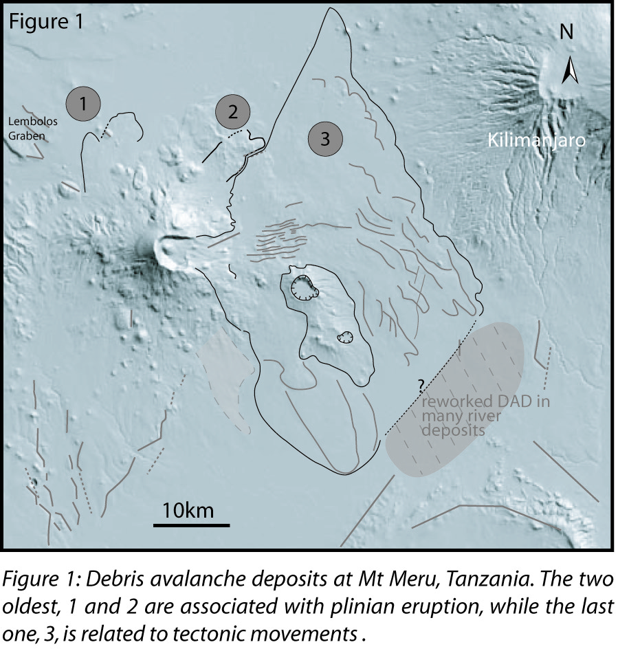

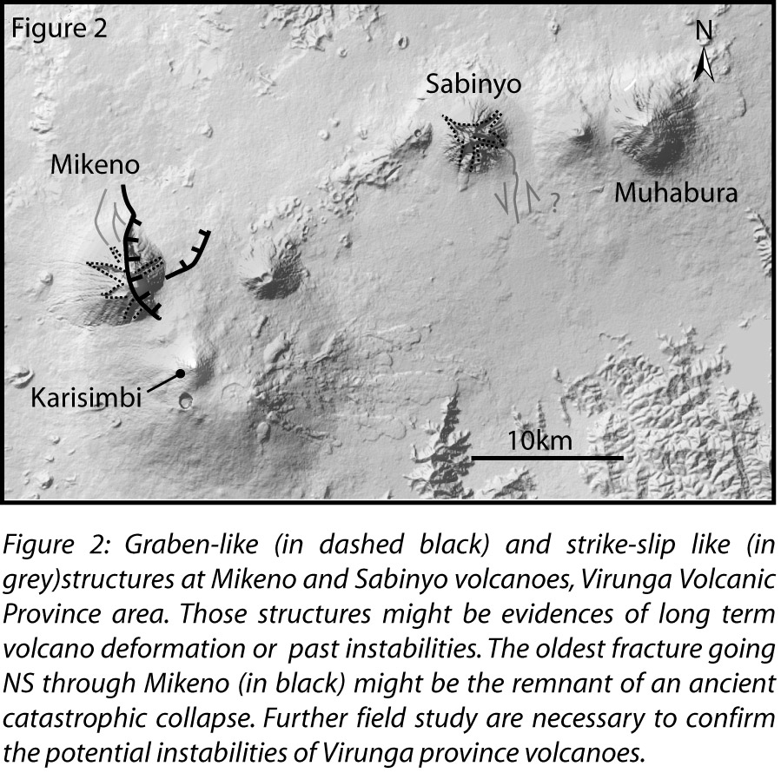

SESSION 2

Geochemistry, volcanic plume, rock and water

Géochimie, panache volcanique, roche et eau

Session 2 Geochemistry, volcanic plume, rock and water/Géochimie, panache volcanique, roche et eau
Talk / Oral

Lake Kivu Monitoring Program

A. Umutoni(1).

(1) Lake Kivu Monitoring Program, EWSA (Energy and Water Sanitation Authority), Rwanda

ABSTRACT/RÉSUMÉ
Lake Kivu is shared between Rwanda and DRC (Democratic Republic of Congo) and is an exceptional Lake: it contains in its deep water enormous quantities of dissolved gases (especially carbon dioxide and methane gas). Extraction of methane gas from Lake Kivu has double benefits: it reduces the risk of a gas outburst from the lake and it can also contribute to solving the energy crisis that faces the great lakes region. In addition to methane, the lake’s bottom may contain reserves of oil, just as in other lakes of the Albertine Rift, such as Lake Albert and Lake Edward. Concessions for methane exploitation and oil exploration have already been given out in Rwanda, but gas concession agreements are also being negotiated in DRC. If all these concessions were to become active in the future, different companies could be at work with a potentially massive impact by 2020. Methane gas and oil (if its presence is proven) should be extracted in a safe and sustainable way to respect the already very complex structure of Lake Kivu. It is in this regard that the Government of Rwanda, through the Ministry of Infrastructure (MININFRA), while promoting extraction of methane gas has, at the same time, established the Lake Kivu Monitoring Program (LKMP), to monitor the impact of methane gas extraction on the lake’s environmental stability and to make sure that it is done in a sustainable way. “Management Prescriptions for Development of Lake Kivu Gas Resources – MPs”, have also been elaborated, which form the guidelines for sustainable exploitation of gas resources. The LKMP has been monitoring pilot projects in Lake Kivu since 2008. Apart from its gas resources, the lake is of great importance as a source of drinking water for around 2 million people (about half of them in the DRC town of Goma) and for thousands of fishermen’s families, fishing being their main source of livelihood. Other economic activities abound in the lake’s watershed, such as agriculture and tourism. On the lake itself transportation is on the increase. Finally, the lake’s outlet, the Rusizi River flowing between Lake Kivu and Lake Tanganyika, has two existing hydropower plants while plans for other two big hydropower plants are in an advanced stage (the total potential on River Rusizi is around 500 MW).With such on-going and future developments, it is deemed essential that potential negative impacts are foreseen and prevented as much as possible. With a baseline in place (a biological baseline survey is currently on-going) it will be possible to monitor changes on the stability of the lake, as well as in hydrological and biological parameters in the lake. Lake Kivu is considered as a high risk region it is recognized for potential limnic eruptions, high volcano tectonic activities, all coupled with high density population and valuable natural resources in and around the lake. All aspects (natural risks and manmade risks) need to be well studied about, understood and well managed. The LKMP has built up its activities by a dedicated small team and seems a logical platform for enhanced monitoring. However, considering the complexity of the management of Lake Kivu resources, a lot still needs to be done: supplementary activities need to be initiated and existing programs need to be reinforced to make sure that the resources of Lake Kivu will be protected and exploited in a sound and sustainable manner. Although small, the LKMP is doing efforts to build a good reputation and serves increasingly as a focal point and knowledge center for (international, regional and national) research and government planning. General agreement exists amongst all stakeholders that the LKMP 2013-2016 needs to be designed from the integrated perspective of regional cooperation (DRC-Rwanda), environmental management, public safety and socio-economic development. This perspective includes, but goes far beyond the specific focus on extraction of methane gas and the lake safety. It basically comprises having a good understanding of the complex system and considers all socio-economic developments that depend on and may have an impact on the lake’s waters and other natural resources. Integrating these views has implications for organizational functions with respect to carry out more study on the lake, set up and implement technical monitoring, law enforcement based on these data, wider communication of information based on monitored data about Lake Kivu and its shores, in all its human, geological and ecological functions. The presentation will give an overview of the background of the LKMP, its current status and its perspectives.

Session 2 Geochemistry, volcanic plume, rock and water/Géochimie, panache volcanique, roche et eau
Talk / Oral

Methane cycle and methane oxidation in Lake Kivu and Kabuno Bay

F. Roland(1), F. Darchambeau(2), A. V. Borges(3).

(1) Université de Liège
(2) Université de Liège
(3) Université de Liège

ABSTRACT/RÉSUMÉ
Huge amounts of methane (CH4) (60 km3 at 0°C and 1 atm) are dissolved in deep waters of Lake Kivu. Factors controlling its production and consumption have to be well understood for its sustainable exploitation. CH4 is produced in the anoxic deep waters (monimolimnion) by the reduction of dissolved carbon dioxide and by degradation of settling organic material. CH4 then diffuses slowly from the monimolimnion to surface waters where many is consumed by specific microorganisms called methanotrophs. In Lake Kivu, this biological oxidation of CH4 can occur with different electron acceptors: oxygen (aerobic oxidation) but also nitrate, nitrite, sulfate, iron (Fe) or manganese (Mn) in anaerobic conditions. The aim of this project is to study factors controlling aerobic and anaerobic CH4 oxidation in Lake Kivu. Two field campaigns were conducted in 2013, during the rainy season (May) and the dry season (August). The sampling stations were located in the great basin (off Gisenyi, Rwanda) and in the Kabuno Bay (in the Democratic Republic of the Congo). The Kabuno Bay is a particular sub-basin isolated from the main basin and characterized by a shallow stratification (the oxycline is located at 11m) with high concentrations of CH4, Fe and Mn in the anoxic waters. Samples were collected for the measurements of CH4, nutrients, Fe, Mn, sulfate and sulfide concentrations. Rates of aerobic and anaerobic CH4 oxidation coupled to denitrification and sulfate reduction were also measured in both stations. First results indicate high CH4 oxidation rates in both main basin and Kabuno bay. For the first time, CH4 and N2O vertical profiles have been designed at high resolution in the Kabuno Bay.

Session 2 Geochemistry, volcanic plume, rock and water/Géochimie, panache volcanique, roche et eau
Talk / Oral

The history of subaquatic volcanism recorded in the sediments of the main basin in Lake Kivu

K.A. Ross(1)&(1'), M. Schmid(2), S. Ogorka(3), F.A. Muvundja(4)&(4'), F.S. Anselmetti(5).

(1) Department of Surface Waters Research and Management, Eawag, Switzerland
(1') Institute of Biogeochemistry and Pollutant Dynamics, ETH, Switzerland
(2) Department of Surface Waters Research and Management, Eawag, Switzerland
(3) Department of Surface Waters Research and Management, Eawag, Switzerland
(4) Institute Supérieur Pédagogiqe, Département de Chimie-Physique, Democratic Republic of Congo
(4') Department of Biology, University of Namur, Belgium
(5) Institute of Geological Sciences and Oeschger Centre for Climate Change Research, University of Bern, Switzerland

ABSTRACT/RÉSUMÉ
Subaquatic volcanic activity has been ongoing in Lake Kivu since the early Holocene and has a dynamic effect on the biological productivity in the surface water, and the preservation of carbonate in the deep anoxic water. Groundwater discharge into the deep water of the lake drives an upward advection that supplies nutrients to the surface water for biological production. The amount of nutrients can be increased suddenly by (1) a cold meteorological event that drives deep seasonal mixing, or (2) subaquatic volcanic activity that induces a buoyant hydrothermal plume, which would entrain nutrients. Previous sedimentological studies in Lake Kivu have hypothesized that regional climatic changes are responsible for sudden changes to the preservation of carbonates and organic carbon in the Main Basin. Here we reveal that an increase in hydrothermal activity is most likely responsible for the abrupt changes to the geochemistry in the sublacustrine sediment in Lake Kivu. An unprecedented look into the sediment stratigraphy and geochemistry using high-resolution seismic, and 15N isotope analyses was conducted in the Main Basin. The results reveal that subaquatic volcanic activity yields increased biological productivity and organic carbon preservation. Furthermore, ongoing hydrothermal discharge increases the alkalinity in the deep water, resulting in carbonate preservation.

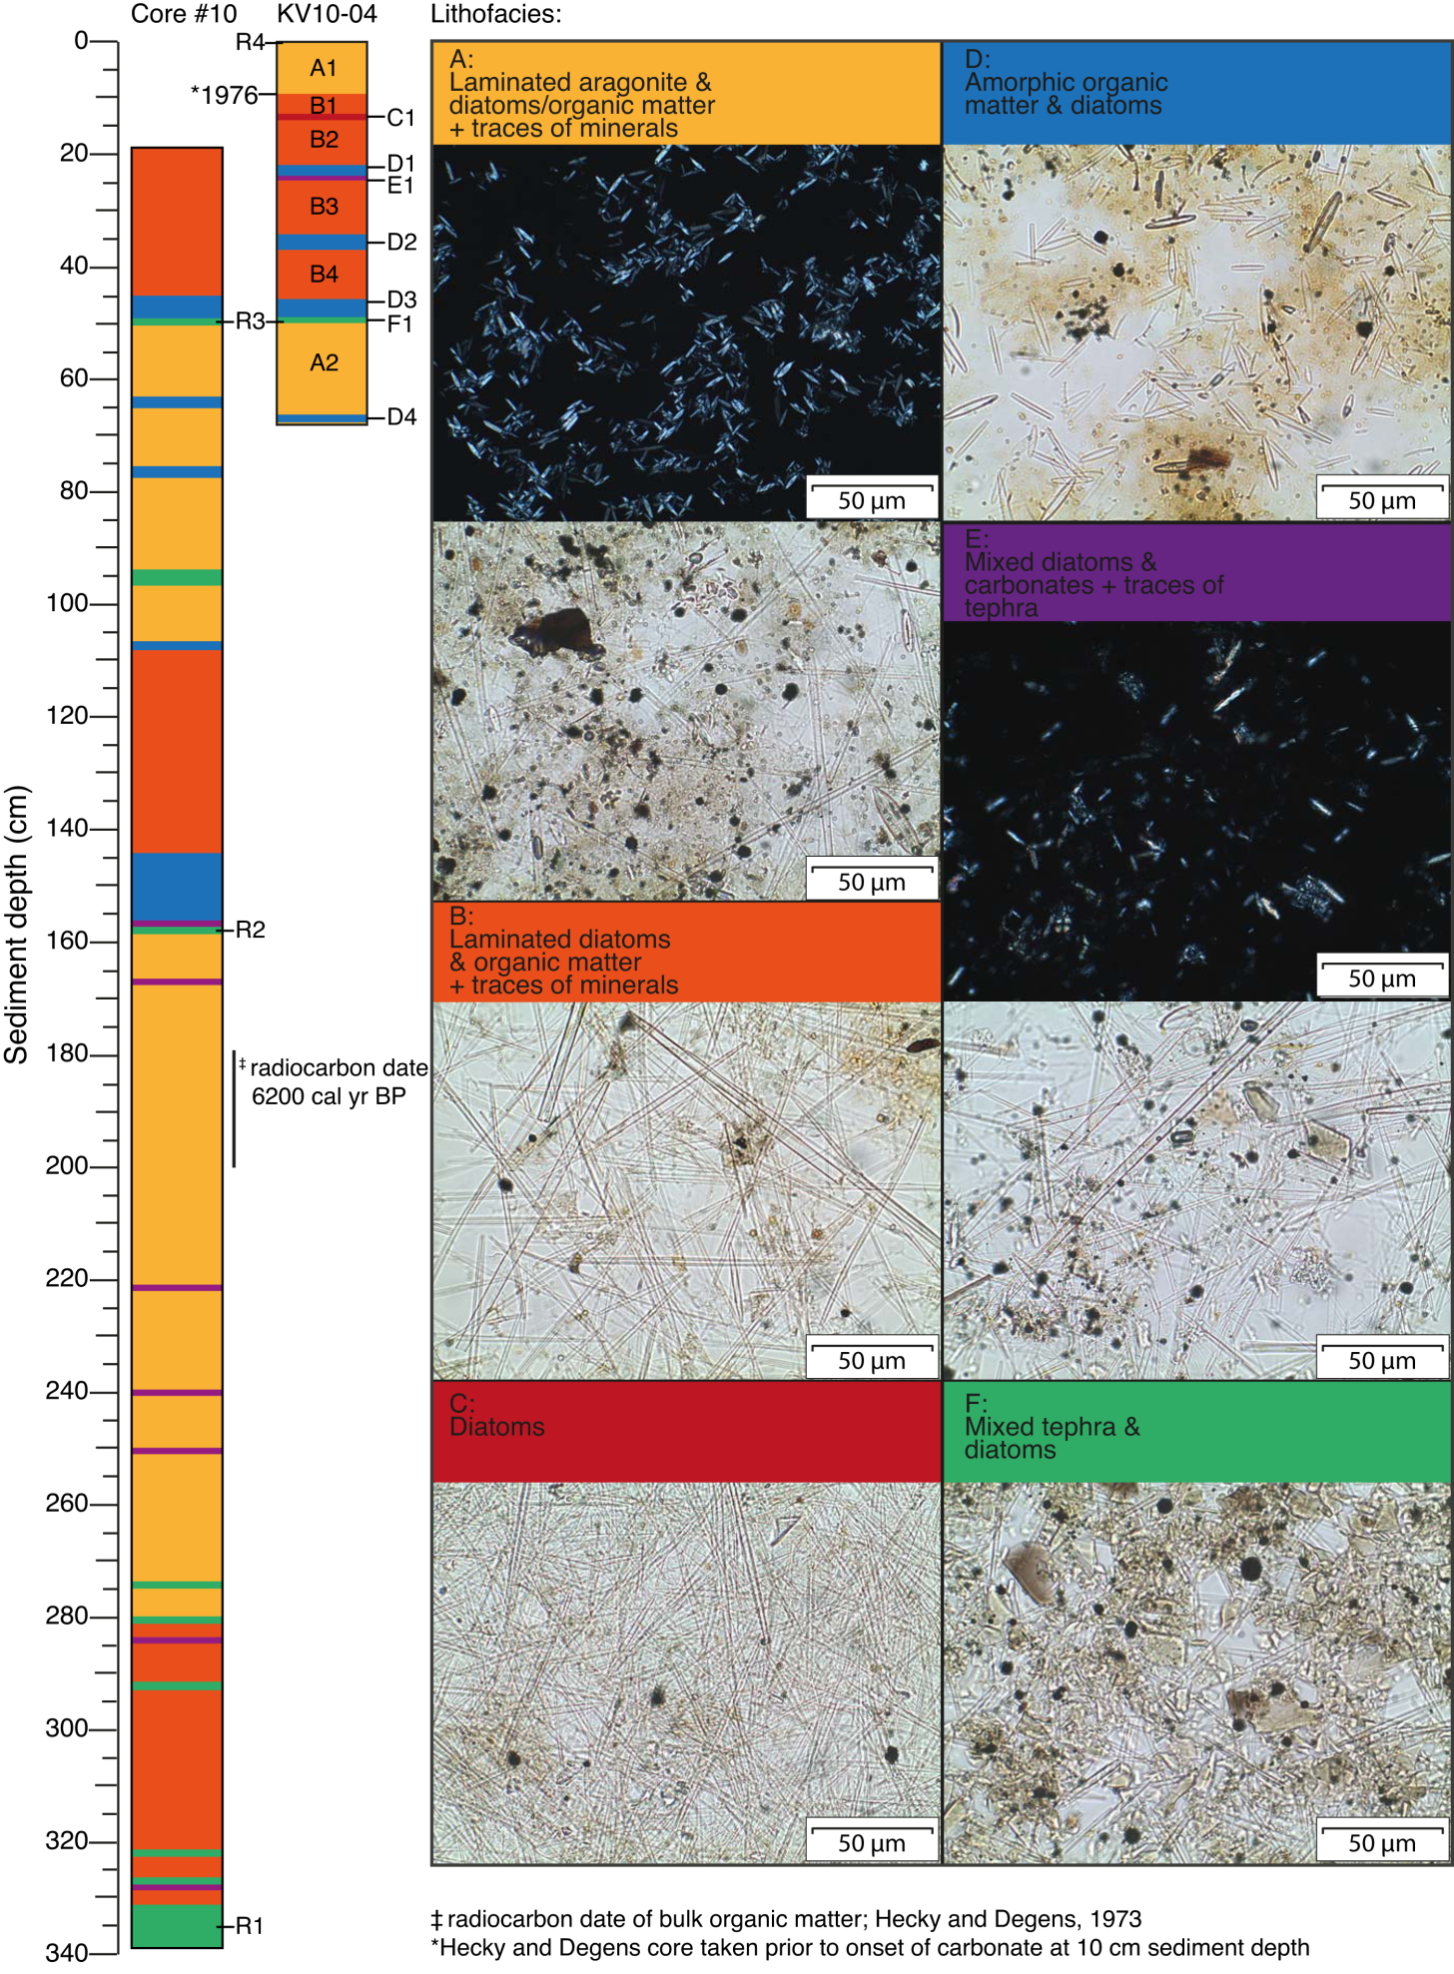

Session 2 Geochemistry, volcanic plume, rock and water/Géochimie, panache volcanique, roche et eau
Talk / Oral

Petrogenesis of felsic peralkaline rocks at the Quaternary Kone Volcanic Complex, Main Ethiopian Rift

Y. Gezahegn(1).

(1) School of Earth Sciences, Addis Ababa University

ABSTRACT/RÉSUMÉ
The Kone Volcanic Complex (KVC) is a major Quaternary centre of volcanism on the axis of the northern part of the Main Ethiopian Rift (MER). The complex consists of two nested, low relief calderas of ~8 and ~11 km diameter, with several explosive eruptive episodes having contributed to the formation of the two calderas. The KVC rocks consist primarily of trachytes and rhyolites, both as lavas and pyroclastic rocks, including a widespread welded ignimbrite that is the most voluminous pyroclastic deposit in the KVC. Explosive activity has also resulted in thick pumice-fallout deposits and phreatomagmatic ash layers. The only mafic unit is represented by basalt lava that erupted as part of the caldera-forming sequence of eruptions and as such represents material that presumably came out of the magma chamber. Later eruptions of basalt lavas and scoria cones are widespread both within the calderas and the lowlands to the northeast and south of the KVC. Similar Quaternary rift basalts characterize the northern MER and are not directly associated with the magma chambers that formed the KVC volcanic products. The KVC rocks form a compositionally bimodal mafic-felsic suite that consists of transitional basalt lava, oversaturated trachyte and sub-alkaline to peralkaline rhyolite lavas and pyroclastic materials. Volcanics of intermediate composition have not been encountered during the course of this investigation. This bimodal suite is typical of Quaternary MER central complexes as well as most continental rift volcanic systems. Geochemical data and modeling suggest that KVC peralkaline rhyolites have been derived from trachytes mainly through protracted fractional crystallization processes occurring at mid-upper-crustal depths, starting from a parental transitional basaltic magma that is compositionally similar to recent rift-related basalts in northern MER. The differentiation of basalt to rhyolite was dominated by fractionation of olivine, clinopyroxene, Fe-Ti oxide and alkali feldspar. Additional evolution involved contamination of the melts by crustal assimilation. The lack of intermediate and mafic products may be explained by a two-step polybaric process in which basaltic magma undergoes a large degree of fractional crystallization at mid-crustal depths to produce trachyte melt which, in a second stage, rises to a shallower depth and continues to fractionate, thereby generating rhyolitic liquids for subsequent volcanic extraction. The results of the present study are consistent with models of AFC-dominant magma evolution proposed for other large northern MER rift-axis peralkaline volcanic complexes.

Session 2 Geochemistry, volcanic plume, rock and water/Géochimie, panache volcanique, roche et eau
Talk / Oral

Geochemistry of continental rivers of the Virunga Volcanic Province, East Africa

C. Balagizi Muhigirwa(1), F. Darchambeau(2), M. Kassereka Musosekania(3), S. Bouillon(4), M. Mapendano(5), A. Borges(6).

(1) Department of Environmental Sciences, Via Vivaldi 43, 81100 Caserta: Italy
(2) Chemical Oceanography Unit, Université de Liège, Liège, Belgium
(3) Geochemistry and Environmental Department, Goma Volcano Observatory; Goma, D R Congo
(4) Department of Earth & Environmental Sciences, Katholieke Universiteit Leuven, Leuven, Belgium
(5) Geochemistry and Environmental Department, Goma Volcano Observatory; Goma, D R Congo
(6) Chemical Oceanography Unit, Université de Liège, Liège, Belgium

ABSTRACT/RÉSUMÉ
Between December 2010 and January 2012, monthly sampling was carried out on 13 rivers in the Virunga Volcanic Province (DR of the Congo) ; 8 of which drain into Kabuno bay (a sub-basin of Lake Kivu), the 5 others draining into Lake Edward. We analysed both in situ physico-chemical characteristics as well as a suite of biogeochemical parameters. Most parameters showed no pronounced seasonal variation, whereas their spatial variation suggests a strong control by catchment characteristics such as the geology, soil type, slope and vegetation. The maximum concentrations of nutrients such as nitrate (178 µM), nitrite (0.3 µM), ammonium (13.4 µM) and total phosphorus (14.5 µM) indicate that anthropogenic pollution is relatively limited. However, high suspended sediment concentrations (245-1467 mg L-1) were recorded in rivers in the Kabuno bay catchment, indicating high soil erodibility, possibly as a consequence of deforestation.
Vegetation and relief regulate the type and concentration of organic matter; maximum concentrations for dissolved and particulate organic carbon (DOC and POC) were 1.80 and 0.57 mg L-1, respectively, in rivers from lava field, while their respective concentrations were 4.92 and 26.29 mg L-1 in non-volcanic sub-catchments. Dissolved inorganic carbon (DIC) dominated the C pools as a result of high carbonate and volcanic rocks dissolution. Specific conductivity and total alkalinity presented high values in rivers located in the volcanic field where K+ and Na+ were the dominant cations as product of water interactions with the highly alkalic basalts lavas. δ13CPOC (-27.2 to -18.2 ‰ ) and δ13CDOC (-27.2 to -21.2 ‰ ) signatures showed a mixed origin of organic carbon from both C3 and C4 vegetation. δ13CDIC (-10.7 to 0.0 ‰ ) values were intermediate between those of CO2 produced by terrestrial organic matter degradation, and those of DIC from carbonates rocks dissolution.
The rivers of the Virunga Volcanic Province were sources of carbon dioxide (CO2) and methane (CH4) to the atmosphere, with CH4 and pCO2 values ranging from 4.95 to 5051.95 nM and 3474 to 23339 ppm nM respectively. Highest pCO2 values were found in rivers from volcanic fields and were correlated with dissolved nitrous oxide (N2O) concentrations (24 to 68 nM). These rivers were the only sites where N2O concentrations were oversaturated with respect to atmospheric equilibrium. Globally, CH4 values were high in rivers located in the catchment of Kabuno bay where swamps promote CH4 production.

Session 2 Geochemistry, volcanic plume, rock and water/Géochimie, panache volcanique, roche et eau
Talk / Oral

Impact de l'arsenic dans l'environnement de Nagarwa au Sud-Kivu

N. Buliba(1), F. Kwinja(2).

(1) Université Officielle de Bukavu
(2) Université Officielle de Bukavu

ABSTRACT/RÉSUMÉ
Notre travail s’est effectué en raison de deux approches notamment l’approche pétrographique pour déterminer les types de roches du milieu et l’approche géochimique qui nous a servi de déterminer les concentrations en métaux toxiques tel que l’arsenic et d’évaluer leur impact environnemental. Du point de vue pétrographique, 6 types des roches ont été mises en évidence dans le secteur de Nagarwa : les siltites, conglomérats, grès, quartzites, shales et les schistes. L'analyse microscopique en lumière transmise a montré que les quartzites présentent une structure hétérogranulaire et parfois équigranulaire. Les grains de quartz sont arrondis, subarrondis voire jointifs. Les schistes quant à eux sont caractérisés par l'abondance des minéraux argileux et des micas dont la taille est d'environ 500 microns, montrant une orientation préférentielle.
Du point de vue géochimie de l'environnement, l'analyse des éléments traces nous a permis d'identifier les teneurs des métaux toxiques contenus dans les roches. Nous avons établis les clarkes de concentration en métaux. 3 métaux ont présentés des anomalies géochimiques positives. Il s'agit de : or, étain et arsenic. Le réseau hydrographique étant parallèle à la direction préférentielle des couches géologiques, nous avons observés que les joints de fracturation sont les principales voies d’écoulement des eaux de surface.
A l'issue des analyses géochimiques des formations des shales et quartzites qui sont affectées par des joints de fracturation, un important taux d'arsénic a été observé. Par conséquent, l'eau qui emprunte ces joints est fortement enrichis en arsenic. Ces joints de fracturation affectant les shales et les quartzites fortement enrichis en arsenic. Vue le réseau d'eau qui traverse les roches contaminées à travers la fracturation, les communautés locales sont fortement exposées à la contamination. D'ailleurs des signes d'empoisonnement sont déjà décelables sur des enfants en bas-âge de la région

Session 2 Geochemistry, volcanic plume, rock and water/Géochimie, panache volcanique, roche et eau
Talk / Oral

A detailed geochronology of the Rungwe volcanic province at the southern end of the East African Rift System

M. Maqway(1)&(1'), C. Class(2), G.T. Mesko(3)&(3'), N. Boniface(4), S. Manya(5).

(1) Geology Department, University of Dar Es Salaam, Dar Es Salaam 35052,Tanzania
(1') Lamont Doherty Earth Observatory of Columbia University, Palisades NY 10964, USA
(2) Lamont Doherty Earth Observatory of Columbia University, Palisades NY 10964, USA
(3) Department of Earth and Environmental Sciences, Columbia University, New York, NY 10027, USA
(3') Lamont Doherty Earth Observatory of Columbia University, Palisades NY 10964, USA
(4) Geology Department, University of Dar Es Salaam, Dar Es Salaam 35052,Tanzania
(5) Geology Department, University of Dar Es Salaam, Dar Es Salaam 35052,Tanzania

ABSTRACT/RÉSUMÉ
The Rungwe volcanic province (RVP) is situated in the accommodation zone between the major border faults forming the Songwe, Usangu and Karonga Basins in the western branch of the East African Rift System (EARS), SW Tanzania (Ebinger et al., JGR 1989). The Western Rift consists of a number of deep lakes and sedimentary basins, surrounding the western side of the Archean Tanzania Craton. The RVP, which represents the southernmost expression of the EARS, consists of five main volcanic centers and small numerous eruptive centers situated within the rift structure. The RVP rift -related, magmatism, like other part of the EARS, is associated with mantle plume activity (Hilton et al., GRL 2011; Rooney et al., Geology 2012). Previous studies have indicated that the RVP mafic melts are the mixture of various mantle compositions due to heterogeneity in both chemistry and the rift structure. Initially it was assumed that the RVP represents the youngest volcanic province in the EARS, following the model that volcanism migrated to the South since about 40 Ma in southern Ethiopia (Ebinger et al., JGS 1993; George et al., Geology 1998). The following Ar-Ar geochronology of Rungwe volcanics has shown that early eruptions are as old as 26-24 Ma and 19-17Ma (Robert et al., Nat. Geo. 2012; Rasskazov et al., G&G 2003), more corresponding with the initiation of the rift of the volcanically active eastern branch to the north. The previous researches have proposed various sources for RVP volcanics, yet a detailed analysis is needed, especially a temporal relationships between these sources. Here we present new geochronological constraints that refine the evolution history of the Rungwe magmatism particularly the early stage. Preliminary results of traditional K-Ar/Ar-Ar analyses on 33 groundmasses and 2 biotite are presented from areas of older flows and phonolites domes as well as the major central volcanoes of Rungwe, Ngozi and Kyejo of the RVP. One of the phonolitic domes were dated at 17.7Ma using the Ar-Ar method. Preliminary K-Ar dates of existing domes show that the volcanic eruption started at least 18 Ma. These ages agree with the previous geochronological and stratigraphic constraints in the region. The majority of dates obtained are <10Ma consistent with the estimated time of extension and basin development. The volcanic rocks in the RVP region are also associated with carbonatitic intrusions as old as 165.7 Ma. The relationship between these carbonatite and the Rungwe volcanics still needs to be evaluated. The Rungwe volcanics are generally characterized as the low K- alkali basaltic lavas containing only about 0.5-3 Wt.% K2O , enriched in LILE (Ba,Sr) and LREE (La, Sm) with respect to the HREE and HFSE (Zr, Hf) on N-MORB-normalized REE and multi-element diagrams.

KEYWORDS
East African Rift System (EARS), Rungwe Volcanic Province (RVP), Volcanic rocks, 40Ar/39Ar geochronology

REFERENCES:
Ebinger C.J, Deino A.L, Drake R.E, and Tesha A.L, 1989: Chronology of Volcanism and Rift Basin Propagation: Rungwe Volcanic Province, East Africa: J. Geophys. Res., v. 94, p. 15785-15803.
Ebinger C.J, Yemane T, T, Woldegabriel G, Aronson J.L and Walter R.C, 1993b: Late Eocene–Recent volcanism and faulting in the southern main Ethiopian rift: Journal of the Geological Society, v. 150, p. 99-108..
George R, Rogers N and Kelley S , 1998: Earliest magmatism in Ethiopia:evidence for two mantle plumes in one flood basalt province: Geology, v. 26, p. 923-926.
Hilton D.R, Halldórsson S.A, Barry P.H, Fischer T.P, De Moore J.M, Ramirez C.J, Mangasini F and Scarsi P 2011: Helium isotopes at Rungwe volcanic Province, and the origin of East African Plateaux : Geophysical Research Letters , V, 38, L21304.
Rasskazov S.V, Logachev N.A, Ivanov A.V, Boven A.A, Maslovskaya M.N, Saranina E.V, Brandt I.S and Brandt S.B, 2003: A magmatic episode in the western rift of East Africa (19–17 Ma): Geologiya i Geofizika, v. 44, p. 317–324.
Roberts E.M, Stevens N.J, O'Connor P.M, Dirks P.H.G.M, Gottfried M.D, Clyde W.C, Amstrong R.A, Kemp A.I.S and Hemming S, 2012: Initiation of the western branch of the East African Rift coeval with the eastern branch: Nature Geosci, v. 5, p. 289–294
Rooney O.R, Herzberg C, and Bastow D.I 2012: Elevated mantle temperature beneath East Africa: Geology, v.40, p.27-30.

Session 2 Geochemistry, volcanic plume, rock and water/Géochimie, panache volcanique, roche et eau
Talk / Oral

Lake Kivu a unique lake : a resource or a treat for the local population ?

D. Tedesco(1)&(1'), O. Vaselli(2)&(2’), F. Tassi(3)&(3').

(1) UNOPS
(1') Second University of Napoli (DISTABIF)
(2) University of Florence (Department of Earth Sciences)
(2') CNR-IGG Institute of Geosciences and Earth Resource of Florence (Italy)
(3) University of Florence (Department of Earth Sciences)
(3') CNR-IGG Institute of Geosciences and Earth Resource of Florence (Italy)

ABSTRACT/RÉSUMÉ
Lake Kivu (1°24’ S to 2°30’ S and 28°50’ E and 29°23’ E) lies between the Democratic Republic of the Congo (DRC) and Rwanda. The lake water, at an altitude of 1,460 a.s.l., covers a surface of about 2,400 km2 (1,370 km2 of which are in the Congolese territory) with a catchment area of about 7,000 km2. The maximum length of Lake Liku is 84 km and the maximum width is 50 km. Lake Kivu belongs to the western branch of the East African Rift System (EARS) and is part of the Virunga Volcanic Province where silica-undersaturated, ultra-alkaline and alkalic-mafic magma predominate. The two active Virunga volcanoes, Nyiragongo and Nyamuragira, are located north of Lake Kivu. The erupted Nyiragongo lavas have an unusual composition with the lowest recorded viscosity among terrestrial magmas.
Lake Kivu is an important water resource among the African Great Lakes, having an estimate water volume of 560x109 m3. Its depth is remarkable, the mean depth being 240 m, while the deepest point is 485 m. Lake Kivu drains to the south into the Ruzizi River, which finally feeds Lake Tanganyika.
One of the most striking peculiarities of Lake Kivu is the presence of a large CO2-CH4-rich gas reservoir at depth >250 m and for this reason in the past limnologists and geoscientists have been attracted by the singularity of the physico-chemical composition of the lake water. An estimated 300 km3 of carbon dioxide and 55-60 km3 of methane are dissolved and trapped at significant depth in the lake.
In January 2002, the sudden eruption of Nyiragongo produced between 15 and 25x106 m3 of fresh magma that fed several lava flows and one of them entered the lake down to a depth of ≈70/100 m. This event promptly recalled the disastrous limnic eruption at Lake Nyos (Cameroon) in 1986. Here, about 1,800 people were suffocated by a CO2-rich cloud released from the deepest part of this. The magnitude and the number of people possibly involved in a gas outburst at Lake Kivu would be much higher. Moreover, the scenario generated by the presence of an inflammable gas such as methane can hardly be constrained. The comparison between these two lakes is ABSOLUTELY impossible, and it is a huge mistake by some scientists to try to find out similarities.

An overturn of Lake Kivu has been seriously taken into consideration after the January 2002 Nyiragongo volcanic eruption from a NS-oriented fissure located on the southern flank of the Congolese volcano. The possibility of a rollover derives from the fact that Lake Kivu is meromictic and below ≈250 m a CO2-CH4-rich gas reservoir is present. Thus, the riparian population (≈2,500,000 people) might be endangered by a possible limnic eruption. During the last 30 years several vertical profiles carried out by several researchers have evidenced a relatively pronounced vertical physico-chemical and isotopical variation. Nevertheless, saturation of CO2 and CH4 appears to be far from critical values, indicating that presently the hydrostatic pressure it extremely far to be presently overcome. Recent studies and measurements have suggested that due to the increase of the dissolved gases at depth (particular of CH4) and the uprising of the chemocline, a limnic eruption could possibly occur within 80 to 200 years from now. These data, increase of these two parameters, are NOT supported at the moment by any evidence.
More studies are needed to follow up the lake evolution with time. Simulations will shed light on possible internal and external factors able to provoke the release of a suffocating and, possibly, inflammable killer cloud. In this talk, using recent historical eruptive events of Nyiragongo and Nyamulagira volcano, it will be discussed the possibility that a limnic eruption CANNOT occur occur in a near future. Obviously, the stability of Lake Kivu, being presently very high, helps in this moment to play down the hazard. Several scientists have discussed that only exceptionally high magnitude events appear to be able to destabilize the 560x109 m3 water volume contained in its basin. Is this true ? The talk will be discussing all possible external and internal events and explaining that it is easier and more profitable to talk about a possible future disaster than playing down the hazard, because currently, from our knowledge, there are no possible events that COULD destabilize the lake.

Session 2 Geochemistry, volcanic plume, rock and water/Géochimie, panache volcanique, roche et eau
Talk / Oral

Gas geochemistry at the Nyiragongo volcano and surrounding areas

O. Vaselli(1)&(1'), D. Tedesco(2)&(2'), F. Tassi(3)&(3'), T. Darrah(4), M.M. Yalire(5).

(1) Department of Earth Sciences, University of Florence (Italy)
(1') CNR-IGG Institute of Geosciences and Earth Resource of Florence (Italy)
(2) UNOPS (Goma, RDC)
(2') Department of Environmental Sciences - Naples 2 (Italy)
(3) Department of Earth Sciences, University of Florence (Italy)
(3') CNR-IGG Institute of Geosciences and Earth Resource of Florence (Italy)
(4) School of Earth Sciences, Columbus (Ohio, USA)
(5) Goma Volcano Observatory

ABSTRACT/RÉSUMÉ
After the January 17, 2002 event that partly destroyed the city of Goma as two of the several lava flows erupted from a roughly N-S oriented fracture system formed along the southern flank of Mt. Nyiragongo DRC (Democratic Republic of Congo) entered downtown, A humanitarian and scientific response was promptly organized by international, governmental, and nongovernmental agencies coordinated by the United Nations and the European Union. Among the different scientific projects undertaken to study the mechanisms triggering this and possible future eruptions, we focused on the isotopic (He, C, and Ar) analysis of the magmatic-hydrothermal and cold gas discharges related to the Nyiragongo volcanic system, the Kivu and Virunga region. The studied area includes the Nyiragongo volcano, its surroundings, and peripheral areas inside and outside the rift. They have been subdivided into seven regions characterized by distinct 3He/4He (expressed as R/Rair) ratios and/or 13C-CO2 values. The Nyiragongo summit crater fumaroles, whose R/Rair and 13C-CO2 values are up to 8.73 and from 3.5% to 4.0% VPDB, respectively, show a clear mantle, mid-ocean ridge basalt (MORB)-like contribution. Similar mantle-like He isotopic values (6.5–8.3 R/Rair) are also found in CO2-rich gas emanations (mazukus) along the northern shoreline of Lake Kivu main basin, whereas the 13C-CO2 values range from 5.3% to 6.8% VPDB. The mantle influence progressively decreases in (1) dissolved gases of Lake Kivu (2.6–5.5 R/ R/Rair) and (2) the distal gas discharges within and outside the two sides of the rift (from 0.1 to 1.7 R/ R/Rair). Similarly, 13C-CO2 ratios of the peripheral gas emissions are lighter (from 5.9% to 11.6% VPDB) than those of the crater fumaroles. Therefore, the spatial distribution of He and C signatures in the Lake Kivu region is mainly produced by mixing of mantle-related (e.g., Nyiragongo crater fumaroles and/or mazukus gases) and crustal-related (e.g., gas discharges in the Archean craton) fluids. The CO2/3He ratio (up to 10x1010) is one order of magnitude higher than those found in MORB, and it is due to the increasing solubility of CO2 in the foiditic magma feeding the Nyiragongo volcano. However, the exceptionally high 40Ar*/4He ratio (up to 8.7) of the Nyiragongo crater fumaroles may be related to the difference between He and Ar solubility in the magmatic source. The results of the present investigation suggest that in this area the uprising of mantle-originated fluids seems strongly controlled by regional tectonics in relation to the geodynamic assessment of the rift. These fluids are mainly localized in a relatively small zone between Lake Kivu and Nyiragongo volcano, with important implications in terms of volcanic activity.
To the best of our knowledge, no gas geochemical monitoring is currently going on at any of the investigated sites in the present study. However, it is our belief that some of the gas discharges should periodically be analyzed and associated with the seismic and ground deformation data in order to better understand the state of Nyiragongo volcano.

Session 2 Geochemistry, volcanic plume, rock and water/Géochimie, panache volcanique, roche et eau
Talk / Oral

Gas emission measurements of the active lava lake of Niyragongo, DR Congo

N. Bobrowski(1), G.B. Giuffrida(2), D. Tedesco(3), M. Yalire(4), S. Arellano(5), C. Balagizi(6), B. Galle(7), S. Calabrese(8).

(1) University of Heidelberg, Germany
(2) Instituto Nazionale di Geofisica e Vulcanologia, Palermo, Ital
(3) University Napoli, Caserta, Italy
(4) Observatoire Volcanologique de Goma
(5) Chalmers University of Technology, Göteborg, Sweden
(6) Observatoire Volcanologique de Goma
(7) Chalmers University of Technology, Göteborg, Sweden
(8) DiSTeM, Università di Palermo, Italy

ABSTRACT/RÉSUMÉ
Four intensive field surveys were carried out at the crater rim of Nyiragongo volcano, DR Congo between 2007 and 2011 (June 2007, July 2010, June 2011 and December 2011). Nyiragongo is considered to be currently one of the most active volcanoes in Africa.
The volcano is one of eight volcanoes in the Virunga volcanic chain, it has a height of about 3470 m and it is overall famous for its large lava lake. Nyiragongo is an exceptional volcano regarding some of its properties. Nyiragongo has a very lava viscosity, which is even lower than the very closely situated, frequently effusive erupting volcano, Nyamuragira. Further, Nyiragongo is characterized by a relatively unusual magmatic composition, under-saturated in silica but with a very high potassium and sodium content. Particularly, Nyiragongo gives the rare possibilitiy to directly observe magma movements as the conduit is completely filled and finalizes with an open lava lake at the surface during large time frames. Though movements of magma can be directly put into relation with geochemical and geophysical observations.
The ground - based remote sensing technique - Multi Axis Differential Optical Absorption spectroscopy (MAX-DOAS) using scattered sunlight and a Multi-GAS-instrument have been simultaneously applied during three of the field trips and among others bromine monoxide/sulphur dioxide (BrO/SO2) and carbon dioxide/sulphur dioxide (CO2/SO2) ratios were determined. Additionally alkaline trap samples were taken in all four field visits. At the various field trips lava lake level changes were observed (in the order of minutes up to days and also between the years).
The measured gas ratios varied as well for CO2/SO2 between 1.2 and 16.2 and between 0.2-1.6 x 10-5 for BrO/SO2 ratios. BrO/SO2 ratios showed similar behavior as CO2/SO2. Higher CO2/SO2 and BrO/SO2 levels were generally observed before significant lava lake levels changes (e.g. overflow of terrace, significant drop of the lava lake in June 2011 see Fig. 1). During all campaign also Cl/S and Br/S ratios have been determined by filter-pack sampling. Overall the Cl/S ratio shows an increase with time from earlier literature data of 0.05 to up to 0.55 in 2011, which is accompanied but not only caused by a decreasing sulfur dioxide flux, measured nearly continuously since 2004.
A simple conceptual model is proposed to explain the gained although limited data. This model assumes various convective magma cells inside the conduit and the possible temporary interruption of part of the cycling. Our proposed model is able to explain our data set as a whole but is probably far from complete.

Figure caption: A short time series of CO2/SO2 (black rectangle) and BrO/SO2 (red circles) for the measurements in June 2011 are shown. An impressive lake level drop of about 30 m appeared in a time frame of < 5 min during the third night in the field on 3rd June 2011. The “boiling activity” and the convection of the cold surface plates of the lake was clearly enhanced after this event (including bigger 'waves' at the surface etc.) and during the following days, which is indicated in the sketch below.

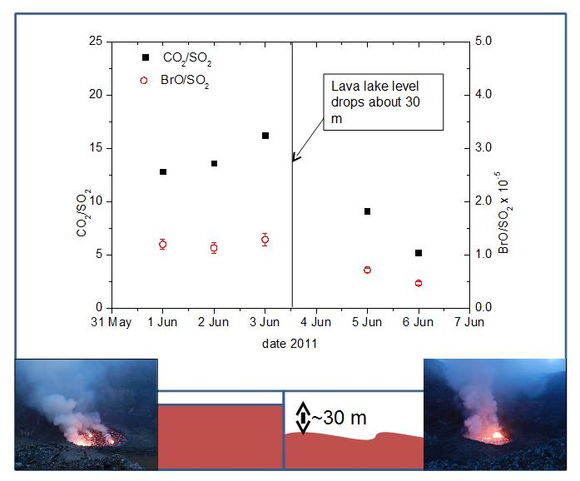
FIGURE 1: A short-time series of CO2/SO2(black rectangle) and BrO/SO2(red circles), June 2011 are shown. An impressive lake level drop of about 30 m appeared in a time frame of < 5 min on 3rd June 2011.

Session 2 Geochemistry, volcanic plume, rock and water/Géochimie, panache volcanique, roche et eau
Talk / Oral

CO₂ dynamics in mofettes

A. Kies(1), O. Hengesch(2), B. Smets(3), Z. Tosheva(4), H. Pfanz(5), M. Yalire(6).

(1) University of Luxembourg, 162a, av. Faïencerie, L-1511 Luxembourg
(2) University of Luxembourg, 162a, av. Faïencerie, L-1511 Luxembourg
(3) European Center for Geodynamics and Seismology, Luxembourg
(4) University of Luxembourg, 162a, av. Faïencerie, L-1511 Luxembourg
(5) Faculty of Biology, University of Duisburg-Essen, 45117 Essen, Germany
(6) Observatoire volcanologique de Goma

ABSTRACT/RÉSUMÉ
The Tyrrhenian-Apennine region of Central Italy is characterized by enhanced CO2 degassing from focused emissions (vents), diffuse soil exhalation and CO2-enriched groundwater connected to geothermal fluids. We report here on measurements on a mofette, known locally as the Bossoleto mofette, situated close to the village of Rapolano, Tuscany. The CO2 vents occur both at the bottom and on the flanks of a circular doline; some 100 m in diameter and 7 m depth (Photo). The CO2 concentrations in the mofette especially close to the ground are so high (up to 85 %) that the area was chosen as a natural laboratory for experiments on plant physiology.
A two-section 7m Campbell Scientific, UT920 aluminium tower was mounted on a concrete base close to the center of the mofette. From the bottom of the tower to the 6.4 m top, at each 40 cm air is sucked successively each 10 minutes to a pressure-temperature compensated CO2 meter, based on infrared absorption. At the same elevations air temperature is measured. On top of the tower a Davis weather station monitors barometric pressure, temperature, humidity, rainfall, wind speed and direction, solar and UV radiation.

Mostly over the day, CO2 concentrations in the mofette are very low. CO2 accumulation starts precisely at reversal of the vertical temperature gradient that happens in the afternoon when solar irradiance decreases sufficiently due to a lack of heating of the lower air masses. Air in contact with the soil cools down, is heavier than the upper warmer air, this difference in gravity, increased with seeping CO2 that is now retained in the mofette, leads to further growth of CO2. Starting at the moment of gradient inversion, a CO2 layering will built up, reaching up to 80 % at the bottom.
After sunrise, the temperature gradient is decreasing and eventually changes. In that precise moment CO2 levels in high situated layers drop rapidly to ambient values whereas lower situated levels tend to stabilize around roughly an identical value for all the lower layers. After a very rapid decline of CO2 is observed, leaving the bossoleto void of CO2.
The observations done in are compared with continuous CO2 measurements in mofettes in Czech Republic (Eder-Graben), in Germany (Maria Laach, Eifel) and in RDC (Goma).

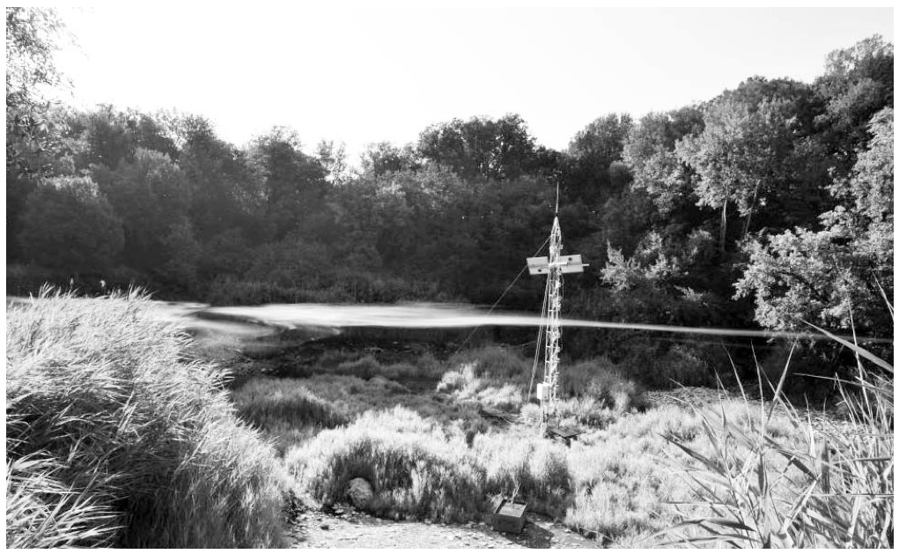
FIGURE 1: Observation tower in the Bossoleto doline; the picture taken in the morning shows the visible boundary separating a hot CO2 atmosphere at the bottom (up to 70 %) and a CO2 depleted colder air above.

Session 2 Geochemistry, volcanic plume, rock and water/Géochimie, panache volcanique, roche et eau
Talk / Oral

A geochemical constraint on the origin of melts using thermobarometry at Rungwe Volcanic Province, Tanzania

G. Mesko(1)&(1'), C. Class(2), N. Boniface(3), S. Manya(4), M.D. Maqway(5).

(1) Department of Earth and Environmental Sciences, Columbia University, New York, NY 10027, USA
(1') Lamont Doherty Earth Observatory of Columbia University, Palisades NY 10964, USA
(2) Lamont Doherty Earth Observatory of Columbia University, Palisades NY 10964, USA
(3) Geology Department, University of Dar Es Salaam, Dar Es Salaam 35052, Tanzania
(4) Geology Department, University of Dar Es Salaam, Dar Es Salaam 35052, Tanzania
(5) Geology Department, University of Dar Es Salaam, Dar Es Salaam 35052, Tanzania

ABSTRACT/RÉSUMÉ
The Rungwe Volcanic Province is the southernmost volcanic province associated with the Cenozoic rifting in the East African Rift [EAR]. Rungwe is constrained within a transform fault zone offsetting two normal fault segments of the western branch of the EAR. It consists of five multi-stage centers situated within the rift structure, with an expansive network of secondary edifices above and below the hanging wall. Rungwe last erupted ~200 years ago, has had multiple explosive Holocene eruptions, and is still considered active today. Rungwe is located ~130 km south of the edge of the Tanzanian Craton (Foley et al., JAES 2012), more than twice the distance of other Cenozoic rift volcanoes around the craton and is thus less often associated with an underlying mantle plume. Nevertheless, recent He isotope measurements (Hilton et al. GRL 2011) suggest contributions of a plume to Rungwe volcanism.
We employ the Thermobarometer of Lee et al. EPSL (2009) and PRIMELT2 (Hertzberg & Asimow, G3 2008) to estimate the mantle potential temperature (Tp) and pressure where Rungwe melts originate to 60 mafic rock samples collected during our Summer 2012 field campaign. PRIMELT2 yields Tp=1480°C for our sample suite, which is elevated over the observed ambient mantle temperature of 1350±50°C. PRIMELT2 was employed to estimate Tp= 1400-1450°C using identical parameters for previously published data (Rooney et al., Geology 2012).
Trace element abundances and geological context serve as evidence that the source of melts at Rungwe is elevated in volatiles, especially CO2 and H2O, and these species are known to greatly reduce the p-T conditions of melting (Thompson, Nature 1992). Water content may be estimated for all samples using H2O/Ce = 200±50, a ‘canonical ratio’ calibrated with MORB samples (Michael, EPSL 1995; Saal et al., Nature 2002; Workman & Hart, EPSL 2005). Results of this H2O calculation are broadly consistent with previous H2O measurements in Rungwe (Ivanov et al., Rus. Pet. 1998). The Lee Thermobarometer estimates Tp=1534-1392C, and P=4.62-2.39GPa (~75-150km depth) from the major element composition and calculated H2O abundances of our mafic sample suite.
Potential temperature estimates are higher than previous estimates for Rungwe despite including H2O in the calculations. New Tp estimates are consistent with potential temperatures of other volcanic complexes attributed to plume activity (Herzberg & Gazel, Nature 2009; Rooney et al., Geology 2012). Rungwe magmas originate at pressures and depths in the garnet stability field (Green & Ringwood, EPSL 1967; O'Hara et al., CMP 1971; Robinson & Wood, EPSL 1998), and are below the modeled depth of the lithosphere in the area (Weereratne et al, JGR 2003). These sub-lithospheric melts originate at potential temperatures elevated above ambient mantle and thus suggest a plume contributes to magma generation at Rungwe.

Session 2 Geochemistry, volcanic plume, rock and water/Géochimie, panache volcanique, roche et eau
Talk / Oral

A single superplume source with multiple heads supplies melt along the East African Rift System

P. Castillo(1), D.R. Hilton(2), S. Halldorsson(3).

(1) Scripps Inst. of Oceanography
(2) Scripps Inst. of Oceanography
(3) Scripps Inst. of Oceanography

ABSTRACT/RÉSUMÉ
It is widely agreed that lithospheric rifting along the East African Rift System (EARS) is influenced by mantle plume-type melting and the EARS sits atop a large, seismically anomalous feature originating in the lower mantle – the African Superplume[1]. Currently, the true nature and number of plumes in the EARS are controversial. Although there has been a consensus that the “Afar” plume with high 3He/4He and centered in the Lake Abhe region, Afar, is present beneath the Main Ethiopian Rift (MER)[2], compositionally distinct mantle plumes have also been proposed to be present beneath the southern branches of the EARS to the east[3] and west[4] of Kenya Dome, and that a mantle plume similar to the “HIMU” plume in the oceanic environment is widespread beneath much of the EARS[5].

Our new geochemical data for the recently discovered high, plume-like 3He/4He basaltic lavas and tephras at Rungwe Volcanic Province (RVP) in southern Tanzania[6] show that the samples have variable trace element contents that are remarkably enriched in highly incompatible trace elements (Fig. 1A). RVP has relatively higher 87Sr/86Sr and lower 143Nd/144Nd than (a) bulk silicate Earth (BSE) implying long-term enrichment of the mantle source; (b) the majority of MER samples which contains the signature of the MER plume; and (c) the proposed Kenya Dome plumes (Fig. 1B). Moreover, RVP has variable Pb isotope ratios that clearly overlap in 206Pb/204Pb with the MER at the depleted (low 206Pb/204Pb) extreme and VVP at the radiogenic (high 206Pb/204Pb) end (Fig. 2). A clear exception is sample TAZ9-12, which has low 206Pb/204Pb but unusually high 208Pb/204Pb (and 207Pb/204Pb) and the highest 87Sr/86Sr and ~lowest 143Nd/144Nd ratios of the RVP sample suite. In summary, our new data indicate that RVP samples can be explained by binary mixing relationships involving old subcontinental lithospheric mantle (SCLM) and a volatile-rich, carbonatitic plume material similar in composition to the MER mantle plume (Fig. 1C). Similar mixing scenarios can explain the compositions of the two Kenya Dome plumes; the carbonatitic plume material is mixed with “local” SCLM beneath the Tanzanian craton and remobilized craton margin. Finally, the volatile-rich, carbonatitic plume material potentially could be coming from recycled ancient carbonate that has a high, long time integrated U/Pb ratio[7] and this could explain the “HIMU-like” Pb isotopic signature of the EARS plume lavas. Thus, we propose that the African Superplume influences magmatism throughout eastern Africa through variable carbonatitic metasomatism of the variably heterogeneous east African SCLM and the high 3He/4He magmatism at RVP and MER represent two different heads of such a single mantle plume source.

[1] Hansen, S.E. & Nyblade, A.A., 2013, Geophys. Jour. Int., doi: 10.1093/gji/ggt116. [2] Rooney, T.O. et al. 2012, Jour. Petrol., doi:10.1093/petrology/egr065. [3] Rogers, N. et al., 2000, Earth Planet. Sci. Lett. 176, 387–400. [4] Chakrabarti, R. et al., 2009, Chem. Geol. 259, 273–289. [5] Furman, T. et al., 2006, Jour. Petrol. 47, 1221–1244. [6] Hilton, D.R. et al., 2011, Geophys. Res. Lett. 38, L21304, doi:10.1029/2011GL049589. [7] Castillo, P.R., 2013, Mineral. Mag., 77(5) 838.

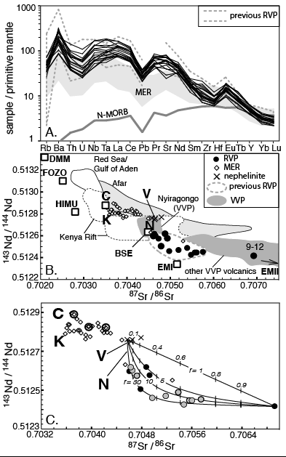
FIGURE 1: A. Primitive mantle-normalized trace element concentration patterns, B. 143Nd/144Nd vs. 87Sr/86Sr and C. Mixing model for RVP samples.

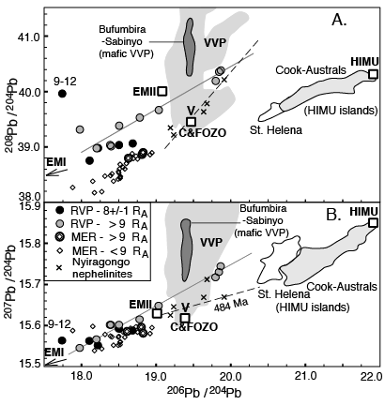
FIGURE 2: A. 206Pb/204Pb vs. 208Pb/204Pb and B. 206Pb/204Pb vs. 207Pb/204Pb for RVP, MER and selected EARS samples.

Session 2 Geochemistry, volcanic plume, rock and water/Géochimie, panache volcanique, roche et eau
Poster

Preliminary data on trace element emissions from Niyragongo volcano (DR Congo)

S. Calabrese(1), N. Bobrowski(2), G.T. Giuffrida(3), W. D'Alessandro(4), L. Brusca(5), S. Bellomo(6), S. Milazzo(7), S. Arellano(8), B. Galle(9), D. Tedesco(10), S. Scaglione(11).

(1) University of Palermo
(2) University of Heidelberg
(3) INGV Palermo
(4) INGV Palermo
(5) INGV Palermo
(6) INGV Palermo
(7) DiSTeM - University of Palermo
(8) Chalmers University of Technology, Goeteborg
(9) Chalmers University of Technology, Goeteborg
(10) University of Naples, Caserta

ABSTRACT/RÉSUMÉ
We present the preliminary results from a study focused on the emission of major and trace elements into the atmosphere from the currently quiescent degassing volcano - Niyragongo. Volcanic emissions were sampled by using active filter-packs for acid gases (SO2, HCl and HBr), passive diffusive samplers (for SO2 and HCl) and specific filters for aerosols (major and trace elements). The impact of the volcanogenic deposition in the surrounding of the rim craters was investigated by using different sampling techniques: the rain gauge collector was used for atmospheric bulk deposition; biomonitoring techniques were carried out to collect gases and particulates by using endemic plant (sp. Senecio) and transplanted mosses (moss-bags). All the samples were collected during a field trip in December 2011.
Concentrations of major and trace elements of volcanic emissions (gases and particulates) were obtained by elution and microwave digestion of the collected filters: sulfur and halogens were determined by ion chromatography and ICP-MS, and untreated filters for particulate were acid digested and analyzed by ICP-OES and ICP-MS. Sulfur to trace element ratios were finally related to sulfur fluxes to indirectly estimate elemental fluxes. Sulfur fluxes were obtained by the permanent Network for Observation of Volcanic and Atmospheric Change (NOVAC). Rain water and plant samples were analyzed for major and trace elements by using ICP-OES and ICP-MS and 55 elements were determined.
The preliminary results confirm that Niyragongo volcano is a significant source of metals to the atmosphere, especially considering its persistent state of degassing from the lava lake. The elemental fluxes range from 100 to 1000 tons per year for Si, Al, Mg, Ca, Na and K highlighting a consistent input of silicatic particles into the atmosphere, which is related to the magma fragmentation on the lava lake surface. Among with major constituents, high enrichment of high volatile element (from 0.1 to 1 tons for year for As, Cd, Se, Tl, Cu) were estimated. The large amount of trace elements emitted have a strong impact on the surrounding of the volcano. This is testified by the results of the acid rain water, which shows very high concentration of dissolved toxic elements. Additionally biomonitoring results confirmed that bioaccumulation of trace elements is very high in the proximity of the crater rim and decreases with the distance from summit crater.

Session 2 Geochemistry, volcanic plume, rock and water/Géochimie, panache volcanique, roche et eau
Poster

The Rungwe Volcanic Province, Tanzania: Physical Volcanology of the Holocene explosive eruptions – and implications for hazard assessment

K. Fontijn(1), G.J. Peeters(2), N. Lenhardt(3), A. Macheyeki(4), D. Williamson(5).

(1) University of Oxford
(2) University of Pretoria
(3) University of Pretoria
(4) Geological Survey of Tanzania
(5) IRD - Nairobi

ABSTRACT/RÉSUMÉ
The Rungwe Volcanic Province (RVP) in southern Tanzania (Rungwe District, Mbeya Region) has been volcanically active since at least the Late Miocene. The current stage of activity started ca. 600 ka ago and is centred on three large volcanoes, Ngozi, Rungwe and Kyejo, aligned on a regional NW-SE trend together with multiple, possibly monogenetic, cones. Of these three volcanoes, only Kyejo had a historic eruption around 1800 AD, in the form of a ca. 8 km long lava flow fed from two scoria cones on the NW flank of the volcano. The entire Mbeya region is home to more than 2.7 million people, with an estimated 700,000 people (about half of them in the city of Mbeya) living within 20 km from the potentially active volcanoes. The area is economically largely dependent on smallholder agricultural activities and is an important producer of export and cash crops, including tea, bananas, potatoes, coffee, maize and wheat. The city of Mbeya, ca. 15 km NW of Ngozi Caldera and the 5th largest city in Tanzania, is also an important business centre for southern Tanzania and neighbouring countries Malawi and Zambia.
Tephrostratigraphic studies centred on Rungwe Volcano indicate that it had at least eight moderate to large explosive eruptions in its Late Holocene history. The largest of these, the ca. 4 ka old Plinian Rungwe Pumice eruption, covered an area of > 1500 km2 with a pumice and ash layer, attaining a thickness of several metres in the proximal-medial areas within 10 – 15 km from the volcano. Fine ash of this eruption likely reached distances of the order of several 100s km in all directions from the vent. The eruption column height of this eruption was estimated at 30 – 35 km; the total erupted mass was of the order of 1012 kg, corresponding to an erupted volume of 3 – 6 km3. Petrological and geochemical data suggest that the suite of trachytic magmas erupted at Rungwe during the Late Holocene results from a zoned magma chamber of which the top is located at shallow-to-mid-crustal levels, at ca. 5 – 7 km depth. However, many questions still exist on the plumbing system and storage levels beneath the volcano.
In addition to large explosive eruptions from Rungwe, there is evidence for large explosive eruptions during the Holocene, including ignimbrite-forming ones, at Ngozi Caldera. So far it has not been established which eruption(s) led to the formation of this complex caldera. A new project was recently initiated, with focus on the Late Quaternary tephrostratigraphic record of Ngozi, which, together with that of Rungwe, will be integrated with the tephra record from existing lacustrine cores in order to establish a more complete eruptive history of the RVP as a whole. Reconnaissance fieldwork on Ngozi so far suggests the occurrence of large pumice fall deposits and ignimbrites on all sides of the volcano. This suggests that despite the chemical similarity between Rungwe and Ngozi, both display unique eruptive behaviours which should be taken into account in volcanic hazard assessment efforts.

Session 2 Geochemistry, volcanic plume, rock and water/Géochimie, panache volcanique, roche et eau
Poster

A wider view on possible causes of observed BrO/SO2 – CO2/SO2 correlations – during volcanic degassing variations

G. Giuffrida(1), N. Bobrowski(2), S. Calabrese(3), M. Liotta(4), D. Tedesco(5).

(1) INGV Palermo
(2) University of Heidelberg
(3) DiSTeM - University of Palermo
(4) University di Napoli, Caserta, Italy
(5) University di Napoli, Caserta, Italy

ABSTRACT/RÉSUMÉ
After the discovery of bromine monoxide (BrO) in volcanic plumes about a decade ago, many measurements and modeling have been undertaken to understand the radical chemistry in volcanic plumes, in particular, the interaction between volcanic gas species, released under strongly reduced conditions, and the oxidizing atmosphere. BrO is not or only to a small percentage directly emitted by volcanoes, it is rather a secondary formed molecule when volcanic gases react with the surrounding atmosphere. Although still a lot of questions remain open several sudies show that the transformation into BrO takes place very fast and there are indication that for a certain and even most commonly investigated plume age the amount of BrO is relativly stable. The advantage of BrO is that similar to SO2 close to continuous data acquisition during daytime with the relatively easy to use remote sensing techniques, differential optical absorption sectroscopy (DOAS) is possible, today.
Recent studies using the remote sensing differential optical absorption spectroscopy method (DOAS) could show that the BrO/SO2 ratio changes weeks to month before volcanic activity changes (e.g. Bobrowski and Giuffrida, 2012, Luebcke et al., 2013). Surprisingly the variations of BrO/SO2 are closer correlated to CO2/SO2 variations than to variations of another much more investiagted halogen (chlorine) and its ratio to sulfur.
A first nearby explication that the heavier halogen bromine could have a much lower solubilty than chlorine and even lower than sulfur might however not be the only and/or complete explication.
A short summary on the understanding of the radical plume chemistry will be given. Data of four field campaigns, carried out at the crater rim of Nyiragongo volcano, DR Congo between 2007 and 2011, will be summarized. Variation of CO2/SO2, BrO/SO2, Cl/S and Br/S in contest of lava lake level changes over the years and between the single days of each field survey and there correlation between each other will be discussed. This will be used as an empirical approach to shed first light on the complex and still more than unsufficient picture on the difference between chlorine and bromine solubilities.
Further possible explications for in some cases occuring anticorrelation of Br/S and BrO/SO2 ratios will be discussed on the basis of thermodynamical equilibrium- and photochemistry calculations.
We will point out the limits of our current understanding and propose future research task.
A summary concluding possible influences on halogen containing molecules, because not only BrO is a non-inert gas molecules will be given pointing out the necessity to be really careful in volcanological interpretations already because we usually don't measure the pristine composition of gases exsolved from magmas.

Session 2 Geochemistry, volcanic plume, rock and water/Géochimie, panache volcanique, roche et eau
Poster

Petrology and Geochemistry of lavas from the Walungu trough (South-Kivu, East African Rift System): geodynamic significance.

C. Kakonkwe N'konzi(1), A. Murhimanya(2), C. Nzolang(3)&(3').

(1) Université Officielle de Bukavu, Department of Geology
(2) Université Officielle de Bukavu, Department of Geology
(3) Université Officielle de Bukavu, Department of Geology
(3') Université de Maroua, Cameroon

ABSTRACT/RÉSUMÉ
The volcanism of the Walungu trough can be linked to initiation of the Western branch of the East African Rift System. It shows flood basalts features and consists of several lava flows distributed within the areas of Butuza, Kaniola and Tshisheke.
The petrographical and geochemical studies reveal that they are differentiated tholeiitic and transitional basalts. Their petrogenesis indicates that the processes of assimilation-fractional crystallization (AFC) controlled the differentiation. It also comes to evidence that the two categories of magma are from different source regions. The comparison with studies on other volcanic areas of the South-Kivu region lead to assign the emissions of tholeiitic magmas in the studied area, to the initial doming stage that precedes the opening of continental rifts; the transitional basalts are interpreted as markers of the present distension process.
This scheme given by magmatism brings to notice that the Western branch of the East African Rift System and its attached Walungu trough do still experience a distension process.

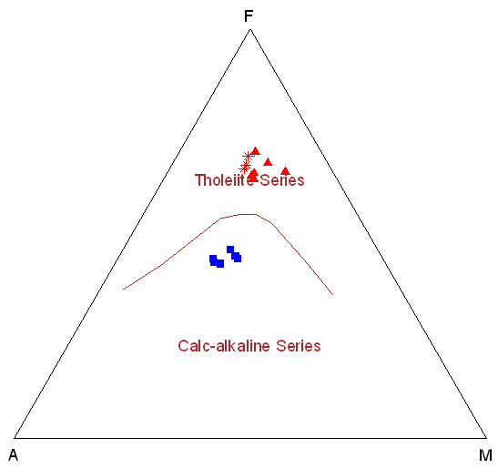
FIGURE 1: Walungu lavas in the AFM diagram of Irvine & Baragar (1971): squares represent alkaline basalts of Tshisheke; other symbols represent subalkaline basalts of Butuza (asterisks) and Kaniola (triangles)

Session 2 Geochemistry, volcanic plume, rock and water/Géochimie, panache volcanique, roche et eau
Poster

L’enregistrement continu du CO2 et du radon dans un Mazuku

M. Kasereka Musosekania(1), B. Smets(2)&(2'), A. Kies(3), M. Yalire(4), C. Muhigirwa(5).

(1) Département de Géochimie et Environnement,Observatoire Volcanologique de Goma/RDCongo
(2) European Center for Geodynamics & Seismology, Luxembourg
(2') Dept. of Geography, VrijeUniversiteitBrussel, Brussels, Belgium
(3) Université du Luxembourg
(4) Département de Géochimie et Environnement,Observatoire Volcanologique de Goma/RDCongo
(5) Département de Géochimie et Environnement,Observatoire Volcanologique de Goma/RDCongo

ABSTRACT/RÉSUMÉ
La Province Volcanique desVirunga regorge de plusieurs zones d’émanation de gaz carbonique (CO2), connues localement sous le nom de « mazuku ».Le CO2, accompagné par de très faibles concentrations en radon (Rn), monoxyde de carbone et autres gaz, s’accumule par gravité dans ces dépressions, qui forment des zones où l’air est toxique, voire même létal. Aux vues du nombre de victimes qu’ils occasionnent, ces mazuku, ou « vents diaboliques qui se répandent et tuent durant la nuit » en Kinyabwisha et Kinyarwanda, représentent un des nombreux risques majeurs dans la ville de Goma et ses environs. Connus depuis longtemps, les mazuku ont récemment fait l’objet d’études dans le but d’identifier l’origine du gaz (Vaselli et al.2003),de définir la menace qu’ils représentent (Smets et al.2010) et de proposer des pistes pour une gestion plus efficace des risques qui y sont associés (Smets 2007, Gorisk 2010).
Depuis 2009, un instrument installé à l’Hôtel le Chalet mesure en continu le CO2 et le Rn dans un mazuku très actif situé le long du lac Kivu. Une station météo y est associée afin de suivre l’évolution des concentrations en CO2 et Rn en fonction des conditions météorologiques.
Les premières interprétations des données récoltées montrent une forte influence de certains paramètres météorologiques. Les concentrations en CO2 et en radon ont une relation proportionnelle directe entre elles, étant donné que le CO2 est le vecteur transportant le radon jusqu’à la surface du sol. Cependant, à l’approche d’éruptions du volcan Nyamulagira, un décrochage progressif entre les concentrations de ces deux gaz a été observé, et ce plusieurs semaines avant le début des éruptions. Ces résultats préliminaires mettent en évidence l’utilité que l’étude du gaz dans les mazuku peut avoir pour la surveillance des volcans actifs des Virunga.

RÉFÉRENCES
Gorisk 2010,Thecombined use of Ground-Based and Remote Sensing technique as a tool for volcanic risk and health impact assessment for the Goma region (North-Kivu, Democratic Republic of Congo). Final report.
Smets B. 2007, Etudes des Mazukus dans la région de Goma (République Démocratique du Congo) et Gestion des Risques. MSc Thèse, Université de Liège. 89p.
Smets et al, 2010. Dry gas vents (« Mazuku ») in Goma region (North-Kivu, Democratic Republic of Congo), Formation and risk assessment. Journal of African Earth Science 58, 787-789.
Vaselli et al, 2003. The “Evil’s winds”(Mazukus) at Nyiragongo volcano (Democratic Republic of Congo).ActaVulcanologica 14-15. 123-128.

Session 2 Geochemistry, volcanic plume, rock and water/Géochimie, panache volcanique, roche et eau
Poster

Caractérisation pétrographique des indices de fer dans le complexe anorogénique tertiaire de Bana (ligne vocanique du Cameroun)

Y. Lemdjou(1).

(1) Council for Geoscience, CGS (South Africa)

ABSTRACT/RÉSUMÉ
Le complexe anorogénique tertiaire de Bana est situé entre 5°8’ et 5°11’ de latitude Nord et entre 10°19’ et 10°22’ de longitude Est dans l’Ouest-Cameroun. Il couvre une superficie de 59 km2. Ce complexe est formé de roches plutoniques et volcaniques en intrusion dans des gneiss et orthogneiss panafricains. A l’Ouest du complexe, affleurent deux corps riches en fer et titane dans un contexte volcanique. Le présent travail est une contribution à la caractérisation pétrographique, géochimique et hydrologique des deux corps.
Du point de vue pétrographique, les roches riches en Fe-Ti sont essentiellement constitués de la magnétite et de la titanomagnétite, et accessoirement des feldspaths alcalins, du quartz et des silicates d’alumine. Certains minéraux de magnétite sont centimétriques, globuleux, orientés et soulignent une fluidalité magmatique.
Du point de vue géochimique, les teneurs en fer oscillent entre 24 et 40 % tandis que celles en titane varient entre 2 et 6 %. Ce sont des concentrations largement supérieures au clarke, présentant ce massif comme un probable gisement de Fe-Ti.
Du point de vue hydrologique, Les données hydrophysiques et hydrochimiques combinées aux données géochimiques ont permis de montrer que les deux affleurements (nord et sud) sont identiques. Les pH des eaux échantillonnées sur ces massifs riches en Fe-Ti et sur les basaltes qui se situent entre les deux formations oscillent entre 8 et 9. Ces résultats montrent que les deux corps représentent deux branches d’une seule intrusion masquée dans sa partie centrale par des basaltes à phénocristaux de plagioclase.
Sur le plan métallogénique, les deux corps possèdent des indices appréciables en fer permettant qu’ils soient classés comme gisements faiblement minéralisés à cause de leurs faibles teneurs en fer.

MOTS CLÉS
Ouest-Cameroun ; Bana ; complexe anorogénique tertiaire ; indices de Fe-Ti, basaltes ; Ph ; hydrologie.

Session 2 Geochemistry, volcanic plume, rock and water/Géochimie, panache volcanique, roche et eau
Poster

Pétrographie et Géochimie des gneiss kibariens de Miowe-Bulambika à Bunyakiri, Sud-kivu, RDCongo

T. Mugaruka Bibentyo(1), R. Cirhuza Cirimwami(2), C. Nzolang(3), E. Mugisho Birhenjira(4), J. Basimike Tchangaboba(5).

(1) Université Officielle de Bukavu
(2) Université Officielle de Bukavu
(3) Université Officielle de Bukavu
(4) Université Officielle de Bukavu
(5) Université Officielle de Bukavu

ABSTRACT/RÉSUMÉ
Les formations magmatiques de Miowe-Bulambika font partie de l’ensemble gneissique de Bunyakiri appartenant au groupe de Bitale correspondant au Kibarien inferieur. Elles sont composées des gneiss œillés et des gneiss granitiques et présentent une alternance répétée des lits minéraux clairs et sombres caractéristique d’une foliation. Cette foliation porte une linéation minérale horizontale à faiblement plongeant. Les poches et les filons de pegmatite ainsi que quelques filonets de quartz sont présents dans ces gneiss. L’étude géochimique sur base des éléments majeurs a relevé que ces gneiss proviennent d’une évolution métamorphique des roches magmatiques intermédiaires et acides de la série calco-alcaline fortement potassique ; ce sont donc des roches formées dans un contexte géodynamique de subduction. Ces protolites sont à la fois d’origine crustale et mantélique car la croute subductée se serait fondu dans le manteau, ceci explique le caractère à la fois métalumineux et peralumineux de ces roches.

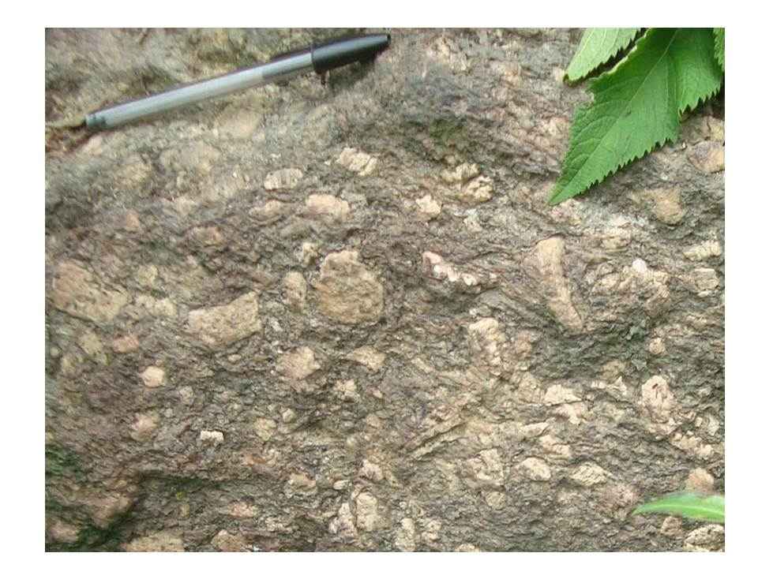
FIGURE 1 : Gneiss

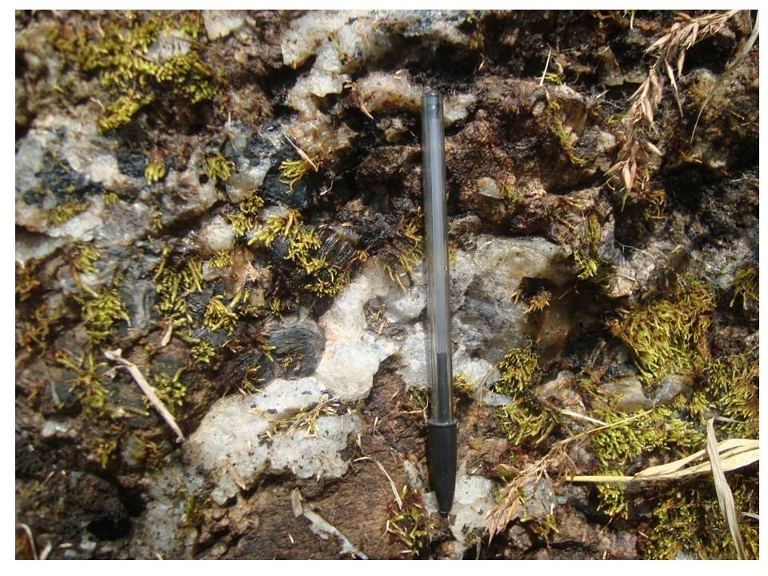
FIGURE 2 : Pegmatites

Session 2 Geochemistry, volcanic plume, rock and water/Géochimie, panache volcanique, roche et eau
Poster

Nouvelle approche sur la mise en place des coulées basaltiques cenozoiques du secteur Nord-Ouest de la Ville de Bukavu/RD Congo

E. Mugisho Birhenjira(1), T.M. Bibentyo(2), A. Gubanja.

(1) Université Officielle de Bukavu
(2) Université Officielle de Bukavu

ABSTRACT/RÉSUMÉ
Situé dans le système du Rift Est Africain (EARST), la ville de Bukavu et ses environs présentent des affleurements des formations volcaniques d’âge miocène à actuel (Kampunzu et Al. 1986).
L’étude cartographique montre bien que les affleurements basaltiques ne sont pas plus distribués dans notre région et que la grande partie de ses formations présente un important recouvrement conduisant ainsi à une altération avancée.
Les affleurements sont soit massif soit en orgues.

Plusieurs phase des coulées on été remarquée : coulée supérieure plus saine reposant sur un paléosol d’environ 3 m d’épaisseur et la coulée inférieur étant la plus altérée expliquant ainsi l’activité volcanique non continue.

Les basaltes présentent des phénocristaux relevant d’un caractère basique (Olivine + Pyroxène (clino pyroxène) + Plagioclase) et un mesostase faite des Oxydes opaques. La majorité des nos échantillons montre que lors de la différentiation magmatique le processus s’est arrêtée au pole basique (teneur en SiO2 comprise entre 45 et 54 %)

Les analyses géochimiques ont conduit à classer la grande partie des nos basaltes dans la série tholeitique et certaines dans la série calco-alcaline.
Le caractère serial permet aussi de confirmer que nous sommes dans la série transitionnelle située dans la zone d’extension caractérisée par le magmatisme anorogénique.

Session 2 Geochemistry, volcanic plume, rock and water/Géochimie, panache volcanique, roche et eau
Poster

Contribution to the description of nitrogen cycle in the surface waters of Lake Kivu

F. Roland(1).

(1) Université de Liège

ABSTRACT/RÉSUMÉ
Lake Kivu, located at the border between Rwanda and the Democratic Republic of Congo, is one of the great lakes of the East African Rift. With a volcanic origin, Lake Kivu is an oligotrophic lake characterized by anoxic deep waters rich in dissolved gases (methane and carbon dioxide) and nutrients, and by well oxygenated and nutrient-depleted surface waters. If the carbon cycle in the lake has been the subject of numerous studies, the nitrogen cycle remains largely unknown. In particular, pelagic sources and losses of reactive nitrogen have not yet been quantified. Thus, our work was aimed in particular to identify and quantify the processes of nitrogen losses by denitrification and/or anammox, and to quantify the biological fixation of atmospheric nitrogen. During a sampling campaign conducted in February 2012, isotopic labeling experiments were used to quantify denitrification and anammox rates along vertical profiles at two pelagic stations of the main lake and into the bay of Kabuno. No anammox process were observed. The heterotrophic denitrification took place under the oxic-anoxic interface in the bottom of the nitracline at depths between 50 and 70 m. The average denitrification rate was estimated at 115 µmoles N m-2 d-1. Denitrification was not the only nitrate-consuming process and dissimilative nitrate reduction to ammonium might be an important process in the nitracline of Lake Kivu. Meanwhile, the rate of biological fixation of atmospheric nitrogen, estimated at one pelagic station, was estimated to 832 µmoles N m-2 d-1. Isotopic labeling accompanied by addition of sulfides in the main lake and iron in the bay of Kabuno allowed, for the first time in a tropical great lake, to highlight important linkages between nitrogen and sulfur cycles, and, by an unique way, between nitrogen and iron cycles. On the other side, the anaerobic methane oxidation by nitrate was not observed and results rather suggest the presence of methane oxidation by sulfate. Finally, inhibition of the activity of sulfate-reducing bacteria has allowed to observe potential anaerobic nitrification in the main lake.

Session 2 Geochemistry, volcanic plume, rock and water/Géochimie, panache volcanique, roche et eau
Poster

Géochimie des roches métébasiques Kibariennes (Bunyakiri et Mitwaba/RDC , Mageyo/Burundi et Rwanda) et implications géodynamiques

M. Shubazi Kabemba(1)&(1').

(1) Commission Nationale de l'Energie (CNE/Sud-Kivu)
(1') Université Officielle de Bukavu

ABSTRACT/RÉSUMÉ
Nous abordons la signification géotectonique des roches orthométabasiques d’âge protérozoïque moyen du rift Est africain par le biais de la géochimie.En règle générale, l’identification précise des caractères magmatiques d’une série volcanique permet d’envisager ses liens possibles avec un contexte géodynamique. A cet égard, la mise en évidence des séries volcaniques à caractère calco-alcalin permet de conclure à un contexte orogénique, tandis que des séries volcaniques à caractères de MORB suggère un environnement océanique de type « rift » (Cabanis, 1986).
Cependant, quelques séries volcaniques possédant des caractères magmatiques identiques peuvent appartenir à des contextes géodynamiques différents et dans certains cas l’ambiguïté ne pourra être levée sur la seule considération des caractères chimiques. Ainsi par exemple, les séries tholéiitiques, transitionnelles et alcalines des rifts continentaux présentent des caractères chimiques très voisins des MORB de type « E » ou « P » et des MORB transitionnels. On connait des MORB de type « N » dans le rift de la mer Rouge, analogues à ceux des rides océaniques ; il sera donc dangereux de vouloir conclure à une océanisation importante sur la seule présence des MORB du type « N » dans une série paléovolcanique. Les tholéiites intraplaques présentent des caractères chimiques extrêmement variables d’une série à l’autre et certains sont même difficiles à distinguer des tholéiites d’îles océaniques ou même de certains MORB transitionnels.
La distinction entre les séries volcaniques orogéniques et non orogéniques n’est pas toujours facile.
L’étude pétrographique a montré l’existence des roches basiques dans le Kibarien. Ces roches basiques ont évolué sous un régime métamorphique essentiellement de type Barrow depuis le greenschist faciès jusqu’à l’amphibolite faciès.
Les études chimiques des éléments majeurs ont révélé :
- La nature essentiellement tholéiitique des dites roches, attestée entre autres par la distribution des analyses dans le digramme normatif de Muir et Tilley et FMA
- Leur caractère distensif suggéré par le diagramme de Bébien et divers diagrammes de Miyashiro
L’étude des éléments en traces a montré globalement, que les éléments hygromagmaphiles et de transition n’ont pas été affectés sensiblement par le processus d’altérations. Cette étude confirme clairement la nature tholéiitique de roches métabasiques kibariennes lorsqu’on se réfère particulièrement au diagramme Nb/Y vs Zr/P2O5 de Floyd et Winchester (1975) : ces éléments ayant été reconnus inertes face aux processus d’altération et de métamorphisme.
Les spectres de REE normalisées aux chondrites ressemblent à ceux des basaltes tholéiitiques intraplaques tels ceux du rift africain (jusqu’à Afar/ Golfe de Tadjoura) ou même des îles océaniques ; exception faite des roches du Burundi présentant des analogies avec ceux de MORB (enrichis).
Le caractère distensif de ce magmatisme est souligné par la distribution des éléments dans les diagrammes Ba/La vs La/Yb et Sm/Ce vs Sr/Ce. Les spectres multi-éléments normalisés aux MORB rappellent ceux des basaltes intraplaques et des MORB enrichis dans le cas du Burundi. Le magmatisme basique kibarien se serait mis en place dans le contexte de type Mer Rouge – Golfe de Tadjoura.

Session 2 Geochemistry, volcanic plume, rock and water/Géochimie, panache volcanique, roche et eau
Poster

The “mazuku hazard” in the Goma region, D.R. Congo

B. Smets(1)&(1'), M. Kasereka(2), A. Kies(3), D. Tedesco(4)&(4'), M. Yalire(5).

(1) European Center for Geodynamics & Seismology, Luxembourg
(1') Vrije Universiteit Brussel, Belgium / Royal Museum for Central Africa, Belgium
(2) Goma Volcano Observatory, D.R. Congo
(3) University of Luxembourg, Luxembourg
(4) University of Naples II, Italy
(4') UNOPS
(5) Goma Volcano Observatory, D.R. Congo

ABSTRACT/RÉSUMÉ
The word “mazuku” comes from Kinyabwisha, a Rwandese dialect, and indicates an area where animals and sometimes humans mysteriously die during the night (Verschuren, 1965). The mazuku actually correspond to areas from which carbon dioxide of mostly magmatic origin escapes and concentrates. As this gas is heavier than air, it can accumulate by gravity and reach lethal concentrations. This phenomenon is frequently observed in the region of Goma (North Kivu, D.R. Congo) and Gisenyi (Rwanda).

In the present work, we describe the typical characteristics of mazuku and their hazard. Although carbon dioxide is colorless, odorless and tasteless, some field indications usually allow the detection of mazuku and the areas of highest gas concentration. The effects of meteorological parameters (e.g. temperature, wind, rainfall, atmospheric pressure, etc.) on gas concentration are highlighted by the comparison of data from weather and gas stations installed in a mazuku in Goma. Based on this, together with additional field data, the hazard and the impact of mazuku on local population are assessed. Contrary to what is said in its original definition, mazuku can kill at any time of the day. According to some local testimonies, they kill tens of persons per year. If the local population is initially aware about this hazard, the socio-political unrests that recurrently affect this zone for more than two decades triggered large movements of new and non-informed population. Indeed, during each armed conflicts, a large amount of persons, mostly coming from rural areas, find refuge in and around the city of Goma. As a consequence, the demography of this city grows rapidly and both urbanization and refugees camps take – or already took – place in areas affected by mazuku. The related lethal risk for the population grows accordingly. We conclude that mazuku should be considered as one of the most lethal natural hazards in the studied area.

REFERENCE
Verschuren J (1965) – Un facteur de mortalité mal connu, l'asphyxie par gaz toxiques naturels au Parc National Albert, Congo. La Terre et la Vie 3, 215–237

SESSION 3

Geomorphology, structural aspects

Géomorphologie, aspects structuraux

Session 3 Geomorphology, structural aspects/Géomorphologie, aspects structuraux
Talk / Oral

Neotectonic setting of the Kivu rift segment within its intraplate Central African context

D. Delvaux(1), B. Smets(2)&(2').

(1) Royal Museum for Central Africa, Dept. Earth Sciences, B-3080, Tervuren, Belgium
(2) European Center for Geodynamics & Seismology, Luxembourg
(2') Vrije Universiteit Brussel, Belgium / Royal Museum for Central Africa, Belgium

ABSTRACT/RÉSUMÉ
The Kivu rift region forms a particular rift segment in the western branch of the East African rift system, between the northern termination of the Tanganyika rift and the southern extension of the Edward-George rift. It is however not isolated in the center of the African plate, but part of the intraplate deformation and influenced by its intraplate setting. A compilation of existing data on earthquake epicenters, focal depth, focal mechanisms, thermal springs and neotectonic faults has been performed. SRTM topographic data at 90 and 30 m resolution, river network extracted from the SRTM 90 m and bathymetric data have been used to better constrain the geographic locations, and also as a new topographic reference for analyzing the morpho-structural elements.

At the scale of the African plate, the western shoulder of the Kivu rift marks the transition between the Congo Basin, characterized by E-W horizontal compression, and the Kivu rift basin, characterized by E-W horizontal extension. This is expressed by a progressive rotation of the stress directions, together with a progressive change in stress regime. The basement structural fabric plays an important role in controlling the development of neotectonic structures. The depth-distribution of earthquakes suggests asymmetric crustal structures, with deeper events (25-40 km, with a few up to 65 km) on the western rift shoulder and shallower events (5-30 km, peaking at 10-25 km) below the rift valley and the eastern shoulder, where seismicity is also slightly more abundant. The general rift structure is marked by the interaction of two grabens systems that join in the Rusizi accommodation zone. A first system, formed by the NNE-SSW alignment of the Edward-George basin, the Virunga volcanoes and the Kivu basin, seems to continue south-westward into a tectonic depression that forms the upper part of the Elila river catchment. This rift valley alignment is bordered on its western side by the Lubero, Mitumba-North and Kahuzi-Biega chain of rift shoulder mountains. The Elila basin and south Kivu basins are flanked on their eastern side by the South-Mitumba Mountains in DRC and the Nyungwe massif in SE Rwanda. This eastern flank is dissected by the Rusizi basin which forms the northern termination of the N-trending Tanganyika rift basin. This complex architecture is controlled by basement structures and influence also the tectonic stress field. The distribution of seismicity and thermal springs shows that tectonic deformation is not limited to the central part of the rift valley but also affect its flanks. It is particularly well expressed for the western flank, which is affected up to 200 km away, i.e. up to the margin of the Congo basin. The eastern flank is also affected by neotectonic activity, in Burundi, Rwanda and NW Uganda. This area was strongly uplifted and tilted in response of rifting activity, as shown by the presence of river flow reversals and captures, inundation lakes, swamps and recent lacustrine deposits, as well as by seism epicenters and rare thermal springs.

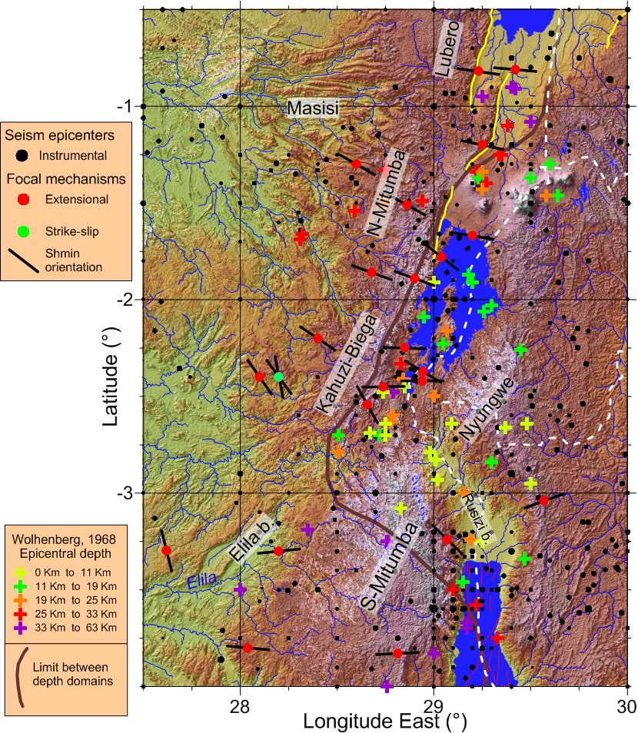
FIGURE 1: Neotectonic setting of the Kifu rift segment and its interaction with the North Tanganyika rift basin.

Session 3 Geomorphology, structural aspects/Géomorphologie, aspects structuraux
Talk / Oral

Are magmatism and volcanism responsible for the structures and morphology of the Kivu Rift Basin?

B. Smets(1)&(1'), N. d'Oreye(2)&(2'), F. Kervyn(3), M. Kervyn(4), K. Ross(5).

(1) European Center for Geodynamics & Seismology, Luxembourg
(1') Vrije Universiteit Brussel, Belgium / Royal Museum for Central Africa, Belgium
(2) European Center for Geodynamics & Seismology, Luxembourg
(2') National Museum of Natural History, Luxembourg
(3) Royal Museum for Central Africa, Belgium
(4) Vrije Universiteit Brussel, Belgium
(5) Eawag: Swiss Federal Institute of Aquatic Science and Technology, Switzerland

ABSTRACT/RÉSUMÉ
The western branch of the East African Rift System (WBEARS) is commonly defined as a succession of (half-)graben basins separated by transfer zones (e.g. Pouclet 1976; Ebinger 1989a,b; Morley 1989; Lœrdal and Talbot 2002; Corti 2007). Volcanic activity in the WBEARS developed in four of these transfer zones (Ebinger, 1989). These rift basins are filled with Tertiary to Quaternary sediments, as well as by water, forming elongated rift lakes. However, Lake Kivu displays a peculiar shape with jagged shorelines linked to the flooded river valleys, and the presence of the 40×12 km wide Idjwi Island in the middle of the basin. Based on its shape, the origin of Lake Kivu has been inferred to be the result of a natural damming of major rivers by the lavas from the Virunga volcanoes. The present geomorphological analysis of the Lake Kivu basin suggests that water and sediments hide a more complex history. Using two different acquisitions of bathymetric data, an updated structural map of the Lake Kivu Basin is proposed. Both South-Kivu and Virunga volcanic provinces extend into the Lake Kivu basin. The high-resolution bathymetry in the northern part of the lake highlights the presence of phreatomagmatic edifices at a depth of ~300 m. Based on our observations in line with an extended bibliographic review, we suggest a new scenario for the Lake Kivu’s basin development, where rift tectonics, magmatism and volcanism play key roles. These results offer new insights into the geodynamic framework of the Kivu rift zone with implications for follow-up studies and the assessment of geo-hazards of this densely populated area.

Session 3 Geomorphology, structural aspects/Géomorphologie, aspects structuraux
Talk / Oral

Contrôle structural de la géomorphologie du secteur de Katana (Sud-Kivu, RD Congo)

G. Ganza Bamulezi(1), E. Mugisho Birenjira(2).

(1) Université Officielle de Bukavu
(2) Université Officielle de Bukavu

ABSTRACT/RÉSUMÉ
Contrôle structural de la géomorphologie du secteur de Katana
(Sud-Kivu, R.D. Congo)
Espoir Mugisho B., Gloire Ganza B.
Faculté des Sciences et Sciences appliquées de l’Université Officielle de Bukavu

Situé approximativement à 48 km vers le Nord-Est de la ville de Bukavu (RDC) et dans le Système du Rift-Est Africain (EARST), le secteur de Katana s’étend entre 2°10’ et 3° de latitude Sud, et entre 28°29’ et 29° de longitude Est (IDIANSO, 1990). Son relief se présente en marches d’escaliers comprenant cinq paliers se relevant progressivement de l’Est vers l’Ouest et correspondant aux anciens fonds du Graben.
- Le premier palier : 1470 m d’altitude, correspond à la plaine de Mwanda ;
- Le deuxième palier : 1580 m d’altitude, correspondant au centre commerciale de Katana ;
- Le troisième palier : 1800 m d’altitude, correspond au CRSN/Lwiro ;
- Le quatrième palier : 2400 m d’altitude, correspond au gîte de CRSN à Tshibati ;
- Le cinquième palier : 3308 m d’altitude, correspond au somment du Mont Kahuzi.

Les quartzites affleurant au deuxième palier présente des plans de glissement ayant une orientation statistique moyenne de : N 07°/40°ESE, et les stries qui y sont associées : N92°/40° ESE. Il s’agit des failles normales senestres avec simga1: N71°/85°ENE, sigma2 :N04°/02°SSW et sigma3N94°/05°ESE. En intégrant ces résultats de cette analyse structurale dans le contexte tectonique de la branche occidentale du Rift-Est Africain, il ressort que les plans de glissements observés au deuxième palier constitueraient les marqueurs tectoniques à l’origine de ces paliers. Les raisons suivantes corroborent cette hypothèse.
1. Le tenseur des contraintes à l’origine des plans de glissement observés au deuxième palier reflète un régime distensif sigma1 étant horizontale et sigma2 et sigma3 horizontales;
2. Les failles sont normales senestres, ce qui conforte l’hypothèse selon laquelle les plis kilométriques allongés N-S qui dominent la région ont été décalés par un mouvement senestre ;
3. L’orientation statistique moyenne des pôles des plans de glissement (N07°/0°ESE) coïncide avec la direction albertienne, avec le regard des failles tourné vers l’Est (situation qui se présenterait en miniature dans la région de Bukavu).

Ainsi, cet épisode tectonique dont les marqueurs structuraux sont les plans de glissement et les stries y associées serait à l’origine des paliers qu’on observe dans cette région de Katana et ses environs immédiats. Toutefois, en vue de bien étayer cette hypothèse, les observations systématiques de ces plans de glissement sur tous les paliers et dans d’autres formations géologiques affleurant (basaltes, schistes et schistes gréseux) s’avèrent donc nécessaire.

Session 3 Geomorphology, structural aspects/Géomorphologie, aspects structuraux
Talk / Oral

Contribution to the understanding of the mechanisms controlling slope instabilities near Bujumbura-Burundi

S. Draidia(1), H.B. Havenith(2), T. Almaz(3), L. Nibijira(4), O. Dewitte(5), P. Tréfois(6), A. Nkunzimana(7).

(1) Department of Geology, Service of Geohazard and Environment, University of Liège, Belgium
(2) Department of Geology, Service of Geohazard and Environment, University of Liège, Belgium
(3) Department of Geology, Service of Geohazard and Environment, University of Liège, Belgium
(4) Department of Geology, Service of Geohazard and Environment, University of Liège, Belgium
(5) Royal Museum for Central Africa, Department of Earth Sciences, Tervuren, Belgium
(6) Royal Museum for Central Africa, Department of Earth Sciences, Tervuren, Belgium
(7) Department of Geography , University of Burundi, Bujumbura, Burundi

ABSTRACT/RÉSUMÉ
Landslides in Central Africa represent a real and ongoing threat to the population and economic development. The case of Burundi and especially the Bujumbura area is a good example. The recorded incidents are increasing due to the development of often unplanned urbanization, but also due to the topographic context of the region, the abundance of streams, and the geological nature of the sites. To this the climatic factor needs to be added, which is the main driver of erosion and weathering processes degrading the strength of rocks and soils. The contribution of remote sensing based on the analysis of satellite images and aerial photographs allowed us to identify hundreds of instabilities. The study of these mass movements and the characterization of the processes governing their release and their evolution in time and space help understand their mechanism. Thanks to case studies, based on mineralogical analyses, geotechnical and geophysical tests coupled with the use of geographic information system, we tried to understand the parameters governing the evolution of these instabilities and thus bringing shows the relationships between them.

Session 3 Geomorphology, structural aspects/Géomorphologie, aspects structuraux
Talk / Oral

Glissements de terrain et cause de leur déclenchement : Cas de la cité d’Uvira et sa partie méridionale (Sud Kivu, République Démocratique du Congo)

S. Butara Mubane(1).

ABSTRACT/RÉSUMÉ
Uvira has always been subject to natural processes of erosion, transport of large masses of materials and deposit-sedimentation. The natural causes of these phenomena are the important relief and tropical rains, the weathering of rocks related to the tropical climate and the presence of active faults and earthquakes connected to the rift activity. This natural situation is exacerbated by human pressure thus leading to environmental degradation and destruction of infrastructure.

The present work focuses on the landslides of Uvira and its southern part while highlighting the mechanisms of their activation. On the basics of a stereoscopic interpretation of aerial photographs of 1959 supplemented by observations of Google Earth images and an IKONOS scene acquired on 26 December 2004, an inventory of 69 landslides has been completed.
A statistical analysis of various parameters (slope, slope orientation, curvature profile, horizontal curve, flow accumulation and distance to drainage) was made using GIS (Geographic Information System) to describe their influence in triggering landslides. We found that the slope, slope orientation and distance to drainage networks exert the strongest effect in slope instability. The weighting of these six parameters allowed us to map the landslide hazard.
By applying Montgomery-Dietrich’s method, it appears that 39 of the 49 slides (with drainage area) are related to the hydrostatic pressure causing a vertical incision, which leads to the destabilization of the slopes the other 10 and the 20 which have no drainage area being probability more connected with tectonics with tectonics.
Finally, a landslide risk map was established by crossing the hazard map and the vulnerability map. The latter has been produced from the superposition of the area built before 1959, the one built after 1959 and the road network.

KEYWORDS
Landslide risk, susceptibility, vulnerability, GIS, Uvira and its southern part, Tanganyika, East Rift African.

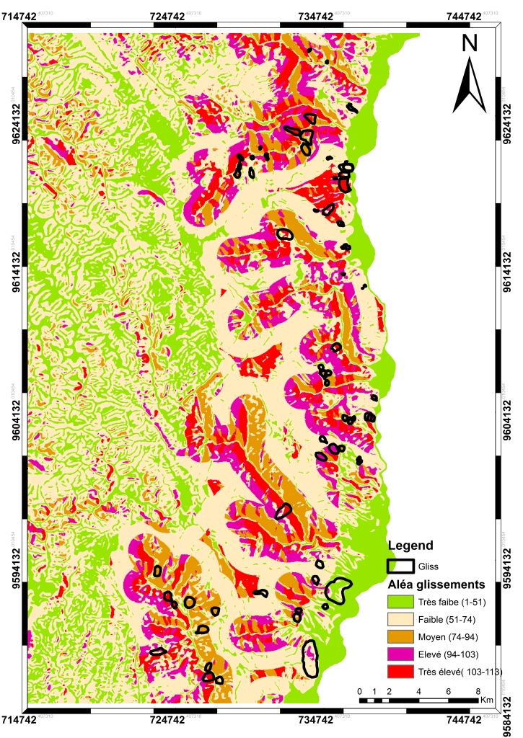
FIGURE 1: Carte de l’aléa glissement de terrain d’Uvira et sa partie méridionale

Session 3 Geomorphology, structural aspects/Géomorphologie, aspects structuraux
Talk / Oral

Évaluation et cartographie par SIG du risque lié aux glissements de terrain à Bukavu (Sud Kivu, RD CONGO)

P. Migombano Useni(1).

(1) Université Officielle de Bukavu

ABSTRACT/RÉSUMÉ
La ville de Bukavu, de part son contexte géologique, morphotectonique, et climatique est fréquemment sujette à des glissements de terrain. Cette situation naturelle est en outre amplifiée par la pression humaine conduisant ainsi à la dégradation de l’environnement et à la destruction des infrastructures.
Afin d'atténuer le risque lié aux glissements, de nouvelles méthodologies sont nécessaires pour une meilleure compréhension de l’aléa glissement de terrain et pour permettre une prise de décision rationnelle. Cette étude utilise l’outil SIG pour cartographier de manière indirecte la susceptibilité au glissement en combinant une carte d'inventaire de glissements de terrain avec 9 cartes composites (2 issues de la géologique régionale et 7 autres dérivées du MNT). La superposition des cartes indexe permet de générer la carte de l’aléa où 3 niveaux de susceptibilité au glissement ont été définis. Le niveau le plus élevé représente environ 12 % de la zone d'étude.
Une carte de vulnérabilité a été également produite sur base d’éléments exposés caractérisés dans les différentes communes de la ville. En combinant la carte de l’aléa à celle de la vulnérabilité, la carte du risque total a été définie sur 5 niveaux de risque. Le risque a été considéré comme intolérable pour le niveau très élevé et comme tolérable pour les niveaux élevé et moyen. Quelques options de mesure de mitigation du risque sont suggérées pour ces deux niveaux.

MOTS-CLÉS
Risque de glissement de terrain, susceptibilité, vulnérabilité, SIG, Bukavu.

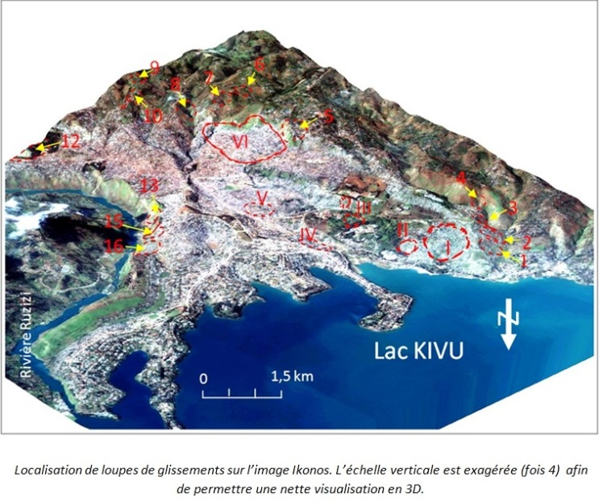
FIGURE 1: Escarpements (1-16) en dehors du microrift Escarpements (I-VI) dans le microrift

Session 3 Geomorphology, structural aspects/Géomorphologie, aspects structuraux
Poster

Les risques que court la ville de Goma et la lithologie de la carriere MUGARA

B. Byamungu (1)&(1').

(1) Université de Goma
(1') SAVE THE LIFE asbl

ABSTRACT/RÉSUMÉ
Dans cette carrière MUGARA située dans le rift Est africain et constituée de Scorie de couleurs variées(du Noire- rougeâtre et de brun-jaunâtre). De pendage orienté vers le Sud suivant sa disposition, et qui ne sont pas consolidés. Cependant ces produits se sont mis en place sans aucun apport de l’eau, càd, l’eau est un agent qui intervient à la cohérence des clastes et son tassement dans un milieu quelconque. Sa lithologie est concentrée en Silice, cela fait que, ce soit des produits de projection et riche aussi en température.
Une portion du côté Sud-Est, constituée d’une couche épaisse ou une couverture de coulé volcanique récente, qui prolifère, comme une ressemblance de la zone de métamorphisme de contact, à l’origine rendant le débris volcanique (Scorie) plus ou moins dure et cuisson à partir de chaleur intense débarqué par coulé de lave.

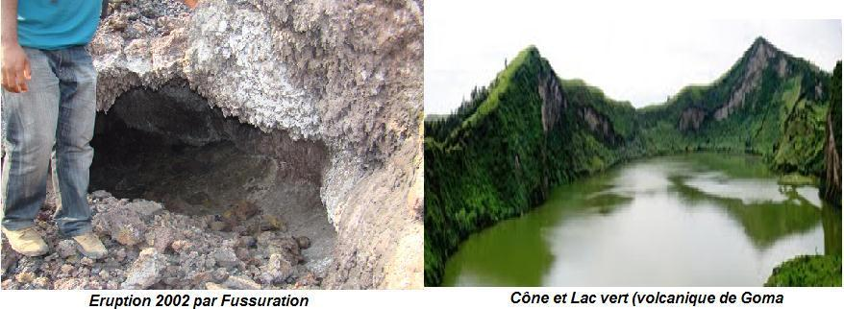
FIGURE 1: Les risques geologiques

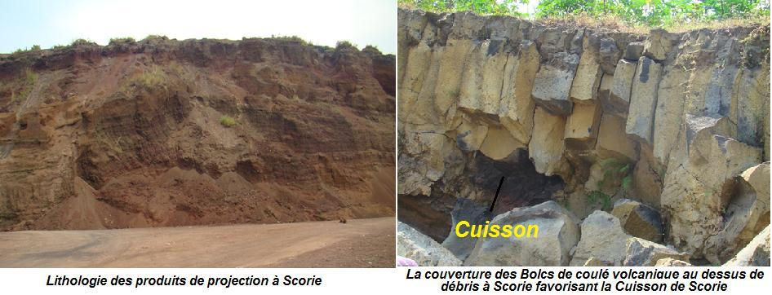
FIGURE 2: Géomorphologie du rift

Session 3 Geomorphology, structural aspects/Géomorphologie, aspects structuraux
Poster

Landslide hazard in the North Tanganyika - Kivu rift zones: current knowledge and research perspectives

O. Dewitte(1), F. Albino(2), J. Basimike(3), D. Delvaux(4), S. Draidia(5), H.B. Havenith(6), F. Kervyn(7), D. Kubwimana(8), C. Michellier(9), E. Mugisho(10), L. Nahimana(11), A. Ndayisenga(12), C. Ngenzebuhoro(13), A. Nkunzimana(14), P. Nkurunziza(15), C. Nzolang(16), J.M. Sabushimike(17), P. Tréfois(18).

(1) Royal Museum for Central Africa, Department of Earth Sciences, Tervuren Belgium
(2) Royal Museum for Central Africa, Department of Earth Sciences, Tervuren Belgium
(3) University of Bukavu, Department of Geology, Bukavu, DR Congo
(4) Royal Museum for Central Africa, Department of Earth Sciences, Tervuren Belgium
(5) University of Liège, Department of Geology, Liège, Belgium
(6) University of Liège, Department of Geology, Liège, Belgium
(7) Royal Museum for Central Africa, Department of Earth Sciences, Tervuren Belgium
(8) University of Burundi, Department of Geology, Bujumbura, Burundi
(9) Royal Museum for Central Africa, Department of Earth Sciences, Tervuren Belgium
(10) University of Bukavu, Department of Geology, Bukavu, DR Congo
(11) University of Burundi, Department of Geology, Bujumbura, Burundi
(12) University of Burundi, Department of Geography, Bujumbura, Burundi
(13) University of Burundi, Department of Geology, Bujumbura, Burundi
(14) University of Burundi, Department of Geography, Bujumbura, Burundi
(15) University of Burundi, Department of Geology, Bujumbura, Burundi
(16) University of Bukavu, Department of Geology, Bukavu, DR Congo
(17) University of Burundi, Department of Geography, Bujumbura, Burundi
(18) Royal Museum for Central Africa, Department of Earth Sciences, Tervuren Belgium

ABSTRACT/RÉSUMÉ
The North Tanganyika – Kivu Rift zones are areas naturally prone to landsliding where triggering and environmental factors that favour the occurrence of mass movement concentrate. In many places landslide hazard is very high, and anthropogenic factors such as land use change and urban expansion increase the sensibility to slope instability. From seismic- to rainfall-induced mass movements we review the current knowledge of the various slope processes and associated hazards that are present in these equatorial environments. A particular attention is given to urban areas such as Bukavu and Bujumbura where landslide threat is particularly acute. Research perspectives on landslide inventorying, monitoring, and susceptibility and hazard assessment are presented.

Session 3 Geomorphology, structural aspects/Géomorphologie, aspects structuraux
Poster

Paleomagnetic and Petrographic comparison of differently named basalts from the Omo-Turkana Depression, southwestern Ethiopia: implication for timing of volcanism

A.E. Doelesso(1).

ABSTRACT/RÉSUMÉ
This Paleomagnetic and petrographic study was carried out on thin widely spread lava flows of Gombe Group basalts from the lower Omo Valley in southwestern Ethiopia. The objective of the study is to integrate paleomagnetic and petrographic results with previous geochronological data to know timing of volcanism. 80 oriented core samples were taken from nine sites in two field trips. Rock magnetic, petrology and paleomagnetic studies were done in the laboratory of Earth Sciences at Addis Ababa University. Pilot specimens were subjected to alternating field (AF) and thermal (TH) demagnetization and acquisition experiments. The Natural Remnant Magnetization (NRM) direction comprises two vector components in most samples. The first component of magnetization was easily erased at 5 to 25mT AF demagnetization and 120°C to 250°C TH demagnetization. A step wise increasing application of magnetic field to selected specimens revealed a saturation magnetization at about 300°C.Integrated results from acquisition experiment together with TH demagnetization and AF demagnetization indicates that titanomagnetite is the dominant magnetic carrier. About 50% of magnetization is removed between Temperature ranges of 250°C - 430°C suggesting pseudo single domains as a primary carrier of magnetic remanence. From a total of nine sites, six sites show reversed polarity and two sites show normal polarity. One site has been removed because of samples from that site may have been affected by lightning. The normal and reversed polarities are 180° apart thus they are antipodal to one another. The overall mean direction for 6 sites of reversed polarity is (DS=186.1, IS=-1.9,KS=38.8, α95=10.9) where as the two sites with normal polarity yield (DS=348.4, IS=4.6, K=378.9, α95=12.9).Petrographic analysis were done on selected samples from previously differently named basalts and indicate plagioclase 42%, pyroxene 35%, Opaque(Fe-oxide) 15%, and Volcanic glass 8%. The result is almost similar with the analysis done by (Haileab et al., 2004) from north Kenya and southwestern Ethiopia. By using the available upper age control of Moiti tuff (3.98Ma) and Naibar tuff (4.02 Ma) which have never been noted to be intruded by the Gombe Group basalts; basalts from Usno, Turmi and Nklabong are correlable with the late Gilbert Chron of Cande and Kent (1995) specifically just above the Cochiti normal sub-Chron (4.18Ma). Comparison of this result with the petrographically and geochemically similar basalts (Haileab et al., 2004) in northern Kenya reflects the same polarity. Paleomagnetic data presented in this paper and previous age data results indicates, Gombe Group basalts in southwestern Ethiopia and Northern Kenya erupted during a short period of geologic time between 4.18Ma and 4.02Ma.Recent paleomagnetic study (Brown and Kidane, in prep) of the Basal member of the Shungura Formation is also similar with the rift floor basalt of Gombe Group. This suggests that the present architecture of the basin might have begun after the emplacement of the Gombe Group basalt.

Session 3 Geomorphology, structural aspects/Géomorphologie, aspects structuraux
Poster

Contribution à l'étude stratigraphique et structurale de Mulambi, chefferie de Kabiza, Sud-Kivu, R.D.C.

C. Kalikone Buzera(1).

(1) Chercheur indépendant en matière de géologie

ABSTRACT/RÉSUMÉ
Notre secteur d’étude appartient dans les formations d’âge kibarien supérieur (1000 – 600 Ma). Il se trouve dans un environnement géologique constitué des roches sédimentaires (les grès, les conglomérats, les argilites, etc.) et les roches métamorphiques (les schistes, les quartzites, les grès-quartzites, les schistes graphiteux, etc.). L’étude de la succession des couches ou des formations rocheuses de notre terrain d’étude nous a permis d'établir une chronologie relative desdites formations et cela par l'application du principe de la stratigraphie (principe de superposition). Les épaisseurs réelles de ces couches ont été déterminées à partir de certaines relatons trigonométriques. Lesdites épaisseurs varient de 4m environ à 202,5 m environ. C’est dans cette optique que nous avons établi les logs stratigraphiques qui, après avoir fait des corrélations, nous ont permis de dresser une esquisse lithostratigaphique de la région (Fig.1). Toutes ces études ont été faites à partir des coupes géologiques. L’analyse structurale sur les affleurements nous a renseigné non seulement sur l’état de déformation finie des roches dont l’interprétation permet de mettre en évidence les différentes contraintes responsables de ladite déformation, mais aussi sur la déformation discontinue. Les contraintes responsables des déformations observées dans notre terrain présentent des orientations différentes, d’où elles ne sont pas de même phase de déformation. Pour les filons, la contrainte maximale est orientée N87°E/75°SSE, la contrainte tangentielle maximale est de N42°E/ 78°SE et l’angle de frottement interne (φ ) est de 25°. Pour les diaclases la contrainte maximale est de N119°E/80°SE, La contrainte tangentielle maximale (Tmax) est de N344°E/42NNW et l’angle de frottement interne (φ) est de 32°. Le graphique construit à partir de la méthode Rf/φ de Ramsay détermine, pour les galets de conglomérat trouvés sur la colline CIRWA (Fig.2), une orientation préférentielle des grands axes des galets. Cette orientation est de N48°E, la contrainte maximale lui étant perpendiculaire est donc orientée N138°E. Signalons que l’allure préférentielle des couche est de N 168°E/72°ENE. L’interprétation du diagramme de Rf /φ nous a donné la valeur du taux de déformation des galets qui est de 33% et leur orientation préférentielle qui est de N48°E. A partir de diagramme de Flinn, nous avons trouvé que la totalité des points plotés dans ce diagramme tombe dans le domaine de la construction apparente c'est-à-dire domaine où 1<K<. Ici l'ellipsoïde de déformation est allongé en forme de cigare et la déformation est du type constructif (construction triaxiale). Il est à noter que les orientations de contraintes qui ont générés les filons, les diaclases et les galets ellipsoïdaux sont différentes. D’où elles appartiennent aux différentes phases de déformation. En s’inspirant des résultats de Villeneuv, nous pouvons conclure que, la phase responsable de la mise en place des diaclases (D2) correspond à sa phase D2.

Session 3 Geomorphology, structural aspects/Géomorphologie, aspects structuraux
Poster

L’alignement volcanique des cônes Nyarutsiru-Nyabyunyu-Buhimba-Kirunga: les dépôts phréatomagmatiques et magmatiques dans le secteur sud-ouesr du volcan Nyiragongo en bordure du Lac Kivu, R.D.C.

R. Montfort Bagalwa(1), M. Fikiri(2), S. Poppe(3), M. Kervyn(4).

(1) Observatoire Volcanologique de Goma
(2) Observatoire Volcanologique de Goma
(3) Department of Geography,Earth system science,Vrije universiteit Brussel
(4) Department of Geography,Earth system science,Vrije universiteit Brussel

ABSTRACT/RÉSUMÉ
Dans ce travail, nous rapportons les observations détaillées d'identification et de caractérisation de l’ alignement de cônes volcaniques, effectuées en Août 2013 dans le secteur sud-ouest du volcan Nyiragongo, en bordure nord du lac Kivu, dans la Région volcanique des Virunga.

La région d’étude inclus l’alignement des cônes de Nyarutsiru-Nyabyunyu-Buhimba jusqu’aux cônes Kirunga 1 et 2 situés à proximité des villages de Bulengo et Mugunga, entre les villes de Goma et Saké. Kirunga 1, un de ces centres éruptifs, est un grand cône de tuff isolé contenant trois cratères. Il est caractérisé par des tuffs de cendres et de lapilli dont la granulométrie et l’épaisseur des bancs augmentent vers le haut. Il est situé très proche du lac Kivu à environ 10 km au Nord-Ouest de Goma. Le cône Kirunga 2 est un cône de spatter avec un cratère d’effondrement et des nombreux hornitos périphériques et un apron de lave très étendu.

Le groupe de Buhimba au sud-ouest est composé d’un alignement de trois cônes de hyalotuffs partiellement coalescents : Buhimba - Nyabyunyu -Nyarutshiru, à environ 9 km au Nord-Ouest de Goma. La séquence finale supérieure se compose de cendres finement laminés et de tuff à lapilli sur au moins deux mètres d'épaisseur sur les cônes Nyabyunyu et Nyarutsiru, le premier ayant le cratère ouvert sur son flanc Nord-Est. Des laminations croisées et des impacts de bombes dans certains niveaux de dépôts suggèrent des phases de mise en place sous forme de déferlantes basales.

Les morphologies volcaniques prédominant dans la région sont des cônes de tuff de grands volumes ayant un caractère essentiellement phréatomagmatiques. La présence de lits de cendres-lapilli stratifiés centimétriques est interprétée comme un dynamisme éruptif par pulses dans des colonnes instables. L’évolution du contenu en cendres et de laminations croisées parallèles suggèrent que l’influence de l’eau dans le dynamisme éruptif à diminuer au cours de l’éruption.

Enfin, nous avons identifié une fissure éruptive associée à plusieurs cônes de spatter et de petites coulées de lave, au sein du cône de tuff Nyabyunyu, relié à des fractures traversant le cône Nyarutsiru. La fraicheur de ces structures suggère que l’activité magmatique est récente et postérieure à la formation du cône de tuff.

Les observations montrent que les éruptions qui ont construit l'alignement de ces cônes avaient un caractère complexe, associé à l’ouverture de plusieurs cratères dans le même cône. La présence d'activité magmatique et phréatomagmatique dans la même zone représente un élément pertinent pour l’évaluation de l'aléa dans cette région densément peuplée et actuellement occupée par des camps de réfugiés.

MOTS CLÉS
Phréatomagmatisme, Cônes volcaniques, Spatter Cône, Hornitos, Tuff-cône, Nyiragongo.

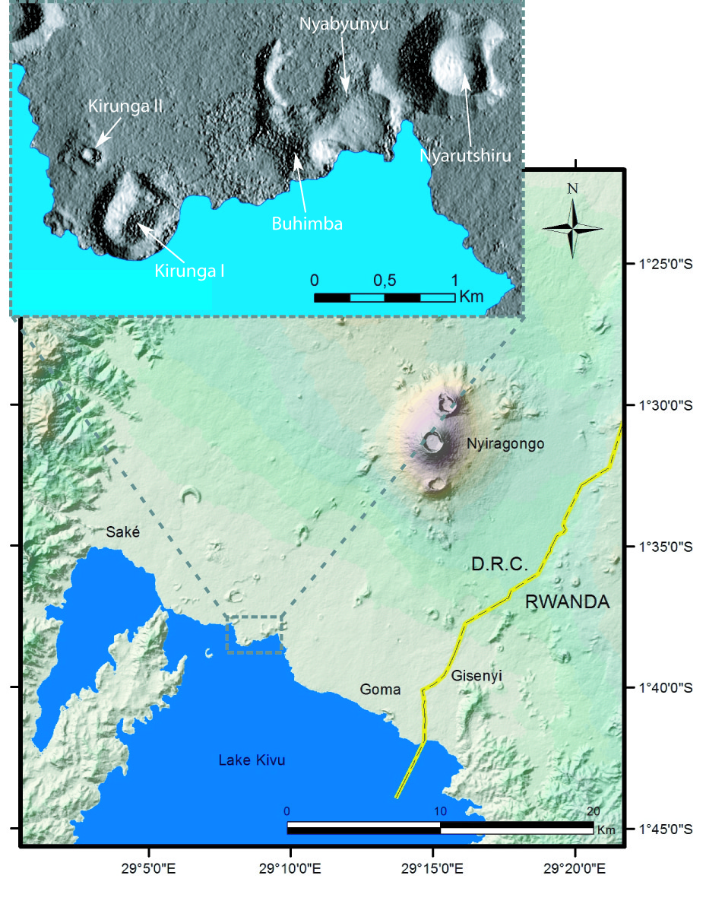

Session 3 Geomorphology, structural aspects/Géomorphologie, aspects structuraux
Poster

Contribution à la caractérisation des événements dommageables du sol, ses problèmes et ses perspectives à Irhambi/Katana

H. Mushayuma(1).

(1) Centre de Recherche en Sciences Naturelles de Lwiro

ABSTRACT/RÉSUMÉ
Le groupement d’Irhambi/Katana situés dans le territoire de Kabare, province du Sud-Kivu (R.D. Congo) est parmi les principaux groupements pourvoyeur en produits vivriers de la ville de Bukavu. Ce travail a pour objectif identifier tout en évaluant les sources de dégradation des terres observables ou mesurables par les scientifiques et les aménagistes du milieu rural et les mettre en relation avec les indicateurs reconnus et utilisés par les agriculteurs, concernant la qualité des terres de Katana. L’étude qui a durée 12 mois est réalisée suivant une démarche méthodologique qui s'inspire de l'approche d'inventaire. Cet inventaire a consisté en une visite des sites d’intervention (villages) par une marche transversale (transect walk) en suivant des axes Horizontaux pour identifier les sources de dégradation des terres.
Le niveau d’appréciation de ces sources de dégradation s’est fait par observation libre avec des questions simples et ouvertes auprès des personnes du village rencontrées pour des éclaircissements sur l’état de dégradation des terres. Nos résultats montrent que l’érosion (60%) et le surpâturage (50
% ) constituent un problème de gestion des terres à Kajuchu ; les déchets ménagers menace l’environnement terrestre à Mwanda (45%). La source de dégradation du sol identifié dans le présent travail sera un indicateur privilégié pour permettre aux agriculteurs de décider de l’opportunité d’exploiter ou non leur sol.

Session 3 Geomorphology, structural aspects/Géomorphologie, aspects structuraux
Poster

Sediment yields estimation and identification of their sources in Lake Tanganyika basin

S. Ongezo Muzaliwa(1)&(1').

(1) University of Dar es Salaam
(1') Université Officielle de Bukavu

ABSTRACT/RÉSUMÉ
Soil erosion / sedimentation are immense problems that have threatened water resources development in the Tanganyika basin, particularly in the northwest of Lake Tanganyika (Mulongwe sub catchment in Uvira City). This study was conducted in Mulongwe sub catchment (DRCongo) to set up and calibrate model, to estimate the sediment yields in the sub catchment and identify the sediment sources. The required input data for this study were Digital Elevation Model (DEM) with spatial resolution of 30x30m, Land use/cover and soil map for the year 2004. Eight types of land use/cover have been determined and two types of soil in the study area. The hydro meteorological observations were set up around the Mulongwe sub catchment. Stream flows and sediment loads were monitored from two years 1999 and 2004 at Mulongwe gauging site on the main Mulongwe River. Sediment sources have been determined by fing printing method and water chemistry.
Model performance evaluation statistics for calibrating daily stream flow and sediment were satisfactory with NSE and R2 greater than 0.62 and 0.71 respectively. For the validation the NSE and R2 were also greater than 0.56 and 0.63 respectively. Sediment erosion rate were in the range of 0.17-5.23tons/ha/yr with average of 0.53tons/ha/yr and average amounts of 6,096tons/yr for sediment yields. The sediment sources should be the weathering of rocks, tectonic effects and anthropic activities in the study area.
Key words: Sedimentation, Erosion, AVSWAT2005, Weathering and Landslide

Session 3 Geomorphology, structural aspects/Géomorphologie, aspects structuraux
Poster

The Virunga Volcano Province: A new volcano-structural map based on morphological analysis of a high-resolution Digital Elevation Model

S. Poppe(1), B. Smets(2)&(2'), F. Albino(3), N. d'Oreye(4), F. Kervyn(5), M. Kervyn(6).

(1) Department of Geography, Earth System Science, Vrije Universiteit Brussel, Belgium
(2) European Center for Geodynamics and Seismology (ECGS), Luxembourg
(2') Department of Geography, Earth System Science, Vrije Universiteit Brussel, Belgium
(3) Royal Museum for Central Africa, Geology Department, Tervuren, Belgium
(4) European Center for Geodynamics and Seismology (ECGS), Luxembourg
(5) Royal Museum for Central Africa, Geology Department, Tervuren, Belgium
(6) Department of Geography, Earth System Science, Vrije Universiteit Brussel, Belgium

ABSTRACT/RÉSUMÉ
The Virunga Volcanic Province (VVP) is situated at a transfer zone within the Western branch of the East-African Rift system, hosts eight large volcanic edifices, and stretches over D.R.Congo, Rwanda and Uganda. Nyamulagira and Nyiragongo are the most recently active volcanoes, in the Western VVP. The former erupted 30 times since 1900, while the latter is occupied by a semi-permanent crater lava lake, which fed a lava flow flooding large parts of Goma city in 2002.
The Central and Eastern VVP holds six dormant to supposedly inactive central volcanoes, surrounded by tens of eruptive fissures and small satellite cones. The so-called ‘Mugogo’ eruption, ~11 km North of Visoke volcano, represents a mere exception. Mugogo is a small-volume volcanic cone and adjacent ~1.5 km long lava flow, emitted from an East-West oriented fissure in 1957.
A new volcano-structural map of the VVP has been constructed based on the morpho-structural interpretation of a new Digital Elevation Model (TanDEM-X) at 5 m resolution, supported by colonial-time geological maps and reports, Pleiades, SPOT and SAR satellite imagery and limited field observations (Figure 1). A Geographical Information System (GIS) database was assembled, including the outline of historical and some pre-historical lava flows, the location and boundaries of eruptive cones and fissures, and larger-scale topographic escarpments, interpreted as potential volcano-tectonic structures.
The positions of volcano-structural features in the Central and Eastern VVP exhibit an overall NE-SW to E-W orientation. This is in sharp contrast with the N-S to NNE-SSW dominated orientations observed on and around Nyamulagira and Nyiragongo in the West.
The map evidences varying geomorphological characteristics of the volcanic edifices within the VVP. Sabinyo volcano has a highly eroded profile with deeply incised valleys, which may be the result of deformation by gravitational spreading of the edifice. An extended vertical scarp on Mikeno volcano (Central VVP) and a ~50 m high front of blocky volcanic debris to the East of Muhabura volcano (East VVP) are important evidence of potential voluminous flank failure during the lifetime of VVP volcanoes. Visoke and Gahinga both exhibit an uneroded topographic profile, suggesting a relatively young age for their volcanic construction. These geomorphological characteristics are consistent with geochronological studies suggesting a Late Pleistocene to Recent age of the Virunga volcanoes but contradict some of the relative chronology between individual volcanoes. Karisimbi volcano at last, is an elevated dome dissected by a pit-crater and caldera, and dominates the Central VVP. Trachytic lava flows on Karisimbi’s Southeastern flank witness its most recent volcanism.
The geomorphological study of the VVP reveals that the Eastern and even more the Central VVP volcanoes may be still active, with Karisimbi, Visoke, Gahinga and Muhabura as the most potential candidates. Karisimbi volcano specifically displays a broad differentiation series, implying a broad range of eruptive behavior, in contrast with the typically effusive eruption style of e.g. Nyamulagira. Even in the absence of potential future volcanic activity, volcano instability processes may pose a different type of geo-hazard to the relatively highly populated areas surrounding the VVP volcanoes.

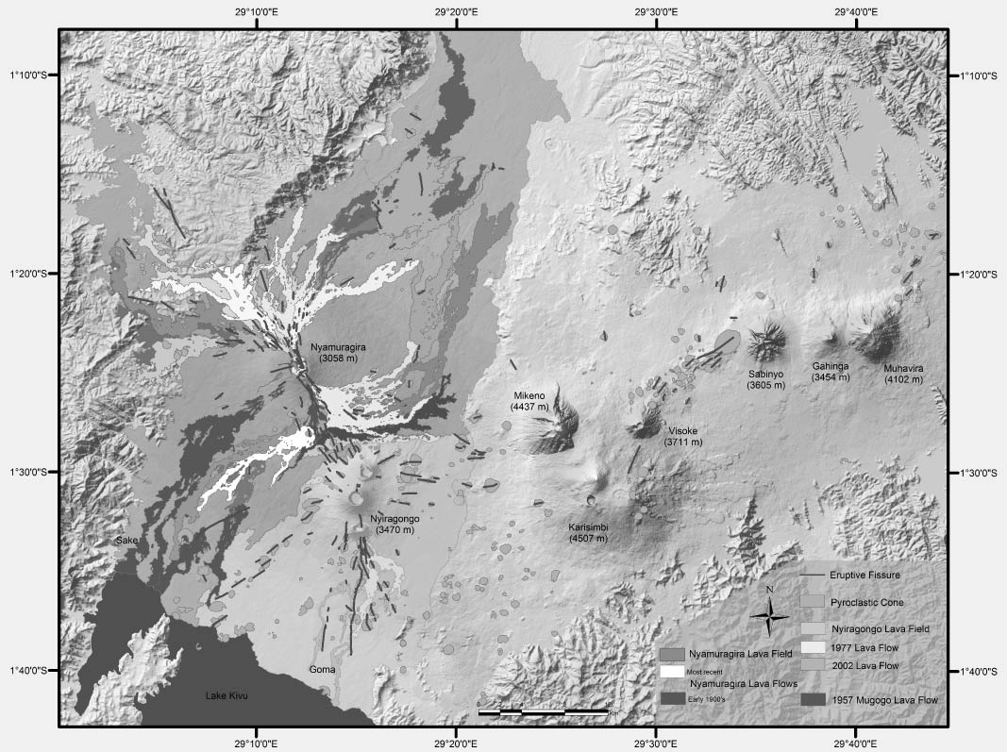
FIGURE 1: Figure 1: Volcano-structural map of the Virunga Volcanic Province, with eruptive cones and fissures. Historic lava flow boundaries from Smets et al., 2010, J. Afr. E. Sc.

Session 3 Geomorphology, structural aspects/Géomorphologie, aspects structuraux
Poster

Basin history of the eastern graben of Lake Kivu from marine reflection seismic data

D. Wood(1), C. Scholz(2), X. Zhang(3).

(1) Syracuse University, Department of Earth Sciences, Syracuse, New York, USA
(2) Syracuse University, Department of Earth Sciences, Syracuse, New York, USA
(3) Syracuse University, Department of Earth Sciences, Syracuse, New York, USA

ABSTRACT/RÉSUMÉ
Marine seismic reflection data acquired within the eastern basin of Lake Kivu, Rwanda by Syracuse University between 2010 and 2013 reveal it to be a half-graben formed by north-south striking, east dipping faults, many of which show recent activity. The faults are in segments of up to 19 km long, and dip between 40 and 65 degrees. Basin extension is measured to be at least 20%, most of which is accommodated by basin margin faults along the eastern sides of Iwawa and Idjwi Islands. Although the lake basin is hydrologically overfilled at present, the ~1500 m sedimentary record reveals at least 3 desiccation events, with the most recent event displaying a dendritic network of north draining paleo-channels. Since an early Holocene rise in lake level, these channels accommodate repeated turbidites. Onlapping sediments observed within the seismic data and shallow water beach deposits and ooids from sediment cores show historic, stable lake stands that range from ~320 to ~370 meters below the modern lake level.

SESSION 4

Geomorphology, structural aspects

Géomorphologie, aspects structuraux

Session 4 Seismology, tectonic activity and volcano related seismology/Séismologie, activité tectonique et séismologie liée au volcanisme
Talk / Oral

Recent seismicity of the Main Ethiopian and implication for earthquake and volcanic risks

A. Ayele(1).

(1) Addis Ababa University

ABSTRACT/RÉSUMÉ
The Main Ethiopian Rift is one of the most seismically and volcanically active tectonic units in East Africa next to the Afar Depression. Notable seismic events have occurred in 2010 and 2011 in Hosanna and Yirgalem, respectively. The main shock of the Hosanna event occurred on December 19, 2010 with magnitude 5.2 mb and located 15-20 km northwest of the town. It caused significant damage on several buildings in Hosanna and the shaking was felt from Mizan town in south far as Addis Ababa in the north. Damges on buildings were sever in walls facing east and west which is sub-parallel to the extension direction of the main Ethiopian rift. Patients rushed out unconsciously from hospitals in Hosanna but luckily no damage on human life was reported. It was also strongly felt in Jimma and students from Jimma University accommodated at higher floors were terrified and rushing down where it caused injuries of over 26 students during that event. The seismic activity continued for over a year.

The Yirgalem earthquake occurred on March 19, 2011 with magnitude 5.1 mb close a highly populated area near Yirgalem town and it was widely felt in the area but there was no significant damage except demolishing of loosely plastered walls. The feeling of the residents was complicated by their perception on the famous Tohuku earthquake of March 11, 2011 and the associated disaster which was widely televised all over the world. Seismologists and geophysicists had to go to the site to make some presentations and make some outreach campaigns that saved thousands of residents from fleeing the area.

These recent seismic activities in the highly populated Main Ethiopian rift were a warning signal both for the construction industry and decision makers to create awareness so as to save human life and property from eminent earthquake disasters.

Session 4 Seismology, tectonic activity and volcano related seismology/Séismologie, activité tectonique et séismologie liée au volcanisme
Talk / Oral

The Seismotectonic model of Southern Africa

B. Manzunzu(1), V. Midzi(2), T. Mulabisani(3).

(1) Council for Geoscience
(2) Council for Geoscience
(3) Council for Geoscience

ABSTRACT/RÉSUMÉ
Southern Africa is largely a stable intra-plate region characterised by a relatively low level of seismic activity, with earthquakes randomly distributed in space and time. Large events have been recorded that resulted in severe damage to infrastructure in nearby cities, towns, underground mines and even death in some circumstances. Therefore, it is necessary that we consider the effects of these events in the design of our infrastructure. A seismotectonic model for the region is being compiled to determine potential seismic hazard areas for mitigation and planning purposes. Data compiled in this report consists of seismicity data, active faults, focal mechanism solutions as well as geophysical data. The seismic data used are part of the earthquake catalogue being prepared for the GEM-Africa project, which includes historical and instrumental records as collected from various agencies. A lot of faults have been identified in unpublished materials as being active, thus more work is being carried out to obtain information that can be used to characterise them before they are included in the seismotectonic model. It should be noted that this information is the first draft of the seismotectonic model of the region. We continue to collect and improve collection methods of historical and instrumental seismicity data as well as fault characterisation. Further interpretation of the data is envisaged which might result in a more detailed. The work was prepared as part of the requirements for the SIDA/IGCP Project 601 titled “Seismotectonics and Seismic Hazards in Africa”.

Session 4 Seismology, tectonic activity and volcano related seismology/Séismologie, activité tectonique et séismologie liée au volcanisme
Talk / Oral

Locating water ingress-induced micro-earthquake in the Central Rand Goldfields, South Africa

A. Mangongolo(1).

(1) Council for Geoscience, CGS (South Africa)

ABSTRACT/RÉSUMÉ
The seismic activity associated with the ingress of water into the abandoned mines within the Central Rand is currently being monitored by a network of twelve seismological stations under the framework of the Strategic Water Management Project (SWMP). The ingress of water causes temporal stress and strain changes underground, which can be withstood by the rock materials up to the threshold that characterises the resistance of those rock materials. Beyond that threshold, the pressure that is released will trigger micro-earthquakes. Usually, the pressure is released along pre-existing geological features (faults or dykes) or through the creation of new features. Accurate locations of the triggered micro-earthquakes help to identify which faults were responsible for the seismic activity or which have been reactivated. The identification of culprit faults (or fractures) can be used for the modelling and monitoring of the fracturing process.

In order to accurately locate seismic events, a ‘multiple-events’ method may be used. The ‘multiple-events’ location method is based on the double-difference algorithm which aims to improve the seismicity pattern. The method uses precise differential times from waveform cross-correlation and/or catalogue phase arrivals to locate events in clusters. In fact, if the distance between two earthquakes in a cluster is small compared to the event–station distance and the scale length of velocity heterogeneity, then the ray paths between the two events and a common station are similar along almost the entire ray path. The residual (double-difference) between the observed and the calculated differential travel time between two events of the cluster at one station can be attributed to the spatial offset (relative hypocentral parameters) between the events. The offset can then be calculated with a high accuracy using the residual differential travel time between the two events. The advantage of ‘multiple-events’ location is the reduction of the cloud-like (or diffuse) pattern of seismicity which is often observed. The result of this method is more of a clustered pattern of seismicity which can easily help (but not always) to correlate seismicity to the faults and/or dykes.

Using the double difference location method, earthquakes were located in the Central Rand Basin from April 2010 to October 2012 and produced the following results: (1) the seismicity displays a clustering pattern related to the abandoned mining areas, (2) although all the events do not fall along known faults and dykes, active faults and other lineaments close to the clusters can now be identified, (3) the location of clusters seems to follow both a northwest and northeast striking zone and is shown to be associated with faults and dykes, (4) events of magnitude >2.5 seem to occur mainly in the East Rand proprietary mines (ERPM) and not in the Central Rand, (5) diffuse areas can still be recognised, east and west of the Central Rand, outside the network, and (6) the events are located at a depth range of 0 to 9 km, with most of them being shallower than 4 km.

The errors in the longitudes, latitudes and depths for most of the events located are between 56.1 to 800 m, 27.4 to 850 m and 53.5 to 1 200 m, respectively. These values are small compared to the ‘single-event’ location method where the errors are of the order of a thousand metres and greater.

The ‘multiple-event’ location method applied in the Central Rand Basin shows that seismicity is shallower, clustered and follows both a northwest and northeast striking zone. It is also associated with faults and dykes.

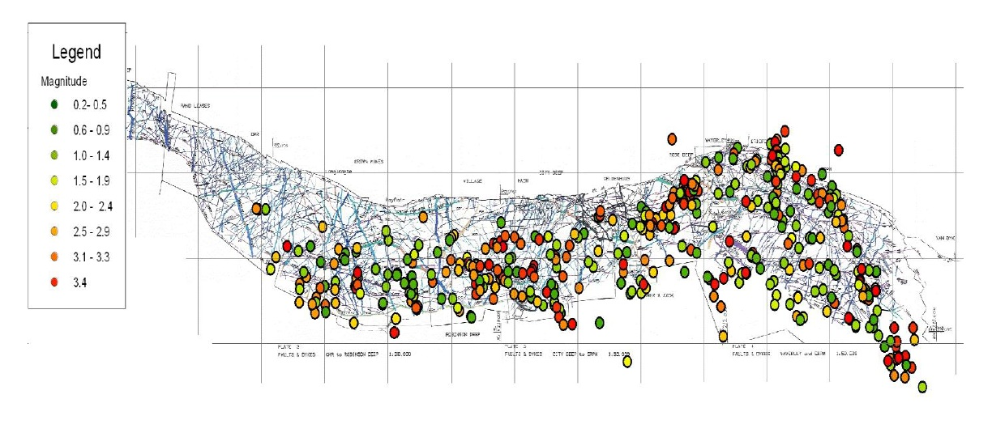

Session 4 Seismology, tectonic activity and volcano related seismology/Séismologie, activité tectonique et séismologie liée au volcanisme
Talk / Oral

Hypocenter determinations of volcanic earthquakes prior to the November 6, 2011 eruption at volcano Nyamuragira, Western Rift Valley of Africa, DR of Congo

B. Rusangiza(1), M. Tuluka(2), L. Nyombo(3), E. Ossondundu(4), B. Rukeza(5), B. Agama(6), C. Assani(7).

(1) Observatoire Volcanologique de Goma
(2) Observatoire Volcanologique de Goma
(3) Observatoire Volcanologique de Goma
(4) Observatoire Volcanologique de Goma
(5) Observatoire Volcanologique de Goma
(6) Observatoire Volcanologique de Goma
(7) Observatoire Volcanologique de Goma

ABSTRACT/RÉSUMÉ
Earthquake swarms observed before the November 27, 2006 and the November 06, 2011 Nyamuragira eruptions were analysed. The activities and hypocenter distributions of these earthquake swarms were mainly examined.
The former swarm was characterised by a higher seismic activity that the latter. Although the two swarms accompanied eruptions, most of the swarms observed in 2006 and 2011 were not followed by any eruptions. These swarms probably represent an intrusion of magma at a shallow depth. Hypocenters of these earthquake swarms show that most of the events are located in and around the crater of Nyamuragira summit at a shallow depth less than 5km. Some of events were located at a deep depth around 20-25km. Numerical examinations of the hypocenter determination indicate that some small errors in arrival times make the hypocenters not re-located or relocated at a depth of 0km. This suggests that to obtain more reliable hypocenter distribution, it is necessary to deploy seismic stations on and around Volcano Nyamuragira. Such a dense seismic network will enable us to discuss more in detail the swarm activity preceding eruptions and differences between the swarms preceding eruptions and those caused only by magma intrusion at a shallow depth.

Session 4 Seismology, tectonic activity and volcano related seismology/Séismologie, activité tectonique et séismologie liée au volcanisme
Talk / Oral

Crustal structure beneath four seismic stations at the Southern flank of volcano Nyiragongo revealed from teleseismic P wave receiver function analysis

G. Mavonga Tuluka(1), D. Delvaux(2), R. Durrheim(3).

(1) Observatoire Volcanologique de Goma
(2) Royal Museum for Central Africa, Bruxelles, Belgium
(3) University of the Witwatersrand, Johannesburg, South Africa

ABSTRACT/RÉSUMÉ
Crustal structure beneath RSY, BLG ,GOMA and BOBN was estimated by inverting stacks of teleseisms receiver functions. The resulting velocity models were presented as P-wave velocity model. The crust mantle transition zone beneath the south flank of volcano Nyiragongo is estimated at a depth from 26 to 39 km using H-k stacking analysis. A low velocity zone was observed beneath RSY, BLG and GOMA stations at depth from 8 to 18 km, 10 to 15 km and 10 to 16 km, respectively. This zone may probably relate to a magma chamber or a melt-rich sill in the field of Nyiragongo volcano. One zone corresponding to an average velocity of 7.8 km/s at depth about 3–10 km was found below GOMA. This zone is indicative of magma cumulate within the volcanic edifice. No sensitive anomaly was observed beneath BOBN
The velocity structure obtained in this study combined with that obtained in the previous study can be used as a first approximation for high resolution tomography in the Virunga area. The result obtained in this study can be improved by setting up one supplementary broadband station at KTL station and using a long study period of observation. An example of average velocity model , crustal thickness and Vp/Vs ratio beneath BLG station is shown in Figure 1 and 2.

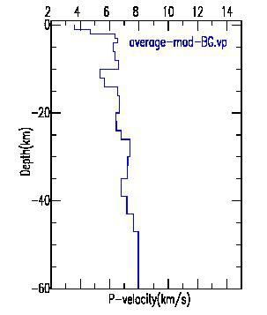
FIGURE 1: Average velocity model beneath BLG station
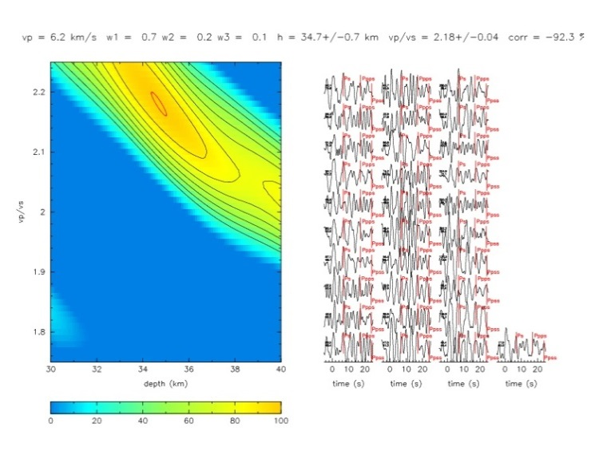
FIGURE 2: Crustal thickness and Vp/Vs ratio beneath BLG stationusing H-k stacking analysis

Session 4 Seismology, tectonic activity and volcano related seismology/Séismologie, activité tectonique et séismologie liée au volcanisme
Talk / Oral

Aftershock sequences of February 3, 2008 earthquake in the Kivu Province, Western Rift Valley

J.P. Lukindula Wilondja(1).

(1) Observatoire Volcanologique de Goma

ABSTRACT/RÉSUMÉ
The temporal and spatial distribution of the aftershock sequences of the Bukavu (February 3, 2008, Mw (5.9)) earthquake have been studied. This was the second largest earthquake ever to be recorded in the Kivu basin, a section of the western branch of the East African Rift since 1900. In this paper, we combine data recorded by the stations surrounding DRC (MBAR, ZP BKBA, ZP FOPO, ZP BIHA, ZP BKBA, ZP KBLE, ZP MKRE, ZP MLBA, and ZP SULU) and the digital seismic local network such as Kibumba (KBB), Kibati (KBT), Luboga (LBG) and Rusayo (RSY) stations. It has been found that most of the aftershocks of the Bukavu earthquake are located on the western rift valley to the south part of Lake Kivu. This earthquake is of particular interest due to its shallow depth and proximity to active volcanoes and Lake Kivu, which contains high concentrations of dissolved carbon dioxide and methane. The aftershocks cluster at shallow depths of a few kilometers and in a deeper zone around 15 km depth, though these depths are strongly dependent on the velocity model. The seismic moment of the largest aftershock is 5.59206814E+22dyne.cm; the predicted value of corner frequency is 1.71 Hz.
The daily frequency of aftershock decrease after the largest aftershock correlates well with those of previous studies which occurred in the Western Rift valley. The difference between the magnitude of the main shock and the largest aftershock is about 0.8.

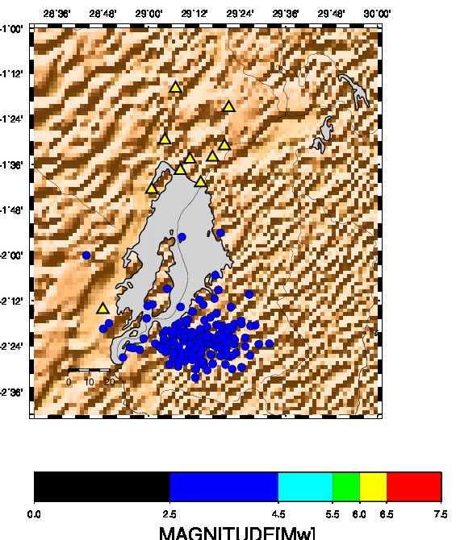
FIGURE 1: localisation des Epicentres.
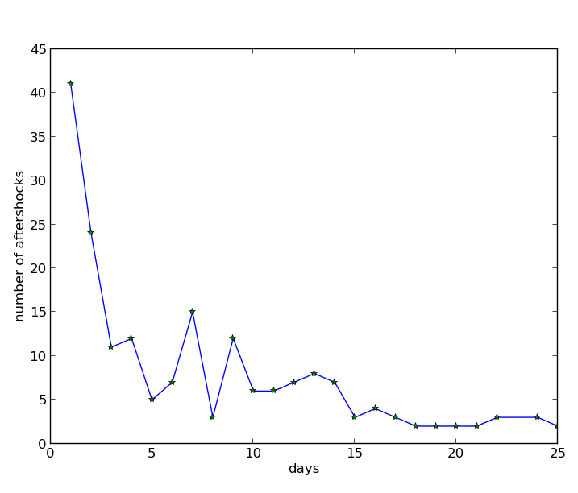
FIGURE 2: Daily frequency

Session 4 Seismology, tectonic activity and volcano related seismology/Séismologie, activité tectonique et séismologie liée au volcanisme
Talk / Oral

Les Sources Thermales et Séismicité du Bassin du Lac Kivu

S. Fiama Bondo(1).

(1) Centre de Recherche en Sciences Naturelles de Lwiro

ABSTRACT/RÉSUMÉ
Un regard sur la séismicité et sa relation entre avec les sources chaudes dans le bassin du lac Kivu sismiquement active et quelques impacts sur le lac ont été la tentative de ce travail.

Les sources thermales de Katana-Maziba et Mayi ya Moto (Figure 1) localisées dans les régions volcaniques quaternaires, d’écoulement hydrologique et traversées par des failles actives ont des températures élevées (>60°C). Les sources de basses températures jaillissent à Tingi, Sake, Kihira et Kikingi au Nord–Ouest du lac Kivu qui pourrait être chauffées sous le champ volcanique des Virunga ou jaillir près le lac Kivu et contrôlées par la faille limitant la baie de Kabuno à l’ouest. Les sources thermales Mahyuza et deux autres à Kabamba (Figure1) sont localisées sur le segment de la faille qui a déclenché le séisme du 03Février 2008 de Bukavu (Mw= 6,1) (USGS), et interceptant la faille principale N-S parallèle au rift (Villeneuve, 1980).

Une variation des températures des sources thermales de Katana-Maziba a été observée avant ou après un séisme. Mais également un tarissement et une augmentation du débit des eaux chaudes ont été observés lors du passage du séisme du 03 Février 2008. Ceci révèlerait que les sources de Katana et Maziba dans la région volcanique du Sud–Kivu seraient probablement contrôlées par les failles. Ce même séisme fut à l’origine d’un tsunami à Ibindja et glissements de terrains dans le lac Kivu.

Le flux thermique estimé sur cinq points majeurs dans le lac Kivu est compris entre 17 et 185 mWm-2(IASPEI-IHFC) dont ceux localisés près des failles ont un flux relativement grand : 99mWm-2 près de la faille bordant l’Est de la baie de Kabuno et 185mWm-2 proche de la faille traversant l’île d’Idjwi. Ainsi, la profondeur des séismes autour de grand flux thermique est comprise entre 2 et 12 Kms et entre 10 et 30Kms autour de faible flux thermique. La profondeur des séismes dans la plaine de la Ruzizi zone hydrothermique et sédimentaire, est comprise entre 10 et 33 Kms.

Les sources thermales sont localisées au niveau des failles qui les contrôlent. La variation spatio-temporelle de la température et flux thermique de ces sources thermales serait un indicateur de l’approche d’un séisme et/ou gouverne l’occurrence des séismes et leur profondeur dans le bassin du lac Kivu. D’autre part, suivant la distribution des séismes six zones séismiques sont caractérisées dont le lac Kivu est très actif. Les impacts des séismes sur le lac Kivu sont par conséquent manifestes.

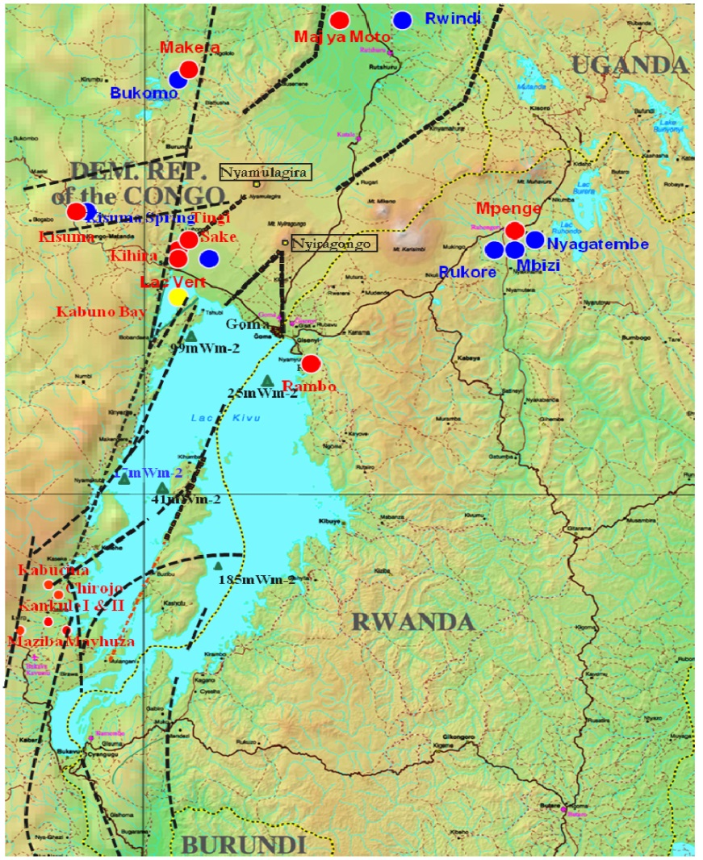
FIGURE 1: sources thermales: cercle plein rouge: eaux chaudes; cercle plein bleu: eau froides et le triangle plein vert: le flux thermique. les traits interrompus: esquisse des lignes de failles

FIGURE 2: Séismicité du bassin du lac Kivu entre 1930 et 2009

Session 4 Seismology, tectonic activity and volcano related seismology/Séismologie, activité tectonique et séismologie liée au volcanisme
Poster

Analyse fréquentielle des essaims des séismes à longues période ayant précédé l'éruption du volcan Nyamulagira du 6 Novembre 2011

D. Birimwiragi Namogo(1), G. Mavonga Tuluka(2), A. Kyambikwa Milungu(3), M. Etoy Osodundu(4).

(1) Observatoire Volcanologique de Goma
(2) Observatoire Volcanologique de Goma
(3) Observatoire Volcanologique de Goma
(4) Observatoire Volcanologique de Goma

ABSTRACT/RÉSUMÉ
L’analyse fréquentielle est un système qui consiste à chercher les spectres des différents séismes LP constituant un essaim qui s’est produit à une certaine période au cours d’une activité volcanique. Pour chaque spectre ; on détermine la fréquence de coupure f0 du déplacement de l’onde P. L’analyse de l’évolution de ce paramètre spectral depuis le premier essaim du cycle d’une activité volcanique jusqu’au dernier essaim ayant conduit à l’éruption donne des informations importantes.
Ainsi pour nos analyses ; les archives issues des enregistrements du réseau des stations séismologiques (BULENGO, RUSAYO, RUMANGABO, et GOMA) équipées des senseurs digitaux Lennartz courte période (5 secondes)et installées autours des Volcans Nyiragongo et Nyamulagira par le département de séismologie de l’Observatoire Volcanologique de Goma a partir du mois de Janvier 2011 jusqu’au 06 novembre 2011 (date de l’éruption du Nyamulagira) nous ont servi et ont conduit aux résultats selon les quels la période de Janvier à Octobre 2011 correspondait du point de vue géodynamique à un mouvement du fluide ( magma) à l’intérieur de la chambre magmatique sans déplacement considérable ( voir essaim du 29 janvier dont f0= 1 à 1,4 Hz ; du 30 juillet dont f0= 1 à 1,5 Hz ; et du 08 octobre dont f0= 1 à 2,6 Hz) , tandis que celle de début Novembre correspondait à un déplacement considérable des fluides qui se faisait déjà à l’intérieur des cassures issues de l’édifice volcanique ( voir essaim du 04 Novembre dont f0= 1 à 7,3 Hz ; et du 05 Novembre dont f0= 3,7 à 9.5 Hz) ; puis s’en est suivi l’éruption du 06 Novembre à 17h55’ (U.T) dont la lave était déjà visible à la surface.

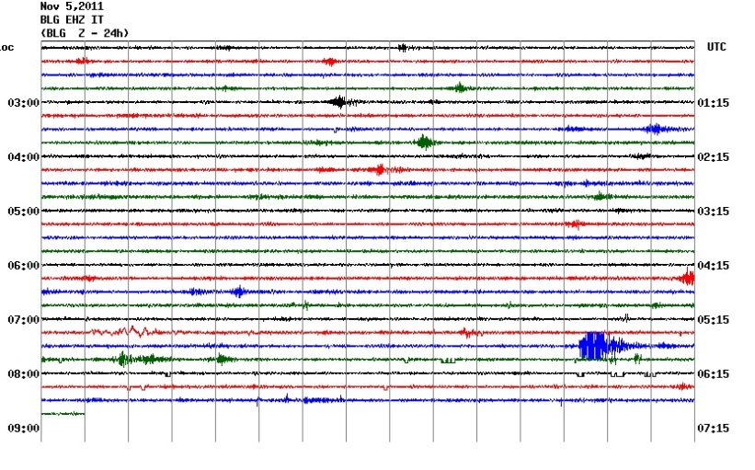
FIGURE 1: Hellicoder montrant l' essaim du 05novembre dont les seismes ont f0=3,5-9.5 f

Session 4 Volcano monitoring (remote sensing, ground based techniques…)/Surveillance volcanologique (télédétection, techniques de surveillance au sol…)
Poster

Volcanic tremors and transients: 7 days of seismic recordings at Nyiragongo Volcano summit (Democratic Republic of Congo)

G. de Gelder(1)&(1'), J. Barrière(2), A. Oth(3)&(3'), N. d'Oreye(4)&(4'), B. Smets(5), G. Mavonga(6), N. Mashagiro(7), F. Kervyn(8), GVO team .

(1) European Center for Geodynamics and Seismology, Luxembourg
(1') National Museum of Natural History, Luxembourg
(2) European Center for Geodynamics and Seismology, Luxembourg
(3) European Center for Geodynamics and Seismology, Luxembourg
(3') National Museum of Natural History, Luxembourg
(4) European Center for Geodynamics and Seismology, Luxembourg
(4') Royal Museum for Central Africa, Belgium/Vrije Universiteit Brussel, Belgium
(5) European Center for Geodynamics and Seismology, Luxembourg
(6) Observatoire Volcanologique de Goma
(7) Observatoire Volcanologique de Goma
(8) Royal Museum for Central Africa, Belgium

ABSTRACT/RÉSUMÉ
Nyiragongo volcano (Democratic Republic of Congo) is an active volcano in the western branch of the East African Rift, and provides a good opportunity for studying seismic activity around one of the few volcanoes worldwide featuring a permanent lava lake in its crater. Broadband seismic recordings were carried out between 14 and 20 September 2011 at five different locations in and around the crater of the volcano. Including the available data from three seismic stations in the vicinity of the volcano (which are part of the Goma Volcanological Observatory network), a detailed analysis in both time and frequency domain reveals both continuous seismic tremor and a variety of transient signals. Tremors, only detected at the stations located on the volcano, occur over a wide range of frequencies and last from minutes to hours. Dominant frequencies are typically in the range of 0.5 to 10 Hz, whereas in each location, different higher frequency bands are detected that seem to be resonance related and can show gliding effects. Regional transient signals include (teleseismic) earthquakes, long period events with dominant frequencies in the 1-5 Hz band, and very long period events (dominant frequency range below 1 Hz). Local transient signals on the volcano itself have a typical duration of 1-8 seconds, and are mostly either broadband over the complete detectable range of our seismometers (up to 100 Hz), or restricted to frequencies below ~45 Hz. The results of this study demonstrate the variability of seismic activity at Nyiragongo crater, and demonstrate how the responsible mechanisms related to the lava lake activity are still far from understood. Acknowledgments: J. Barrière’s participation in this work was made possible in the framework of the BEDLOAD project funded by the National Research Fund of Luxembourg (FNR, BEDLOAD C11/SR/1158445). B. Smets’s participation in this work is in the framework of the AFR PhD Grant n°3221321 (Fond National de la Recherche, Luxembourg).

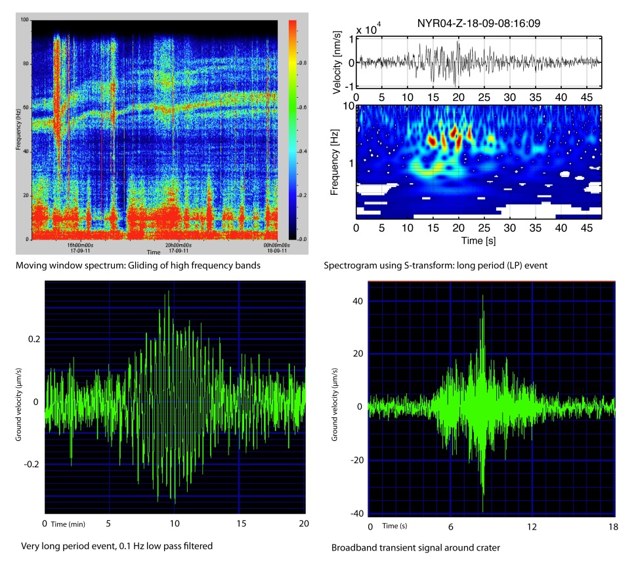

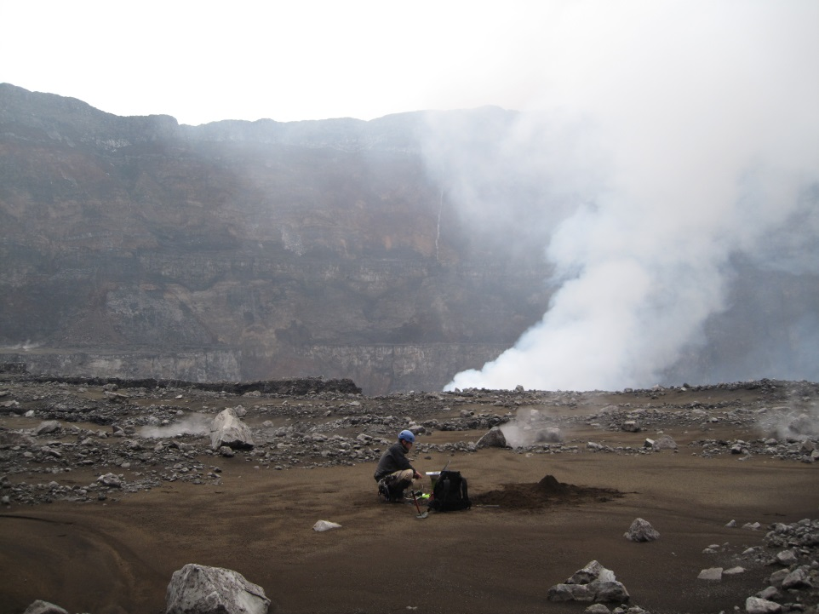
FIGURE 2: Maintenance of a seismic station on "platform 2" (300m below the rim) inside the Nyiragongo crater

Session 4 Seismology, tectonic activity and volcano related seismology/Séismologie, activité tectonique et séismologie liée au volcanisme
Poster

Compiling a homogenous Earthquake Catalogue for Southern Africa

T. Faith Mulabisana(1).

(1) Council for Geoscience

ABSTRACT/RÉSUMÉ
An accurate seismic hazard assessment can only be carried out if a homogenous and sufficiently complete catalogue for the study area is available. Since the catalogue for southern Africa was last updated during the Global Seismic Hazard Assessment Program (GSHAP) it is necessary that a new updated, homogeneous and complete earthquake catalogue be compiled. The process of compiling the new earthquake catalogue for southern Africa (South Africa, Lesotho, Swaziland, Botswana, and Namibia) is done as part of the Global Earthquake Modelling (GEM) project. The final catalogue will include all available events, i.e. paleoseismic, historical, and instrumental events from 1620 to February 2012. This events will be independent and also of tectonic nature. The data from published and unpublished sources, and databases from the South African National Seismological Network (SANSN), Bulawayo (BUL), Lesotho Highlands Water Projects (LHWP), the Geological Survey of Namibia, the Geological Survey of Botswana, the University of Botswana, the National Earthquake Information Centre (NEIC), the Advanced National Seismic System (ANSS), and the International Seismic Centre (ISC) were retrieved and evaluated. After the data from the different sources were merged, duplicates and induced earthquakes were removed. The catalogue was unified with all magnitude types converted to Mw. To ensure that all the events are independent, several procedures were carried out to decluster the catalogue. Figure 1 is the map of southern Africa showing the epicentres in the preliminary catalogue for southern Africa following the declustering process. The largest event in the catalogue occurred in 1952 and is located at Okavango Delta region in Botswana with a magnitude of 6.7.

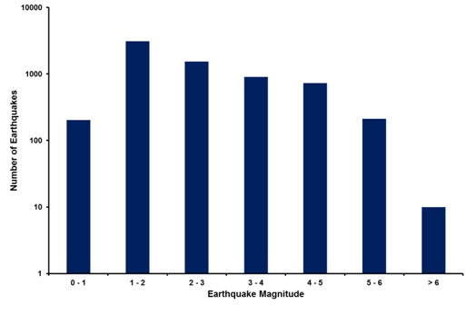
FIGURE 1: Histogram of seismicity of southern Africa

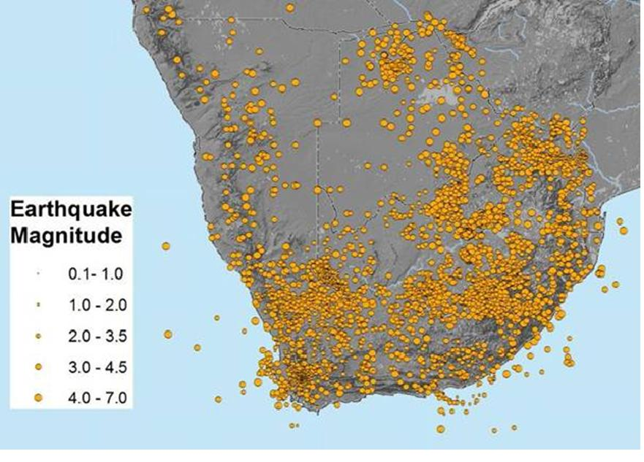
FIGURE 2: Seimicity of southern Africa

Session 4 Seismology, tectonic activity and volcano related seismology/Séismologie, activité tectonique et séismologie liée au volcanisme
Poster

Analyse de l'activité magmatique du volcan Nyamulagira par la mesure sismique des amplitudes à temps réel (RSAM) durant le période du 1 mars au 6 Novembre 2011

A. Kyambikwa Milungu(1), G. Mavonga Tuluka(2), D. Birimwiragi Namogo(3), M. Etoy Osodundu(4).

(1) Observatoire Volcanologique de Goma
(2) Observatoire Volcanologique de Goma
(3) Observatoire Volcanologique de Goma
(4) Observatoire Volcanologique de Goma

ABSTRACT/RÉSUMÉ
La sismicité est l’un des principaux paramètres utilisés pour surveiller les volcans. L’évolution de la sismicité caractérise la dynamique de l’activité magmatique des volcans. Particulièrement pour les volcans Nyamulagira, cette sismicité se manifeste sous forme d’essaim de LP qui traduit le mouvement magmatique en profondeur ou superficiel. Ces signaux peuvent être précurseurs d’une éruption de Nyamulagira. Il a été montre que l’activité sismique augmentait quelques mois avant l’éruption volcanique de Nyamulagira .L’évolution de cette activité peut être quantifiée par la mesure à temps réel de l’amplitude de ces signaux continus enregistrés à nos stations.
Nos analyses se sont faites six mois avant l’éruption volcanique de Nyamulagira de Novembre 2011, et le signal du premier essaim a été détecté à la station de BLG le 4 Septembre et à la station de RSY le 6 Septembre 2011, soit deux mois avant l’éruption. Tout au long de l’essaim la signature amplitudinale de la RSAM était restée stable entre 2000 et 4000. (Figure 1)
Du 30 Octobre au 5 Novembre, soit six jours avant l’éruption, La taille des évènements discrets augmentaient régulièrement (RSAM entre 5000 et 10000) avec un signal presque contenu des tremors qui correspondait a une l’évolution considérable du magma a l’intérieur des cassures de l’édifice volcanique. (Figure 2)

MOTS CLÉS
Essaim sismique (Groupe ou Multitude de séisme) ; Tremor (Séisme volcanique engendré par la remontée du magma lors de l’éruption) ; BLG (Station de Bulengo) ; RSY (Station de Rusayo)

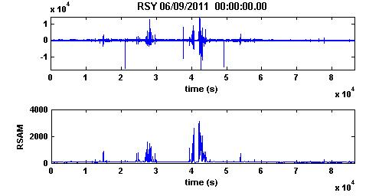
FIGURE 1: Premier essaim detecté à la station de Rusayo le 06/9/2011.

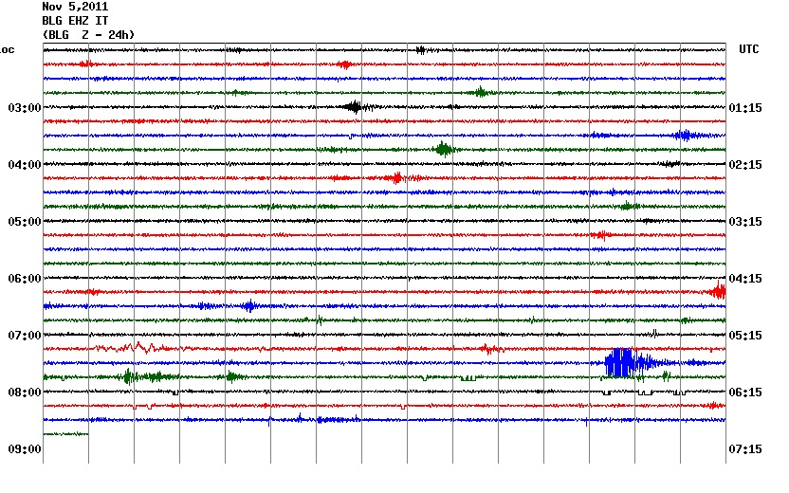
FIGURE 2: Essaim sismique du 05/11/2011 a la station de Bulengo.

Session 4 Seismology, tectonic activity and volcano related seismology/Séismologie, activité tectonique et séismologie liée au volcanisme
Poster

Comparison of seismological, geodetic, and geological observations of rifting in East Africa: Diffuse vs localized deformation

N. Lindsey(1)&(1'), C. Ebinger(2), D. Keir(3), H. Zal(4).

(1) Department of Earth and Environmental Sciences, University of Rochester, Rochester, NY 14627
(1') Lawrence Berkeley National Laboratory, Berkeley, CA
(2) Department of Earth and Environmental Sciences, University of Rochester, Rochester, NY 14627
(3) SOES, University of Southampton, UK
(4) Department of Earth and Environmental Sciences, University of Rochester, Rochester, NY 14627

ABSTRACT/RÉSUMÉ
The rift valleys of eastern and central Africa transect cratons, Precambrian orogenic belts, and oceanic lithosphere, and show profound differences in the volume and composition of magmatic products, the timing of rift initiation, the pre-rift plate structure, and rift morphology exist between rift sectors. The growing evidence of frequent and sometimes volumetrically large magma intrusions, combined with the historic-recent record of damaging earthquakes, motivates our systematic comparison of seismic and geodetic moment release along the length of the East African rift system. We use NEIC and historic seismicity catalogues and published sparse geodetic data, and we invert well-determined CMTs for strain rate vectors within distinct rift sectors, allowing for finite width deformation zones. The maximum fault length within each sector is used to predict a maximum earthquake magnitude, providing some evaluation of the completeness of the earthquake catalogue. The spatial pattern of moment release shows significant deformation outside the fault-bounded rift valleys and across the uplifted plateaus, extending from South Sudan through Botswana. Seismic moment rate is everywhere less than geodetic moment rate, and the discrepancy increases with increasing degree of magmatism within the rift sectors. Thus, much of the plate boundary deformation is accommodated aseismically over the time period of observations, and short term patterns suggest magma intrusion accounts for much of the discrepancy. Opening rates are much lower than predicted from models of geodetic data that assume deformation in narrow zones between plate rigid plates, consistent with broad zones of deformation and aseismic strain. Comparison of seismic moment release and effective elastic thickness shows that seismic moment release is greatest where the rift transects strong lithosphere, as in the Western and Southwestern rift arms. Our results indicate that plate boundary deformation is not restricted to the fault-bounded rift valleys, motivating a re-evaluation of hazards throughout eastern and southeastern Africa, and highlighting the need for widely distributed GPS networks. The broad deformation zone provides new insights into rift initiation processes, including the role of metasomatic modification of thick, cold cratonic lithosphere beneath Africa.

Session 4 Seismology, tectonic activity and volcano related seismology/Séismologie, activité tectonique et séismologie liée au volcanisme
Poster

New Seismic Hazard Maps of Zimbabwe

V.P. Mapuranga(1).

(1) University of Pretoria

ABSTRACT/RÉSUMÉ
Seismic hazard analysis can be done in two ways; deterministically and probabilistically. The deterministic approach uses an accepted earthquake scenario, whereas the probabilistic approach (which has been applied in this case) quantifies the probability of exceeding various ground motion levels at a site, given all possible earthquakes. In this presentation two methodologies for probabilistic seismic hazard assessment are compared using an attenuation relationship developed for hard rock conditions.

The first is the classic Cornell-McGuire (1968, 1978) which permits the use of geological and geophysical evidence to supplement the seismic event catalogues. Application of the procedure includes several steps, the initial step requires the delineation of potential seismic sources which are usually associated with geological and tectonic features such as faults and delineation of potentially active regions (zones) over which all available information is averaged.

The second method is the "parametric-historic" approach (Kijko and Graham, 1998; 1999) which permits the use of incomplete earthquake catalogues and has been developed specifically for the estimation of seismic hazard without the subjective judgment involved in the delineation of seismic source zones, in areas where specific active faults have not been mapped and identified and where the causes of seismicity are not well understood.

The available seismic event magnitudes in the catalogue were converted to moment magnitude which is based on spectral amplitudes such that it has a uniform behavior at all magnitude ranges. The seismic hazard was calculated in the form of a matrix with a grid spacing of 0.25˚ in both latitude and longitude. The area covered lies within latitude 24 to 14˚S and longitude 22 to 36˚E. The next step is to calculate seismic hazard parameters namely seismic activity λ, the Gutenberg b-value as well as the maximum magnitude m_max which was done for each grid point.

It was assumed that the distribution follows a doubly truncated Gutenberg-Richter frequency model magnitude distribution and earthquake occurrence follows a Poisson distribution in time. The method of Kijko Sellevoll (1989, 1992) was used to calculate seismic parameters by finding a solution to the equation
m_max= m_max^obs+∫_(m_min)^(m_max )[〖F_M (m)]〗^n dm, (1)
where m_max is maximum magnitude, m_min is level of completeness of the data set m_max^obs is maximum observed magnitude in the catalogue and F_M (m) is the cumulative distribution function. These parameters are calculated simultaneously using a MATLAB code that’s available from the authors and then used as input to compute the peak ground acceleration.
Results
The results are displayed as maps which show median values of PGA in units of g with a 10% probability of exceedance in 50 years. The accelerations range from 0.01g up to 0.09g with dark blue, light blue, green, yellow, red and dark red indicating levels of seismic hazard which range from very low, moderate, high to very high

Both maps show the highest level of hazard indicated by a dark shade of red on the map to be in the South-East border of the country which is part of the extension of the East African Rift valley. The second region of high hazard is in the Zambezi basin where seismic activity is largely influenced by is a result of the Lake Kariba dam. The central part of the country which is shows the least hazard levels and is part of the Zimbabwe craton. The parametric-historic approach shows moderate levels of hazard near the Save-Limpopo mobile belt which is not indicated in the Cornell-McGuire approach.
Conclusion
The Cornell-McGuire shows levels of hazard in comparison to the parametric-historic approach. In principle, the parametric historic approach in its current states only uses the largest events in the catalogue yet the Cornell-McGuire approach averages out the entire data set and is able to account for migration in seismicity and also makes use of other available geophysical information yet on the other hand the parametric-historic approach requires seismic data only. The parametric-historic approach has the advantage of being able to account for incomplete data sets which is almost always the case. In general, each method can be said to have its own pros and cons dependent on the available information thus it is recommended that the two methodologies be used hand in hand while they are being continually developed over time.

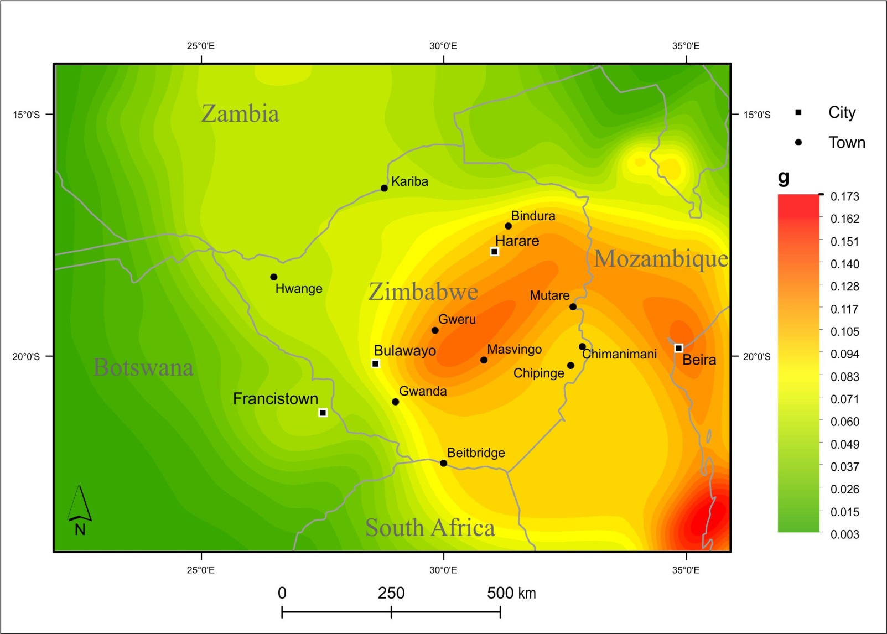
FIGURE 1: Map of the expected PGA with a 10 % probability of being exceeded at least once in a 50 year period according to Cornell-McGuire procedure when applying the Atkinson and Boore (1995, 1997) ground moti

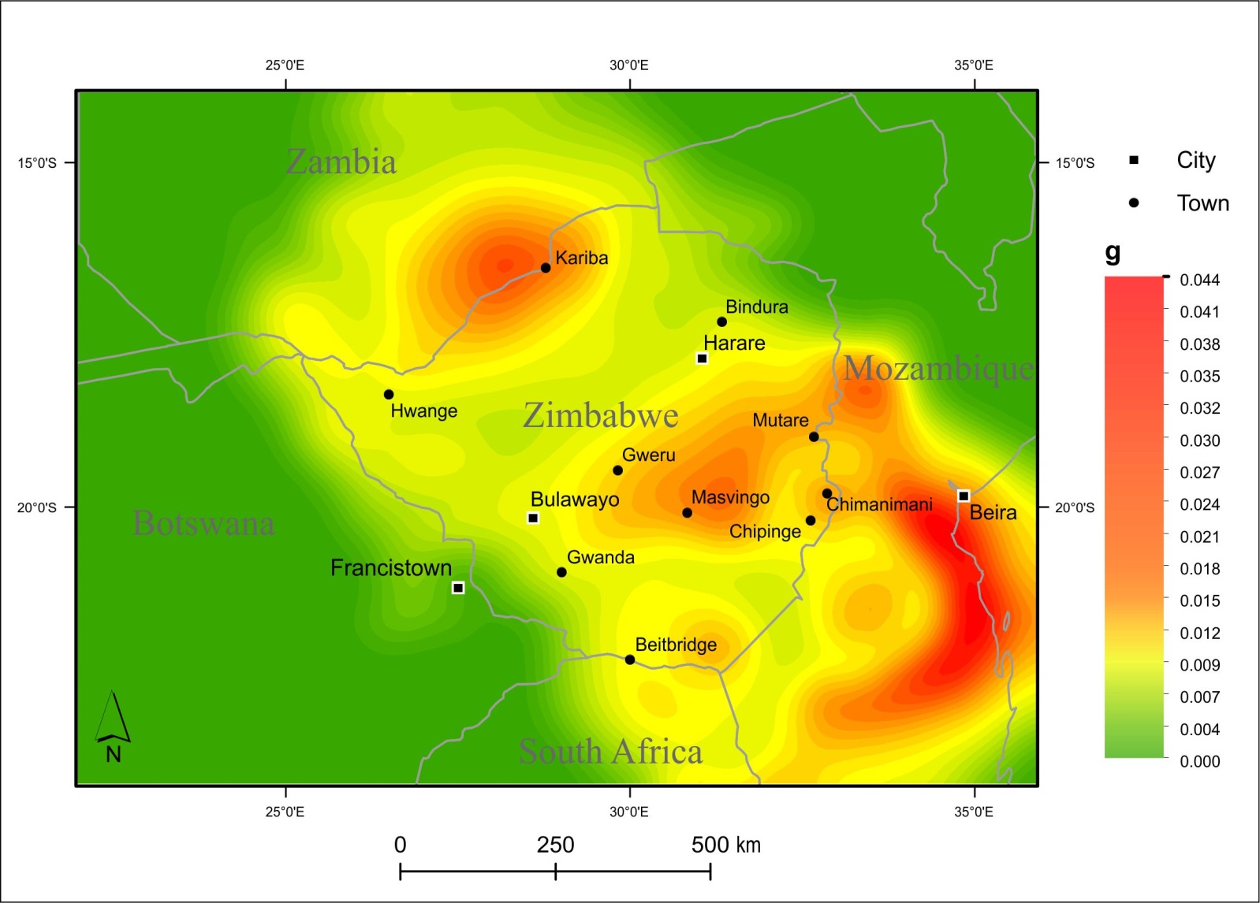
FIGURE 2: Map of the expected PGA with a 10 % probability of being exceeded at least once in a 50 year period according to parametric-historic procedure using the ground motion prediction equation by Atkinson a

Session 4 Seismology, tectonic activity and volcano related seismology/Séismologie, activité tectonique et séismologie liée au volcanisme
Poster

Impacts of tectonic earthquakes in the Western Rift Valley of Africa on the volcanic activity of Nyiragongo, Virunga region

D. Mifundu Wafula(1).

(1) Université Kinshasa

ABSTRACT/RÉSUMÉ
This paper establishes the impact of regional seismicity on the volcanic activities of an intra-plate and continental volcano Nyiragongo in the Virunga Region. The seismic activity in the East African Rifts system is confined in the shallow zone and the focal mechanism of normal faulting type prevails widely. Nyiragongo volcano is characterized by two types of eruptions, one is a flank fissure eruption conducting to the formation of volcanic cones, and another one is intra-crater eruption conducting to the formation of a crater lava lake. It is established that the Nyiragongo is presently in a very active stage, that the tectonic earthquakes occurring within the Western Rift at a certain distance, including those within the Virunga Region have a real impact on the volcanic activities of Nyiragongo. The flank fissure eruption of Nyiragongo January 10, 1977 was triggered by the Ngweshe earthquake of Magnitude mb= 5.3 on January 6, 1977, about 130 km, however that of January 17, 2002, by a seismic event of mb=4.8 in the lake Edward about 140 km. The level and the volume of lava in the summit crater of the volcano remains important factor determining its instable condition for the flank fissure eruption. The knowledge of seismic activity in Western Branch of the East-African Rifts system should be an important tool for the surveillance of Nyiragongo volcano activities.

Session 4 Seismology, tectonic activity and volcano related seismology/Séismologie, activité tectonique et séismologie liée au volcanisme
Poster

Nouvelle Carte Sismique de la RDC et limplication tectonique des seismes majeurs du Rift de grands lacs

D. Ngindu Buabua(1).

(1) UPN/Kinshasa

ABSTRACT/RÉSUMÉ
Depuis plusieurs années, la région du Rift de grands lacs est le siège des séismes et des éruptions volcaniques. Ces phénomènes mettent à rude épreuve les acquis matériels de la population ainsi que la conservation de la nature.
La République Démocratique du Congo est l’un des pays avoisinant le rift Est-Africain où un nombre important de tremblements de terre est connu dans sa partie Est. Ces tremblements de terre ont créé tout un champ de fracture avec plusieurs failles actives capables d’influencer ou provoquer des risques de catastrophes dans cette région.
L’étude géodynamique de cette région a favorisé la récente connaissance de la séismicité de la RDC de 1910 à 2010 avec 1629 séismes enregistrés, de magnitudes variant de 3 à 7,4 sur l’échelle de Richter. Cette étude faite par province a abouti à l’élaboration de la nouvelle carte sismique du Congo montrant la grande concentration des épicentres dans les deux Kivu et le Katanga. La courbe cumulée de fréquences de séismes dans les 11 provinces de la RDC confirme l’intensification de l’activité sismique dans la vallée du rift et surtout dans le bassin du lac Kivu. A l’Ouest du Congo, il y a deux provinces (Kinshasa et Bas-Congo) où aucun épicentre n’a été enregistré. La question reste ouverte «pourquoi ?»
Les mécanismes au foyer de 9 séismes majeurs que nous avons calculés ont montré que les ruptures à l’ origine des séismes résultent d’une extension sur les failles normales. L’axe de tension est toujours perpendiculaire au cisaillement du système, ce qui vient confirmer les résultats de plusieurs chercheurs qui ont travaillé dans cette zone, entre autre, le géologue Holmes (1965).
L’ensemble des failles créées dans cette zone peut entrainer l’affaissement du sol voire le glissement de terrains. Sur ce dernier cas, dans le bassin du lac Kivu, il y a deux grandes failles qui sont entrain de sectionner un bloc de terre au bord du lac-même. Le glissement de ce bloc dans le lac peut entrainer le retournement des eaux du lac où sont dissous les gaz méthane et le CO2 et provoquer un tsunami entrainant ainsi une catastrophe inimaginée, plus puissante que celle du lac Nyos qui a fait beaucoup de victime en 1986 au Cameroun.
Selon les études sur la tectonique, la montagne de la région de Ruwenzori est considérée comme le horst et le graben se situe du côté de Kasese. Dans la région de Lac Kivu, des petits massifs isolés dans le fossé principal constituent des horsts par rapport à la plaine des lacs actuels.
Il est à noter que l’objectif de cette étude est de mettre en évidence la nécessité de l’analyse détaillée du mécanisme au foyer des séismes se produisant dans le bassin du lac Kivu et modéliser le dégazage spontané qu’ils pourraient générer. La voie sismique peut être exploitée comme détonateur potentiel.

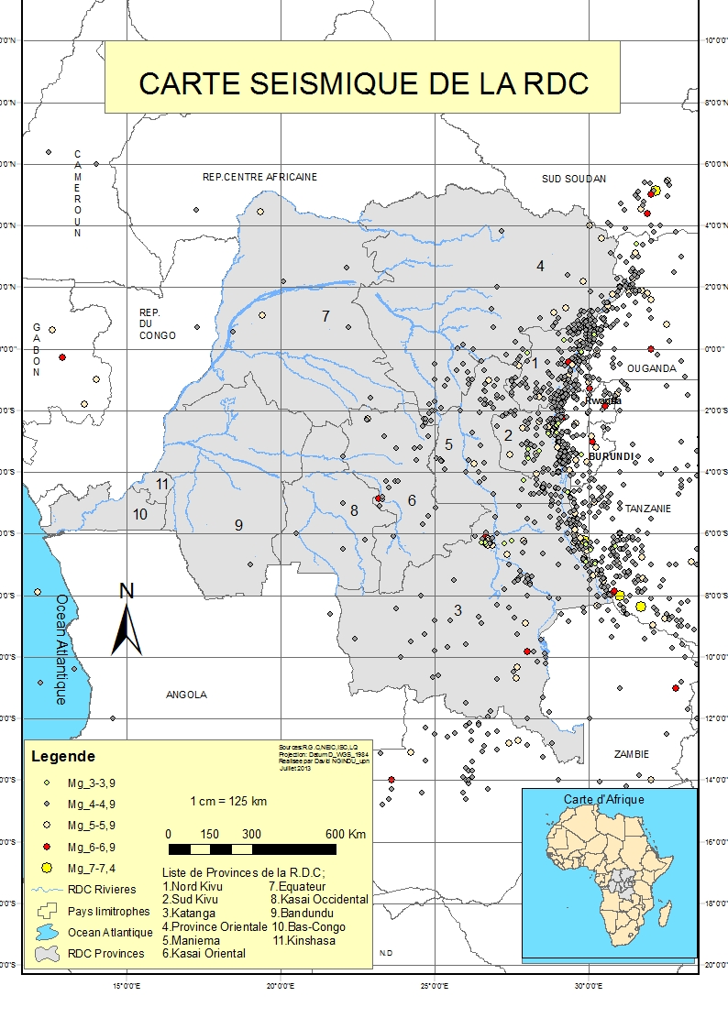

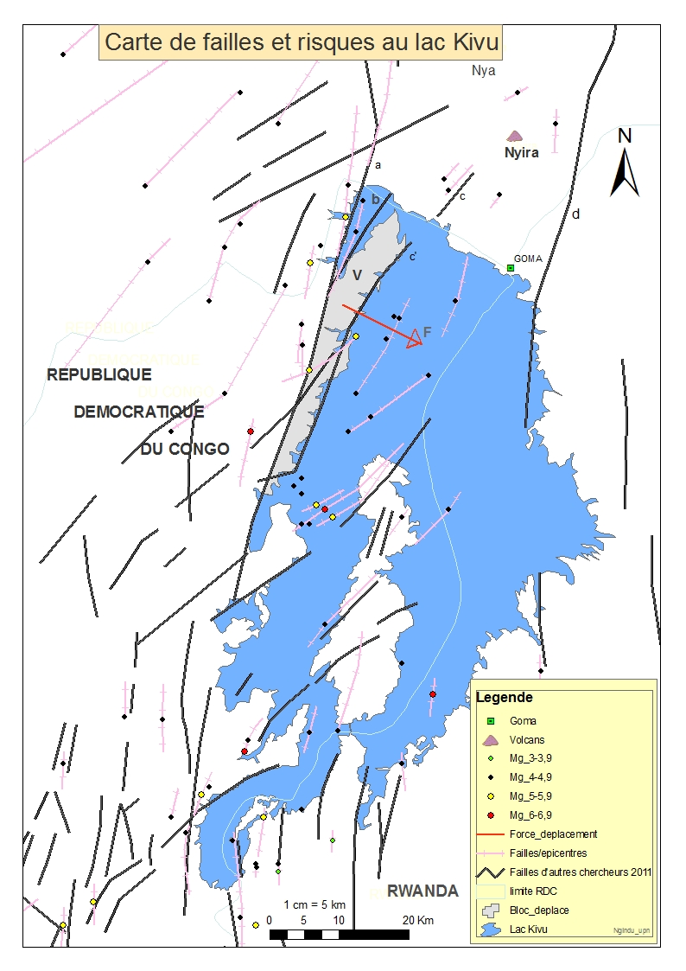

Session 4 Seismology, tectonic activity and volcano related seismology/Séismologie, activité tectonique et séismologie liée au volcanisme
Poster

Seismic Hazards Assessment of Cameroon

A. Ngongang Wetie(1), A. Kijko(2), N. Lanhardt(3).

(1) Department of Physics, University of Pretoria, South Africa
(2) Natural Hazard Centre, University of Pretoria, South Africa
(3) Department of Geology, University of Pretoria, South Africa

ABSTRACT/RÉSUMÉ
Seismological studies have shown that movement on fault and shear zones such as the Adamaoua fault, the Kribi-Campo fault, the Sanaga Fault and the Tcholliré-Banyo fault are responsible for the seismic activity in Cameroon. The majority of seismic activity throughout Cameroon, however, occurs along the 1600 km long Cameroon Volcanic Line (CVL), stretching from the islands of the Gulf of Guinea to Lake Chad on the African continent, and its most active centre the Mount Cameroon. The CVL is a line of volcanic centres, made up of an oceanic and a continental segment that has been active for at least 64 Ma and results from a passive rifting, i.e. mantle upwelling coupled with lithospheric extension. Previous studies show that Mount Cameroon, located on the continental margin mid-way along the CVL is the only current active volcano in Cameroon and has erupted 13 times in the past 200 years. These eruptions are associated with pre- and post-seismic activities.
The first seismic station established in Cameroon in February 1982 was used to show that the CVL is seismically active. The seismicity around Mount Cameroon is characterised by single and swarm events occurring at an average of two events every three days. Hypocentres of the earthquakes are distributed from the surface to 60 km depth (subcrustal activity) with magnitudes ranging between 2 and 3.
A new study was initiated in order to create a complete seismic catalogue and to present the seismic hazards of Cameroon. A probabilistic seismic hazard analysis associated with a frame of the geological setting of Cameroon is vital to understand why Mount Cameroon is the only active volcano along the CVL and will contribute in predicting future volcanic and seismic activities.

So far, the seismic data show that a great number of earthquakes occur along the CVL and that the highest seismic hazard area of Cameroon is the around the Mount Cameroon followed by the southern Cameroon region (Kribi). These observations correlate well with the tectonic and the volcanic setting of Cameroon.

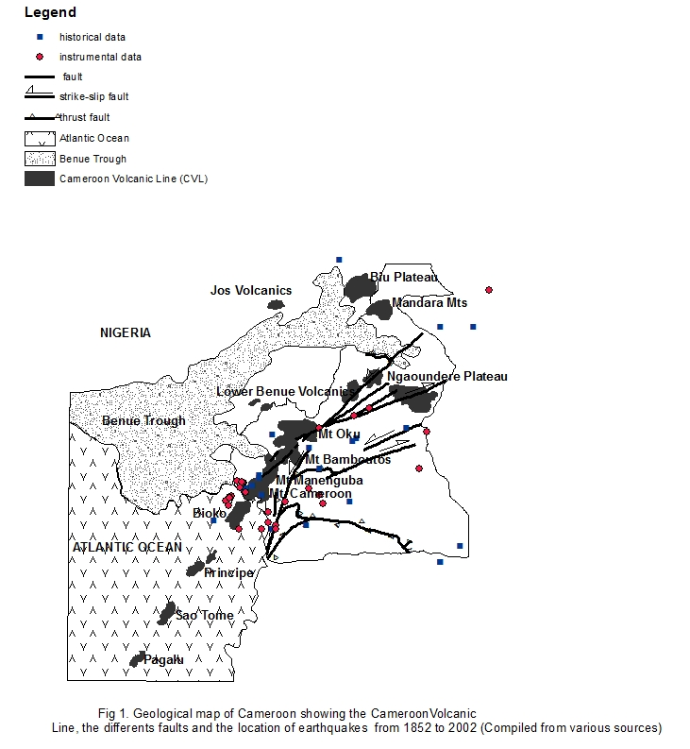
FIGURE 1: Geological map of Cameroon showing the location of the earthquakes.

Session 4 Seismology, tectonic activity and volcano related seismology/Séismologie, activité tectonique et séismologie liée au volcanisme
Poster

What are the hazards associated to a seismic sequence in the Kivu Rift Basin? The 2008 Bukavu/Cyangugu earthquake example.

N. d'Oreye(1)&(1'), P.J. Gonzalez(2), F. Kervyn(3), F. Lukaya(4), A. Oth(5), A. Shuler(6), B. Smets(7).

(1) Dept. Geophys./Astrophys., National Museum of Natural History, Luxembourg, ndo@ecgs.lu
(1') European Center for Geodynamics and Seismology, Luxembourg
(2) Department of Earth Sciences, University of Western Ontario,London, Ontario, Canada
(3) Earth Sciences Department, Royal Museum for Central Africa, Belgium
(4) Observatoire Volcanologique de Goma
(5) European Center for Geodynamics and Seismology, Luxembourg
(6) Department of Earth and Planetary Sciences, University of California Santa Cruz, USA
(7) European Center for Geodynamics and Seismology, Luxembourg

ABSTRACT/RÉSUMÉ
On February 3rd 2008, a seismic sequence started on the Southern shore of Lake Kivu with a Mw 5.9 Earthquake. It caused widespread damages and killed at least 39 people in the cities of Bukavu and Cyangugu along the border between DR of Congo and Rwanda. The main earthquake was followed by a large number of aftershocks among which three were of magnitude above 5 and nine were of magnitude above 3.7. It is the largest event ever recorded in the area after the mb 6.2 earthquake that occurred on October 24th 2002 at Kalehe, 35km South West of Goma and that killed two people.
The Bukavu/Cyangugu seismic episode took place in the South Kivu Volcanic Province, a seismically active transfer zone between the Kivu basin and the Rusizi basin.
This earthquake is of particular interest due to its shallow depth, its proximity to active volcanoes in the Virunga Volcanic province (located 100km to the North), and the Lake Kivu, which contains high concentrations of dissolved carbon dioxide and methane.

The possible similarity with dyking events recognized in other parts of East African Rift suggested the potential association of the earthquake with a magmatic intrusion, emphasizing the necessity of accurate source parameter determination.

In the absence of a local seismic network, studies using satellite Radar Interferometry (InSAR) and teleseismic waveforms allowed to accurately infer the source parameters. In particular, InSAR allowed locating the earthquake under the southern part of Lake Kivu and not along the Birava peninsula as previously inferred by other studies using global seismic database.

Geodetic and seismic modeling and inversions lead to highly consistent results. The focal mechanism, strike and dip are consistent with local tectonics. From this, we infer that the rupture was brittle and occurred with little aseismic deformation, discarding the hypothesis of magma involvement at least at shallow depth.

In the mature eastern branch of the EAR, magmatism is known to play a major role in lowering the seismicity during rift opening. Magma-assisted opening seems also to prevent the occurrence of large magnitude earthquakes in active volcanic provinces of the western branch of the EAR such as in the 12Myr old Virunga Volcanic Province. The mode of extension in the younger, yet extinct, South Kivu Volcanic Province is however poorly understood.
Our results provide insights into the style of rifting occurring in that part of the EAR and hence will aid future studies on seismic risk. It also highlights the possible inter-related hazards (earthquakes, triggered landslides, magmatism, the presence of dissolved carbon dioxide and methane in the Lake Kivu water…).
The occurrence of such a seismic sequence along political borders also highlights the importance of a trans-frontier collaboration and data sharing.

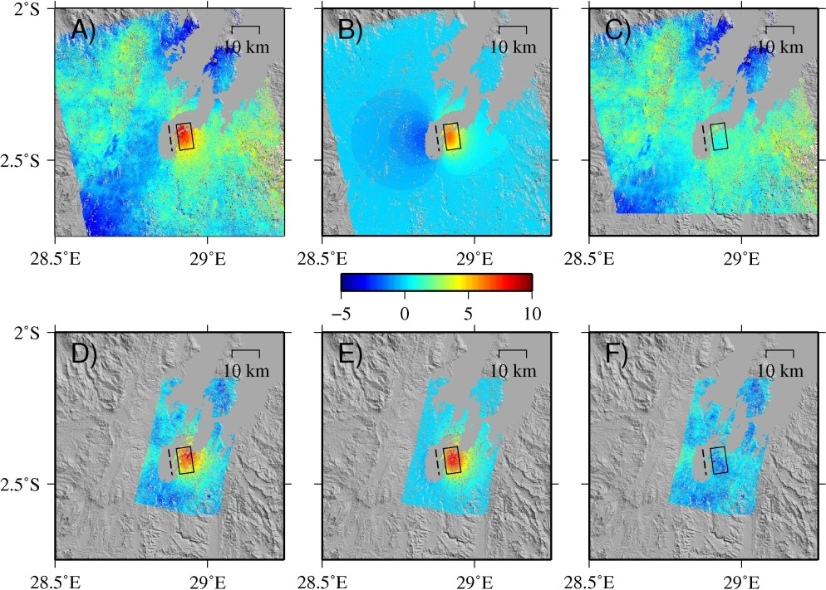
FIGURE 1: Coseismic ground deformation (range displacement – positive away from the satellite, in cm) and models for uniform slip inversion for the 2008 Bukavu-Cyangugu earthquake. A): Ascending track ALOS PALS

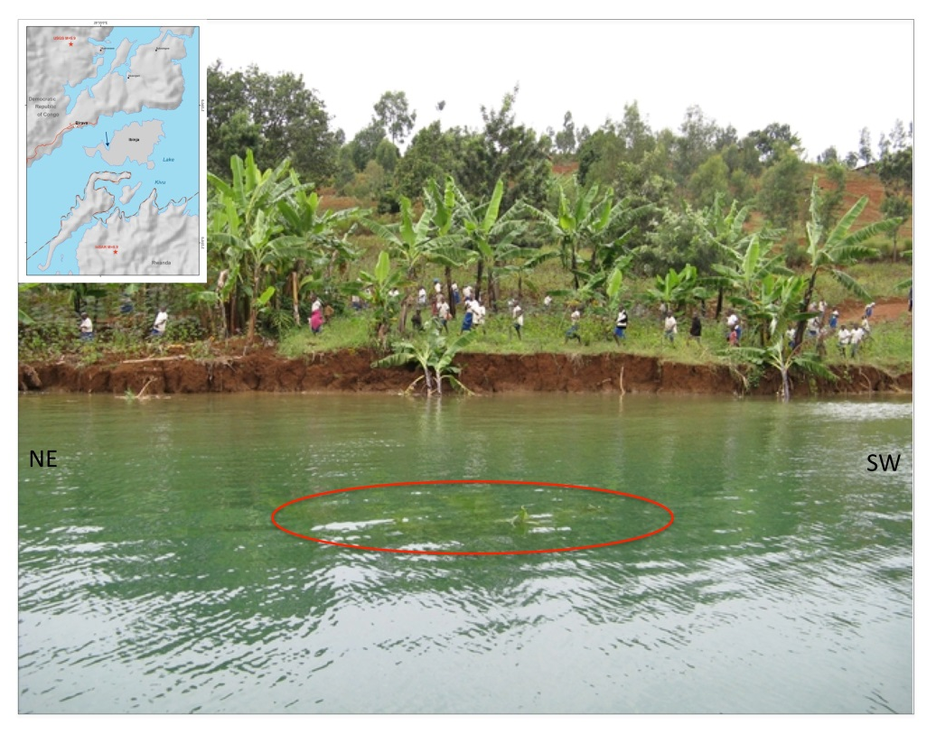
FIGURE 2: View of a landslide triggered by the Cyangugu-Bukavu earthquake on Ibinja Island (located by the arrow in the inset). The ellipse encircles the top of banana trees now underwater. Viewing directions a

Session 4 Seismology, tectonic activity and volcano related seismology/Séismologie, activité tectonique et séismologie liée au volcanisme
Poster

Tremors volcaniques associés à l’éruption du Nyamulagira du 6 Novembre 2011

E. Osodundu(1), M. Tuluka(2), M. Kyambikwa(3), D. Birimwiragi Namogo(4).

(1) Observatoire Volcanologique de Goma
(2) Observatoire Volcanologique de Goma
(3) Observatoire Volcanologique de Goma
(4) Observatoire Volcanologique de Goma

ABSTRACT/RÉSUMÉ
L'éruption du volcan Nyamulagira du 06 novembre 2011 avait commencé à 17h55 minutes TU dans son cratère et ensuite sur le flanc Sud Est, zone dans laquelle toute la grande activité s’y était concentrée pendant environ trois mois. Pendant la période pré-éruptive ,trois mois avant l'éruption, deux essaims de séismes volcaniques à longues et courtes périodes soutenus ont été enregistrés aux stations analogiques (sismomètre courte période 1 seconde) à LBG, BLG, RSY, KBB, respectivement le 30 septembre, le 04 et 05 novembre 2011. L'activité de tremors volcaniques associée à cette éruption dénote une particularité pour la station GOMA, située au Sud Sud-ouest du volcan Nyiragongo Fig.1 en annexe. Après l’analyse des tremors volcaniques de trois mois avant, pendant et après l’éruption des données obtenues à partir du réseau sismique numérique télémétré de l’OVG (stations équipées des A/D convertisseur 32bits, sismomètres Lennartz 5 secondes), il ressort:
La persistance de séquences de tremors longues périodes (comprises entre 10.5 et 6.5 secondes) à la station Goma, Les stations de BLG, KBB et RSY ont enregistrées des tremors des périodes basses par rapport à celle de Goma et sont situées entre 6, 4 et 1 secondes. Jusqu’ à ce jour il y a une persistance de séquences des tremors longues périodes au Mont Goma et nous laisse croire à la présence d’un phénomène particulier local proche de Goma et qui devra être élucidé. Il a été aussi noté une baise sensible des amplitudes de tremors au deuxième jour de l’éruption à BLG et RSY pendant que celles de KBB et GOMA étaient encore grandes fig.1 en annexe.
La distribution épicentrale des séismes volcaniques longues périodes allant de juillet à décembre 2011 a montré plus de concentration au sud Est du Nyamulagira et a coïncidé avec le lieu de l’éruption fig.2a. Les épicentres de séismes hautes fréquences ou séismes résultant de cassure ont été peu profonds et ont été alignés presque perpendiculaire à la fracture qui relie Nyamulagira et Nyiragongo fig.2b.
____________________________________________________________________________

KTL: katale LBG: Luboga BLG: Bulengo KNN: Kunene
RSY: Rusayo GOM: Goma KBT: Kibati KBB: Kibumba
BOBN: Bobandana ▲Station sismique

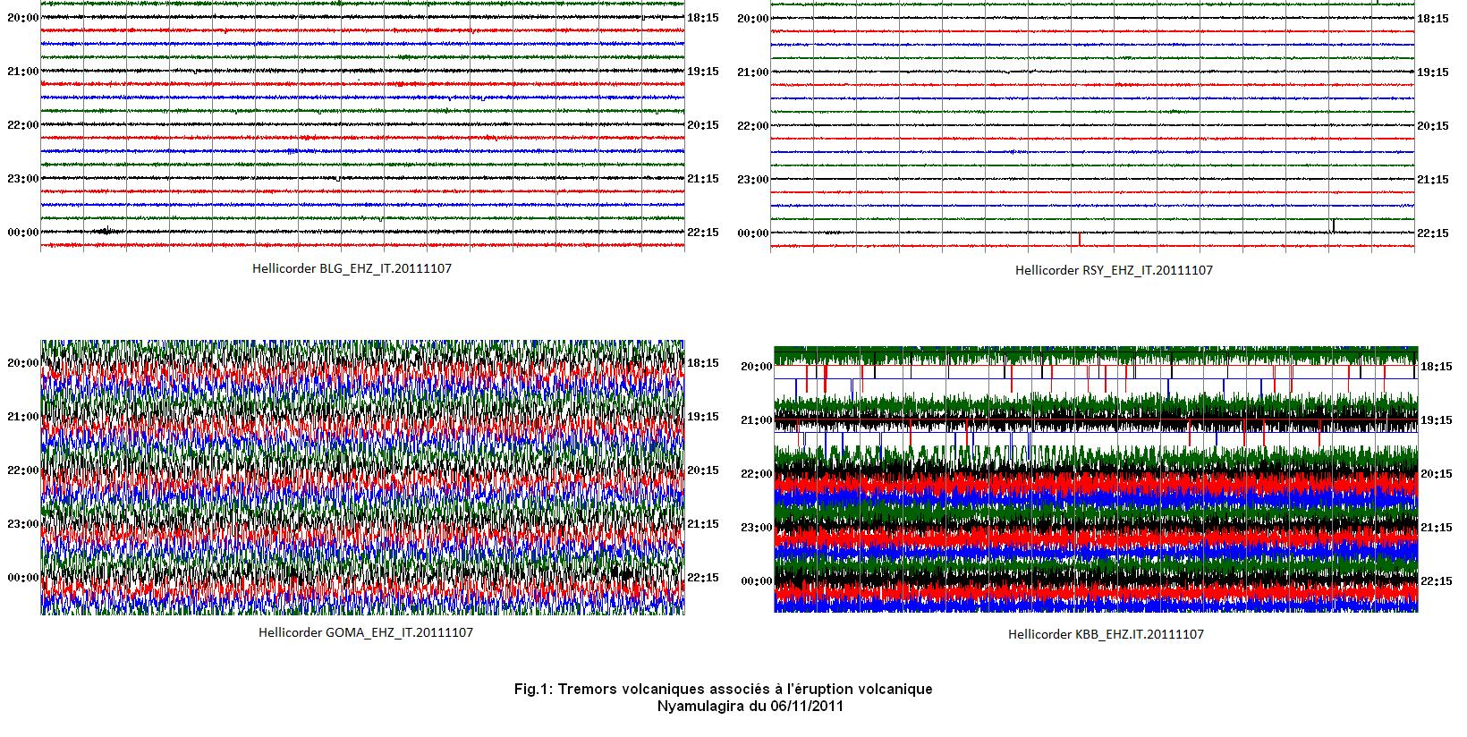
FIGURE 1: L'activité de tremors volcaniques associée à l'éruption Nyamulagira 2011

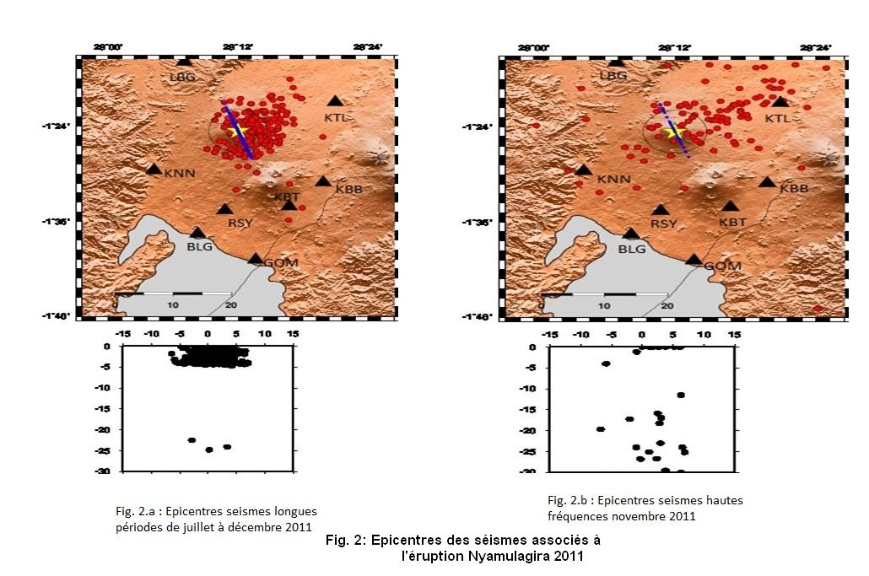
FIGURE 2: La distribution épicentrale des séismes volcaniques Nyamulagira 2011

Session 4 Seismology, tectonic activity and volcano related seismology/Séismologie, activité tectonique et séismologie liée au volcanisme
Poster

Active fault systems of the Kivu rift and Virunga province, and implications for geohazards

H. Zal(1), C. Ebinger(2), D. Wood(3), C. Scholz(4), N. d'Oreye(5), S. Carn(6), U. Rutagarama(7).

(1) University of Rochester
(2) University of Rochester
(3) Syracuse University
(4) Syracuse University
(5) National Museum of Natural History
(6) Michigan Technological University
(7) Energy Water and Sanitation Authority

ABSTRACT/RÉSUMÉ
The weakly magmatic Western rift system, East Africa, is marked by fault-bounded basins filled by freshwater lakes that record tectonic and climatic signals. One of the smallest of the African Great Lakes, Lake Kivu, represents a unique geohazard owing to the warm, saline bottom waters that are saturated in methane, as well as two of the most active volcanoes in Africa that effectively dam the northern end of the lake. Yet, the dynamics of the basin system and the role of magmatism were only loosely constrained prior to new field and laboratory studies in Rwanda. In this work, we curated, merged, and analyzed historical and digital data sets, including spectral analyses of merged Shuttle Radar Topography Mission topography and high resolution CHIRP bathymetry calibrated by previously mapped fault locations along the margins and beneath the lake. We quantitatively compare these fault maps with the time-space distribution of earthquakes located using data from a temporary array along the northern sector of Lake Kivu, as well as space-based geodetic data. During 2012, seismicity rates were highest beneath Nyiragongo volcano, where a range of low frequency (1-3 s peak frequency) to tectonic earthquakes were located. Swarms of low-frequency earthquakes correspond to periods of elevated gas emissions, as detected by Ozone Monitoring Instrument (OMI). Earthquake swarms also occur beneath Karisimbi and Nyamuragira volcanoes. A migrating swarm of earthquakes in May 2012 suggests a sill intrusion at the DR Congo-Rwanda border. We delineate two fault sets: SW-NE, and sub-N-S. Excluding the volcano-tectonic earthquakes, most of the earthquakes are located along subsurface projections of steep border faults, and intrabasinal faults calibrated by seismic reflection data. Small magnitude earthquakes also occur beneath the uplifted rift flanks. Time-space variations in seismicity patterns provide a baseline for hazard assessment, and guide future studies in the Kivu rift, and document the role of magmatism in rifting processes.

SESSION 5

Volcano monitoring (remote sensing, ground based techniques…)

Surveillance volcanologique (télédétection, techniques de surveillance au sol…)

Session 5 Volcano monitoring (remote sensing, ground based techniques…)/Surveillance volcanologique (télédétection, techniques de surveillance au sol…)
Talk / Oral

The importance of multidisciplinary volcano monitoring: insights from the Nyamulagira 2010 eruption (D.R. Congo)

N. d'Oreye(1)&(1'), B. Smets(2)&(2').

(1) Dept. Geophysics/Astrophysics, National Museum of Natural History, Luxembourg
(1') European Center for Geodynamics & Seismology, Luxembourg
(2) European Center for Geodynamics & Seismology, Luxembourg
(2') Vrije Universiteit Brussel, Belgium / Royal Museum for Central Africa, Belgium

ABSTRACT/RÉSUMÉ
Nyamulagira (or Nyamuragira) volcano, in Eastern D.R. Congo, is one of the most active volcanoes in Africa. This volcano is located in the Virunga National Park, in an inaccessible area currently controlled by rebels. Its study is consequently difficult and recurrent armed conflicts in this region prevent the continuous monitoring of its activity using ground-based techniques. Nyamulagira erupted from 2 to 27 January 2010, during a period of moderate insecurity. For the first time in the Virunga, a volcanic eruption was monitored in details using daily field surveys, as well as remote sensing and ground-based geophysical techniques. Based on field observations, eruptive phases were defined. Co-eruptive signals from ground deformation, seismicity, SO2 emission and thermal flux correlate with these eruptive phases. Clear unambiguous pre-eruptive ground deformations are observed about 3 weeks prior the lava outburst. Deformations coincide with small, though clear increase of the short period seismicity and possibly SO2 emission. These precursors contrast with the only precursory signal previously recognized in the Virunga region, namely the increase of tremors and long period seismicity, which were detected less than two hours before this eruptive event. The 2010 eruption of Nyamulagira illustrates that multidisciplinary monitoring, and consequently collaboration between different disciplines and scientific teams, allows the identification of weak signals and the detection of possible precursors that would have gone unnoticed otherwise.

The present contribution results from the fruitful collaboration with François KERVYN4, Matthieu KERVYN3, Fabien ALBINO4, Santiago R. ARELLANO5, Montfort BAGALWA6, Charles BALAGIZI6, Simon A. CARN7, Thomas H. DARRAH8,9, José FERNÁNDEZ10, Bo GALLE5, Pablo J. GONZALEZ11, Elisabet HEAD7, Katcho KARUME6, Deogratias KAVOTHA6, François LUKAYA6, Niche MASHAGIRO6, Georges MAVONGA6, Patrik NORMAN5, Etoy OSODUNDU6, José L.G. PALLERO12, Juan F. PRIETO12, Sergey SAMSONOV13, Muhindo SYAUSWA6, Dario TEDESCO14, Kristy TIAMPO11, Christelle WAUTHIER15 and Mathieu M. YALIRE6.

3 Dept., Geography, Vrije Universiteit Brussel, Brussels, Belgium
4 Dept. Earth Sciences, Royal Museum for Central Africa, Tervuren, Belgium
5 Department of Earth and Space Sciences, Chalmers University of Technology, Gothenburg, Sweden
6 Goma Volcano Observatory, Goma, D.R. Congo
7 Department of Geological and Mining Engineering and Sciences, Michigan Technological University, USA
8 Department of Earth and Environmental Sciences, University of Rochester, Rochester, NY 14627, U.S.A
9 Department of Environmental, Earth, and Ocean Sciences, University of Massachusetts Boston, Boston, U.S.A.
10 Instituto de Geociencias (CSIC-UCM), Ciudad Universitaria, Madrid, Spain
11 Department of Earth Sciences, University of Western Ontario,London, Ontario, Canada
12 ETSI en Topografía, Geodesia y Cartografía. Universidad Politécnica de Madrid, Madrid, Spain.
13 Canada Center for Remote Sensing, Natural Resources Canada, Ottawa, Canada
14 Department of Environmental Sciences, University of Naples 2, Caserta, Italy
15 Department of Terrestrial Magnetism, Carnegie Institution for Science, Washington, USA

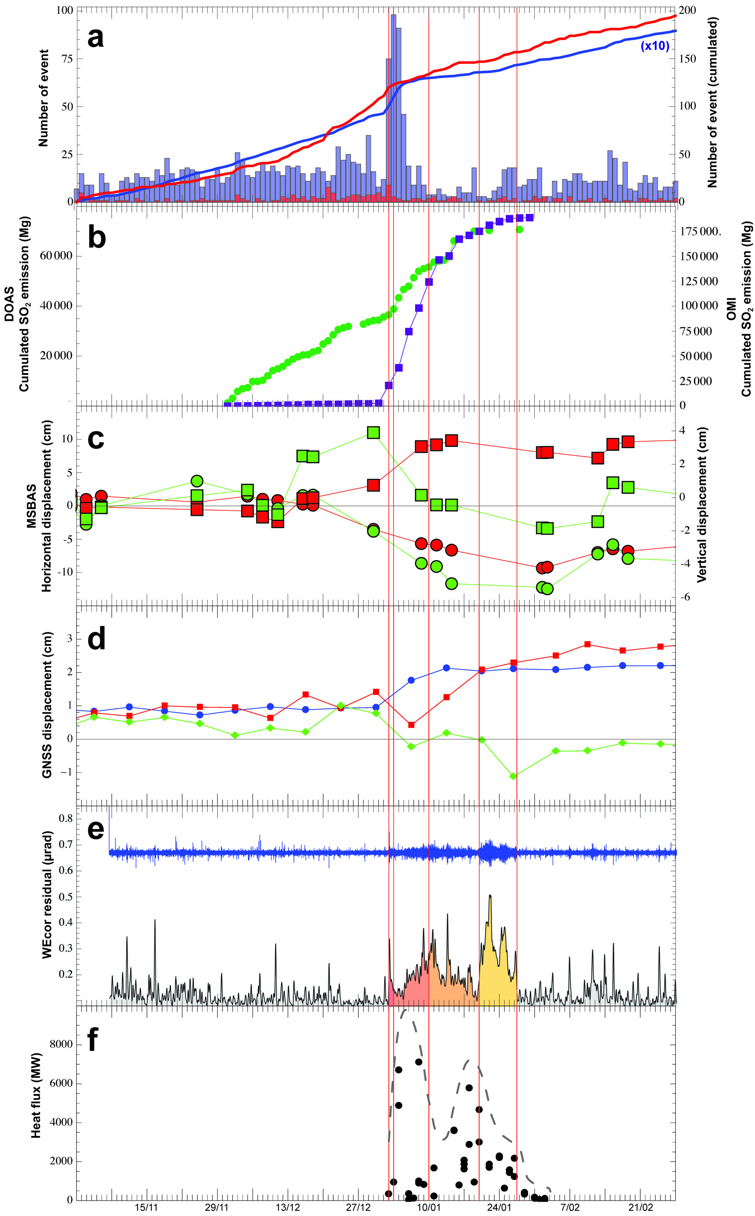
FIGURE 1: Figure 1: Time series of various parameters recorded from 1 November 2009 to 28 February 2010 with ground-based and space-borne monitoring techniques. Vertical orange lines mark the limits of eruptive

Session 5 Volcano monitoring (remote sensing, ground based techniques…)/Surveillance volcanologique (télédétection, techniques de surveillance au sol…)
Talk / Oral

Intensity, magnitude and impact of degassing activity of Nyiragongo volcano during 2004-2013

S. Arellano(1), B. Galle(2), M. Yalire(3), N. Bobrowski(4).

(1) Chalmers University of Technology
(2) Chalmers University of Technology
(3) Goma Volcano Observatory
(4) University of Heidelberg

ABSTRACT/RÉSUMÉ
The emission rate of SO2 from Nyiragongo volcano has been monitored since 2004 by a network of 4 ground-based scanning-DOAS instruments, now part of the Network for Observation of Volcanic and Atmospheric Change (NOVAC). We present an updated analysis of the collected data focused on the temporal evolution of degassing intensity, the frequency distribution of measured fluxes, the magnitude of emissions and their volcanological implications. Furthermore, we present results of the spatial distribution of the plume as a proxy of its impact in the surrounding area and discuss the relation of degassing with other geophysical manifestations of activity.

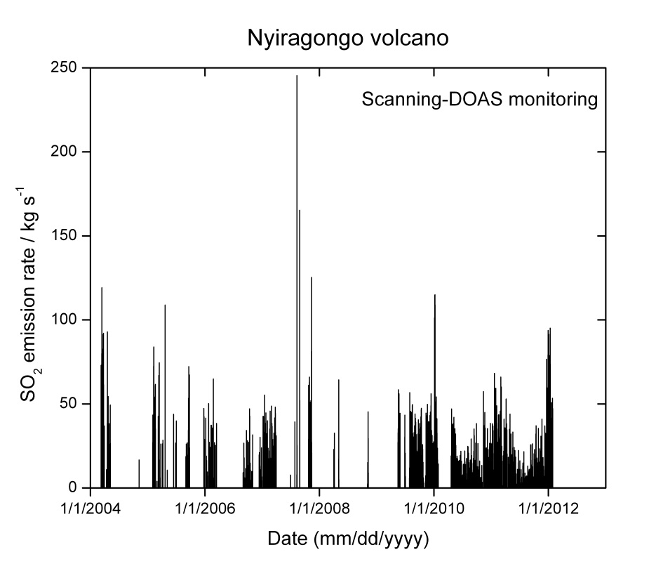
FIGURE 1: Time series of SO2 emission rate from Nyiragongo volcano obtained by ground-based scanning-DOAS monitoring

Session 5 Volcano monitoring (remote sensing, ground based techniques…)/Surveillance volcanologique (télédétection, techniques de surveillance au sol…)
Talk / Oral

How used Tandem-X Radar Interferometry to detect magma transport and quantify eruptive volumes: the example of 2011 Nyamulagira eruption (D.R. Congo)

F. Albino(1), F. Kervyn(2), B. Smets(3)&(3'), N. d'Oreye(4)&(4').

(1) Royal Museum for Central Africa
(2) Royal Museum for Central Africa
(3) European Center for Geodynamics and Seismology
(3') Royal Museum for Central Africa
(4) European Center for Geodynamics and Seismology
(4') National Museum of Natural History

ABSTRACT/RÉSUMÉ
Nyiragongo and Nyamulagira (D.R. Congo) are two very active volcanoes in Central Africa.
Nyiragongo has the largest active lava lake around the world, it had produced two eruptions in historical times in 1977 and then 2002. Both eruptions produced lava flows which reached the city of Goma and caused injury and infrastructure damage. Nyamulagira have an eruption every 2-4 years during this last decade (2001, 2002, 2004, 2006, 2010 and 2011). The last one started November 6, 2011 and stopped few months later in April 2012. The entire event have produced a large lava flow and three scoria cones, in an area located 20 km East from the summit crater.
We study this exceptional effusive eruption through Digital Elevation Model analysis and ground deformation studies. A DEM times series of one year was performed from bi-static interferometry using Tandem-X data -delivered by the German Spatial Agency (DLR) through the Belspo project Vi-X-. From DEM difference, thickness of eruptive products and then the total volume of the eruption is derived. A value of 0.30 km3 is found for the 2011-2012 eruptive volume.
It is a large number in comparison with the last eruptions, which produce an amount of lava in a range of 0.04-0.15 km3. Ground deformation signal associated to the eruption was detected from differential interferometry. We have been focussed in the Goma area where a 20 km width subsidence of few cm occurred during the time period of the eruption. This deformation is probably the consequence at surface of the withdrawal of a large magma chamber.
First modelling shows that a 2-3 km spherical chamber situated 20 km depth can fit the data.
This large and deep source can provide an first explanation on why the 2011-2012 eruption was such voluminous. From this 2011-2012 eruption, update informations are provided on the effusive activity at Nyamulagira volcano:
(1) large voluminous eruption can occur at Nyamulagira even after a short repose time.
(2) effusive eruptions are not only related to small shallow reservoirs or sub-surface vertical intrusions, but its origin could be a large deep storage zone located at the junction between the two active volcanoes.

Session 5 Volcano monitoring (remote sensing, ground based techniques…)/Surveillance volcanologique (télédétection, techniques de surveillance au sol…)
Talk / Oral

The Nyiragongo hazard: Is the literature misleading?

B. Smets(1)&(1'), N. d'Oreye(2)&(2'), F. Kervyn(3).

(1) European Center for Geodynamics & Seismology, Luxembourg
(1') Vrije Universiteit Brussel, Belgium / Royal Museum for Central Africa, Belgium
(2) European Center for Geodynamics & Seismology, Luxembourg
(2') National Museum of Natural History, Luxembourg
(3) Royal Museum for Central Africa, Belgium

ABSTRACT/RÉSUMÉ
Nyiragongo volcano, in Eastern Congo, close to the border with Rwanda, is an active volcano, which is well known for its permanent active lava lake, currently the largest on Earth. But Nyiragongo is also known for the threat it represents in this highly populated area. Paradoxically, this threat is not well constrained, as this volcano is poorly studied. Several scientific articles and reports were published after the only two known flank eruptions in 1977 and 2002. However, the information provided is sometimes contradictory or based on debatable hypotheses. This situation does not allow a clear and unambiguous overview of the Nyiragongo eruptive activity and the related hazards. In this presentation, we give insights into the eruptive history of Nyiragongo through a large literature review, including articles, reports and field notes from the colonial period, which are archived at the Royal Museum for Central Africa (Belgium). Available – and sometimes contradictory – information and observations are analysed and compared. When possible, the most correct information is identified. This analysis summarizes information that in turn can be used as reference and will help better assess the real impact of Nyiragongo eruptions. Finally, we also hope that the present work will help reduce the accidental dissemination of inaccurate, unverified and/or exaggerated facts, as it was sometimes the case in the past.

Session 5 Volcano monitoring (remote sensing, ground based techniques…)/Surveillance volcanologique (télédétection, techniques de surveillance au sol…)
Talk / Oral

Etude de la stratigraphie des dépôts volcaniques du Mont Goma (R.D.C.) et ses implications pour l'aléa phréatomagmatique à Goma

A. Fikiri(1), S. Poppe(2), M. Bagalwa(3), M. Kervyn(4).

(1) Observatoire Volcanologique de Goma
(2) Department of Geography,Earth system science,Vrije universiteit Brussel
(3) Observatoire Volcanologique de Goma
(4) Department of Geography,Earth system science,Vrije universiteit Brussel

ABSTRACT/RÉSUMÉ
Le Mont Goma,situé au sein du champs volcanique du Nyiragongo, se dresse au coeur de la ville de Goma, en bordure du Lac Kivu, Le port de Goma s'abrite au sein du cratère égueulé du Mont Goma.

Nous rapportons ici les résultats d'une étude morphologique et stratigraphique des dépôts pyroclastiques du Mont Goma. La morphologie sub-aérienne du cône suggère l'existence d'au mois trois,possiblement quatre cratères (voir figure). Deux d'entr'eux sont actuellement de petites dépressions en bordures du port. Le plus grand cratère est submergé et est actuellement occupé par le port.

Les dépôts pyroclastiques reposent sur des coulées de laves anciennes visibles dans la partie occidentale du port. Les dépôts pyroclastiques sont dans l'ensemble riches en cendre et lapilli fin et montrent des faciès d'induration et de palagonization varié dans l'espace. Un contact bien marqué sépare des dépôts de hyalotuff fortement indurés et palagonitizé,caracterisé par un degré variable de bombes volcaniques,et un dépôt de cendre et de lapilli fin peu induré de couleur semble.Des laminations fines,par endroit déformés par l'impact de bombes,et des laminations croisées à certains niveau du dépôt démontre que le dépôt s'est formé dans des conditions humides et suggère un caractère phréatomagmatique de l'éruption.

Il n'existe pas de datation de l'activité du Mont Goma,mais le contraste dans le degré d'induration suggère qu'au moins deux phases éruptives ,séparées dans le temps ,ont contribué à l'édification de ce cône.Il découle également de la nature du dépôt que le Mont Goma s'est formé après que le Lac Kivu aie atteint son niveau actuel ou un niveau supérieur.

Les dépôts du Mont Goma se retrouve recouvert par des laves récentes au délà de la base morphologique actuelle de l'édifice. Ceci implique que le Mont Goma est de plus grande taille sous les laves et que ce type d'éruption a un impact sur une étendue de quelques kilomètres de rayon autour du point éruptif. La possibilité de déferlante basale lors d'éruption phréatomagmatioque représente un aléa majeur dans le cas où une nouvelle éruption devrait se produire au niveau ou aux alentours du Mont Goma. La possibilité d'un tel scénario reste à ce jour indeterminée.

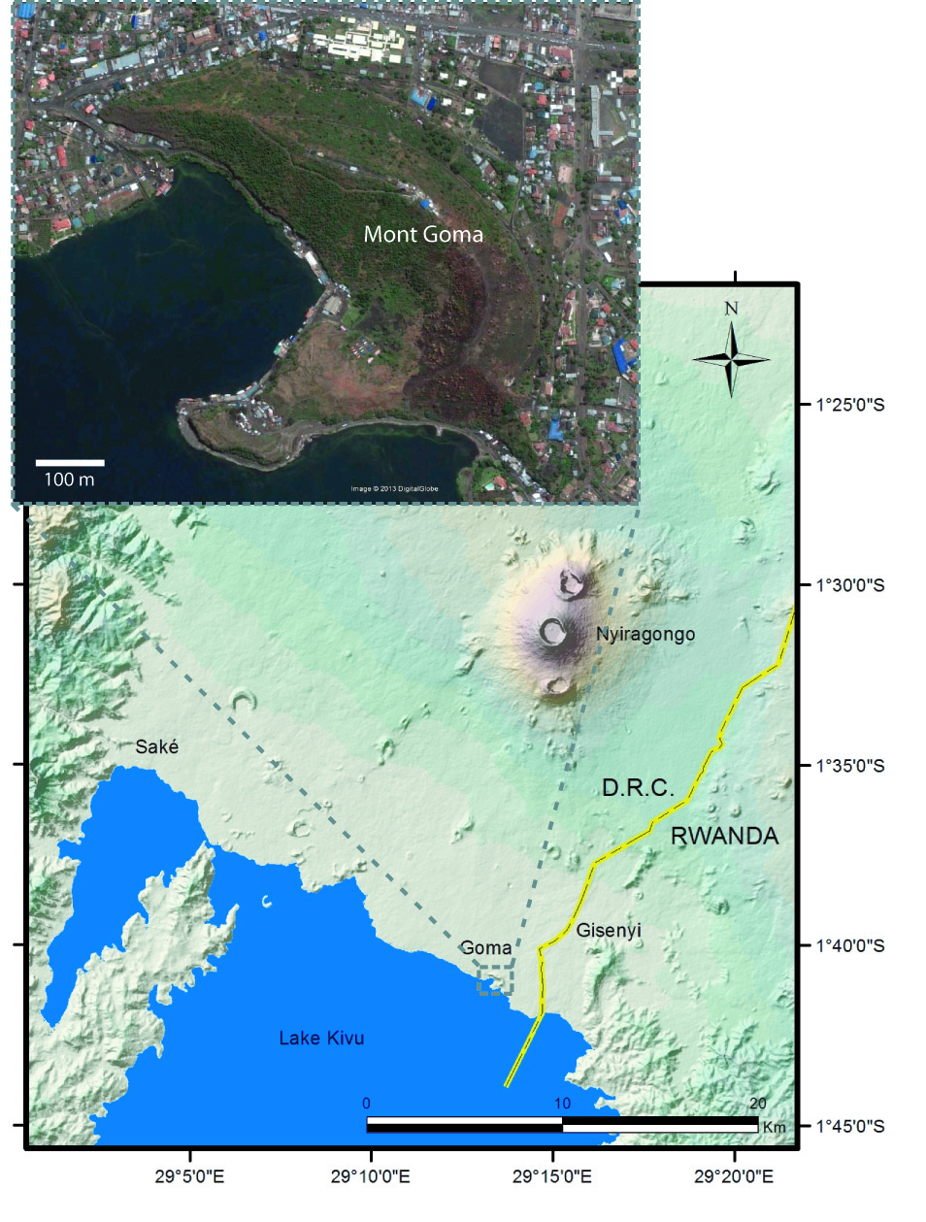
FIGURE 1: Fig:Le cône de Mont Goma,image zoomée du Google Earth et acquise en 2010

Session 5 Volcano monitoring (remote sensing, ground based techniques…)/Surveillance volcanologique (télédétection, techniques de surveillance au sol…)
Talk / Oral

Calibration of a GIS-based combined thermo-rheological and probabilistic lava flow model for Nyamulagira volcano

M. Kervyn(1), A. Feltz(2)&(2'), B. Smets(3)&(3'), S. Moussoux(4), S. Poppe(5).

(1) Vrije Universiteit Brussel
(2) Vrije Universiteit Brussel
(2') Université catholique de Louvain
(3) European Center for Geodynamics and Seismology
(3') Vrije Universiteit Brussel
(4) Vrije Universiteit Brussel
(5) Vrije Universiteit Brussel

ABSTRACT/RÉSUMÉ
Lava flows represent one of the main volcanic hazards on Earth. Although rarely threatening human lives, they are associated with significant damages to human infrastructures and ecosystems. As they emplace over hours to days after eruption onset, rapid simulation of lava propagation is of uttermost importance for effective hazard evaluation and real-time risk management.
Here we present a GIS toolbox that aims at simulating the spatial propagation of lava flows. The model combines an advanced probabilistic approach based on the VORIS model (Felpeto et al., 2001) and a thermo-rheological constraint for the lava flow length based on the FLOWGO model (Harris et al., 2001).
The GIS toolbox is coded in Python and runs in ArcGIS, but is compatible to other GIS platforms. It simulates the propagation of lava flows from a point or linear source selected interactively on a Digital Elevation Model. Multiple flow paths are simulated iteratively, allowing the lava to flow downward, with a probability inversely proportional to the height difference between the source and the surrounding pixels. The lava is allowed to overcome topographic obstacles of contrasted heights where the lava is flowing on a slope or accumulating in a depression.
The length of the simulation can be defined as a fixed value, as a probability density function based on a Gaussian distribution, or it can be controlled by the initial eruption rate and the thermo-rheological parameters controlling the cooling of an open-channel lava flow. The main inputs of this model version are the eruption rate, the channel geometry, the lava viscosity and the phenocryst content.
This toolbox is here tested and parameterized for 4 different lava flows (1980, 1986, 2004, 2006) of Nyamulagira volcano, using a quality parameter. Nyamulagira volcano is one of the most active volcanoes in Africa, with lava-dominated eruptions every 2 to 4 years. Sensitivity analyses are carried out on the 90 m SRTM DEM. Simulation results are stable for 5000 iterations or more. The initial VORIS model simulated complicated flow paths, leading to shorter effective flows than the input length. This issue is overcome by reducing the capacity of flow to overcome obstacles on sloping ground and by attributing a higher probability to the steepest descent paths. The thermo-rheological calibration of flow lengths proved successful in simulating different lava flows with a single set of input parameters. The date of acquisition of the DEM and its sensitivity to vegetation cover are shown to control most of the errors in the simulated lava flows.
The toolbox offers the advantage to be coded in a freeware and can therefore be adapted to the need of the user. It can run with decimal values and adapts to DEMs of different spatial resolution. The parameterization for Nyamulagira lava flows demonstrates that it can be used in near-real time for simulation of future lava flows, once the localization of the eruption is known. This toolbox will also be calibrated and tested in the near future to simulate lava flow hazards from Nyiragongo volcano threatening Goma city.

REFERENCES
Felpeto et al. (2001), Assessment and modelling of lava flow hazard on Lanzarote (Canary islands), Nat. Hazards, 23, 247-257.
Harris and Rowland (2001), FLOWGO: a kinematic thermo-rheological model for lava flowing in a channel, Bull. Volcanol., 63, 20-44.

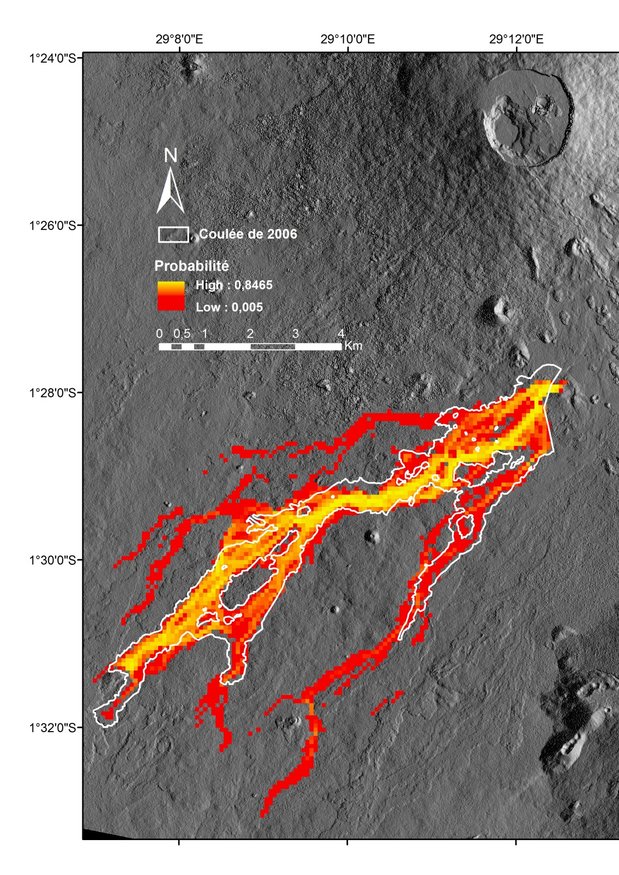
FIGURE 1: Simulation of the 2006 Nyamulagira lava flow using the new probabilistic approach and a probability density function for the length. The white line gives the real lava flow boundary.

Session 5 Volcano monitoring (remote sensing, ground based techniques…)/Surveillance volcanologique (télédétection, techniques de surveillance au sol…)
Talk / Oral

Geological constraints of volcanic hazard assessment

J. Marti(1).

(1) Institute of Earth Sciences Jaume Almera, CSIC, Barcelona, Spain

ABSTRACT/RÉSUMÉ
Volcanic hazard is defined as the probability of any particular area being affected by a destructive volcanic event within a given period of time. Volcanic hazard is usually assessed in the form of event tree structures containing possible eruptive scenarios and probability methods are applied to these structures to estimate the long-term and short-term probability for each scenario. Consequently, long-term forecasting is based on historical and geological data and simulation models, while short-term forecasting is complemented with continuous monitoring data when an unrest episode has started. The complexity of any volcanic system and its associated eruptive processes, together with the lack of data that characterise many active volcanoes, particularly those with long recurrences, make volcanic hazard quantification very challenging, as there is often not enough observational data to build a robust statistical model. A detailed knowledge of the past eruptive record (i.e. volcanic stratigraphy), the internal structure of the volcanic system, and of its tectonic controls, is fundamental to the establish a reliable basis on which to built the hazard assessment structure, to determine the time constraints of the volcanic processes, and to correctly interpret volcanic unrest and precursory signals of future eruptive events.
One of the first questions that should be answered when assessing volcanic hazard is where the future vent(s) will be located (i.e.: volcanic susceptibility). The appearance of a new vent depends on the path that magma will follow from the source (reservoir, chamber, dyke, ….) to the surface. Magma will follow the easiest path to reach the surface (i.e. the path in which the energy investment will be the minimum), but we do not have direct criteria to determine this path a priori. However, there are several direct and indirect sources of data that can provide information on this issue. Field structural data, including in situ stress field measurements (usually measured in boreholes), location of emission centres, and structural alignments (fractures, faults, cone alignments and dykes), constitute the main direct data that we can obtain. Indirect data can be obtained from theoretical 3D stress field models and structural geophysical data (gravimetric, magnetic, seismic tomography, …). Therefore, geology is fundamental to address this problem, both by obtaining the direct structural data and by helping to interpret the indirect geophysical data.
In central, polygenetic volcanism (e.g.: stratovolcanoes) dyke propagation and its subsequent eruption is controlled in a first instance by the magma chamber overpressure, and in a second instance by gravity forces (topography) and tectonic stresses in the host rock. However, in monogenetic volcanism, which is characterised by the absence of a shallow magma chamber, each eruption has a different vent, suggesting that volcanic susceptibility has a high degree of randomness.
Knowing the location of future vents is crucial to determine the extend and potential impact of volcanic hazards. In the same way, the identification of the past eruptive episodes is necessary to infer the different possible outcomes (i.e.: eruptive scenarios) that may exist for future eruptions.
To illustrate how important is geology in volcanic hazard assessment we present two different examples of active volcanic areas, one corresponding to a central volcanic complex (Teide volcano, Tenerife, Canary Islands), and the other corresponding to a monogenetic volcanic zone (La Garrotxa Volcanic Field), and compare the main geological features that characterise both volcanic systems and determine their relevance in terms of hazard assessment.

Session 5 Volcano monitoring (remote sensing, ground based techniques…)/Surveillance volcanologique (télédétection, techniques de surveillance au sol…)
Talk / Oral

QVAST: a new Quantum GIS plugin for estimating volcanic susceptibility

S. Bartolini(1), A. Cappello(2), J. Marti(3), C. Del Negro(4), R. Sobradelo(5).

(1) Group of volcanology, (SIMGEO-UB) CSIC, Institute of Earth Sciences ”Jaume Almera”, Barcelona, Spain
(2) Istituto Nazionale di Geofisica e Vulcanologia, Sezione di Catania, Osservatorio Etneo, Catania, Italy
(3) Group of volcanology, (SIMGEO-UB) CSIC, Institute of Earth Sciences ”Jaume Almera”, Barcelona, Spain
(4) Istituto Nazionale di Geofisica e Vulcanologia, Sezione di Catania, Osservatorio Etneo, Catania, Italy
(5) Group of volcanology, (SIMGEO-UB) CSIC, Institute of Earth Sciences ”Jaume Almera”, Barcelona, Spain

ABSTRACT/RÉSUMÉ
One of the most important tasks of modern volcanology is the construction of hazard maps simulating different eruptive scenarios that can be used in risk-based decision-making in land-use planning and emergency management. The first step in the quantitative assessment of volcanic hazards is the development of susceptibility maps, i.e. the spatial probability of a future vent opening given the past eruptive activity of a volcano. This challenging issue is generally tackled using probabilistic methods that use the calculation of a kernel function at each data location to estimate probability density functions (PDFs). The smoothness and the modeling ability of the kernel function are controlled by the smoothing parameter, also known as the bandwidth. Here we present a new tool, QVAST, part of the open-source Geographic Information System Quantum GIS, that is designed to create user-friendly quantitative assessments of volcanic susceptibility. QVAST allows to select an appropriate method for evaluating the bandwidth for the kernel function on the basis of the input parameters and the shapefile geometry, and can also evaluate the PDF with the Gaussian kernel. When different input datasets are available for the area, the total susceptibility map is obtained by assigning different weights to each of the PDFs, which are then combined via a weighted summation and modeled in a non-homogeneous Poisson process. The potential of QVAST, developed in a free and user-friendly environment, is here shown through its application in the volcanic fields of Lanzarote (Canary Islands) and La Garrotxa (NE Spain).

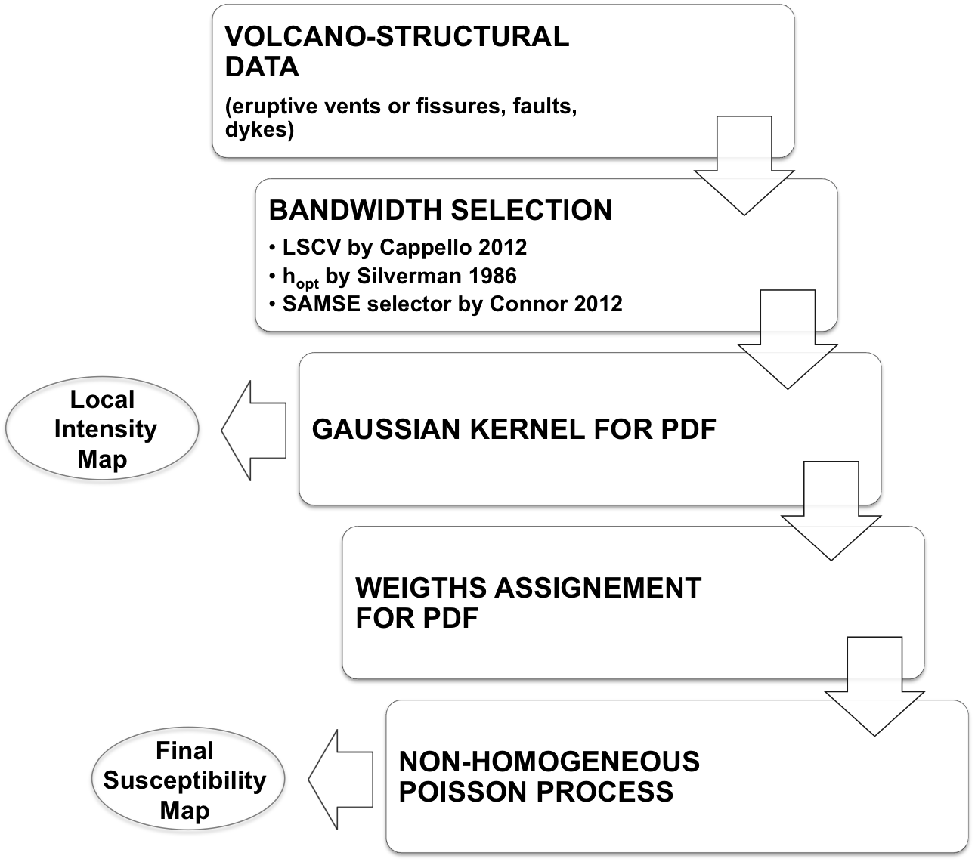
FIGURE 1: Flow chart showing the main steps available in QVAST

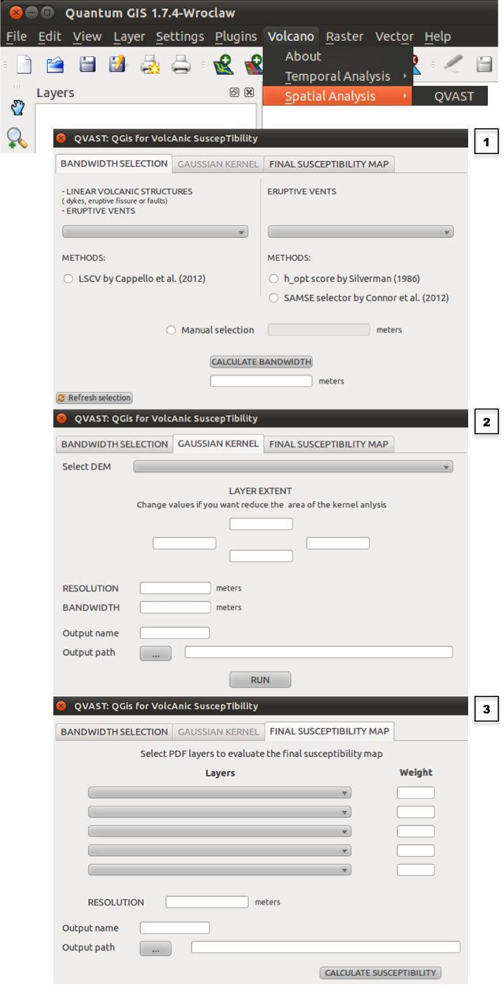
FIGURE 2: QVAST main interface: screenshots for the optimal bandwidth selection (1), for the parameter needed by the Gaussian kernel (2) and for the assignment of weights to the different PDFs (3)

Session 5 Volcano monitoring (remote sensing, ground based techniques…)/Surveillance volcanologique (télédétection, techniques de surveillance au sol…)
Talk / Oral

HASSET: A probability event tree tool to evaluate future volcanic scenarios using Bayesian inference. Presented as a plugin for QGIS

R. Sobradelo(1), S. Bartolini(2), J. Marti(3).

(1) Institute of Earth Sciences Jaume Almera (CSIC-Barcelona)
(2) Institute of Earth Sciences Jaume Almera (CSIC-Barcelona)
(3) Institute of Earth Sciences Jaume Almera (CSIC-Barcelona)

ABSTRACT/RÉSUMÉ
Event tree structures constitute one of the most useful and necessary tools of modern volcanology to assess the volcanic hazard of future volcanic scenarios. They are particularly relevant to evaluate long- and short-term probabilities of occurrence of possible volcanic scenarios and their potential impacts on urbanized areas. Here we introduce HASSET, a Hazard Assessment Event Tree probability tool, built on an event tree structure that uses Bayesian inference to estimate the probability of occurrence of a future volcanic scenario, and to evaluate the most relevant sources of uncertainty from the corresponding volcanic system. HASSET includes hazard assessment of non-eruptive and non-magmatic volcanic scenarios, that is, episodes of unrest that do not evolve into volcanic eruption but have an associated volcanic hazard (eg. sector collapse and phreatic explosion), as well as those with external triggers as primary sources of unrest (as opposed to magmatic unrest alone). Additionally, HASSET introduces the Delta method to assess how precise the probability estimates are, by reporting a one standard deviation variability interval around the expected value for each scenario. HASSET is presented as a free software package in the form of a plugin for the open source geographic information system Quantum Gis (QGIS), providing a graphically supported computation of the event tree structure in an interactive and user-friendly way.

Session 5 Volcano monitoring (remote sensing, ground based techniques…)/Surveillance volcanologique (télédétection, techniques de surveillance au sol…)
Poster

The magmatic system beneath Torfajökull volcano, Iceland: Combining radar and seismic interferometric observations

J. Martins(1), A. Hooper(2), D. Draganov(3), E. Ruigrok(4), B. White(5), R. Hanssen(6).

(1) Delft University of Technology
(2) University of Leeds
(3) Delft University of Technology
(4) Delft University of Technology
(5) Cambridge
(6) Delft University of Technology

ABSTRACT/RÉSUMÉ
Torfajökull has a unique location among Icelandic volcanoes; it is settled in the intersection of the rift zone and the transform zone that connects to Reykjanes ridge. Despite its proximity to one of the most active volcanoes in Iceland (Hekla), Torfajökull erupts infrequently, with only two eruptions in the last 1200 years, the latest of which was over 5 centuries ago. However, ongoing seismicity, deformation and geothermal activity indicate the continued presence of a long-lasting magma chamber. Although historical eruptions have been relatively small, the large caldera (18x12 km diameter) and high geothermal activity within the caldera is evidence of a massive eruption in the past, and the potential for a further eruption of similar size is unknown.

Using radar interferometry (InSAR) time series we analyse the area covering Torfajökull volcano. In addition to displacements related to the tectonic spreading of the area, we detect a pattern of subsidence in the SW region of Torfajökull´s caldera, on-going since at least 1993, at rates of up to ~13 mm yr-1. The data can be fit reasonably well using a model of a NE-SW oriented spheroidal body at ~5 km depth, undergoing a pressure decrease that is uniform in space and time. One potential interpretation for this deformation is therefore that it is due to the presence of a cooling magma chamber.

More insight into the geometry and rock properties can be gained using seismic interferometry (SI); cross-correlation of natural signals can be used to generate seismic records that simulate active sources, allowing tomographic analysis.

For the SI processing we use seismic data acquired during 2005 at 30 stations sparsely distributed around the Torfajökull area. We divide the ambient noise recorded at two stations in portions of 1h, cross-correlate the corresponding portions and then sum the correlated results. The result is a retrieved surface-wave part of the Green’s function between the two stations. This is repeated between all pairs of stations. Dispersion curves are derived based on the cross-correlation results. The retrieved dispersion curves between pairs of stations are then used in tomographic inversion for the derivation of the 3D S-wave velocity distribution in the subsurface.

Here we explore how we use both observations to better constrain the geometry and depth of the deflating pressure source.

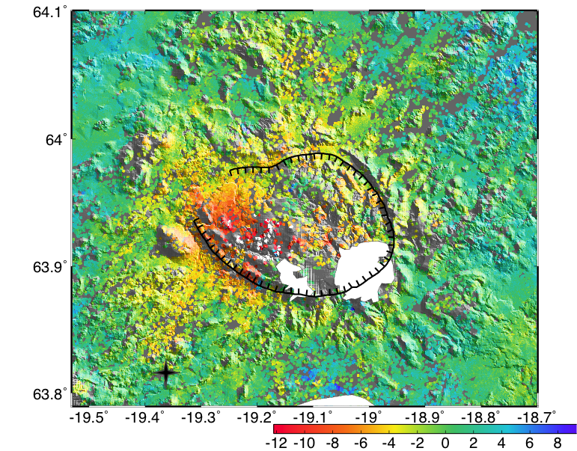
FIGURE 1: Mean LOS (line-of-sight) velocity rates in mm/year around Torfajökull's area.

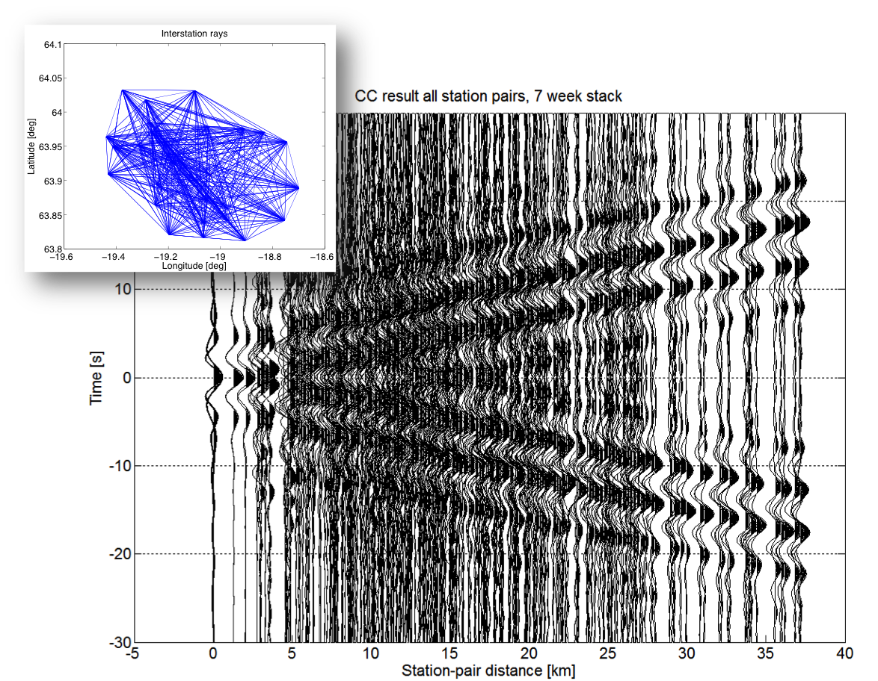
FIGURE 2: Cross-correlation results of station pairs, stack over 7 weeks (Green's functions)

Session 5 Volcano monitoring (remote sensing, ground based techniques…)/Surveillance volcanologique (télédétection, techniques de surveillance au sol…)
Poster

The time discrepancy between the effective eruption and rock failure for the eruptions of Nyamulagira and Nyiragongo volcanoes in the Virunga region

D. Mifundu Wafula(1)&(1'), H. Hiroyuki(2), U. Sadato(3), F. Bondo(4).

(1) Université Kinshasa
(1') CRSN/ Lwiro
(2) University of Tohoku, Japan
(3) University of Tohoku, Japan
(4) Département de Géophysique CRSN/ Lwiro

ABSTRACT/RÉSUMÉ
The method of prediction of the volcanic eruptions based on the fundamental law for failing materials as introduced by Voight, has been used in the present work to determine the time discrepancy between the eruption (te) and the failure (tf) as illustrated by the equation te - tf = f(t). This method has been applied for some eruptions of Nyamulagira and Nyiragongo volcanoes. On the basis of the comparison between the M – T plot and the inverse of strain release rate plot vs time, we have found that the time of the occurrence of events with maximum magnitude of the seismic swarm associated directly to the eruption corresponded to the time of failure (tf) has been noticed, for the eruption of September 20th, 1991, that (te - tf ) = f(t) = 5 days. For the eruptions of Nyamulagira on November 27th, 2006 and on November 6th, 2011, it has been found for f(t) the values of 13 hours and 26 hours, respectively. We have obtained for the catastrophe eruption of Nyiragongo on January 17th, 2002, for f(t) the value of 7 min. The very low value of f(t) obtained for the Nyiragongo eruption is probably due to the type of the eruption which consists mainly to the disappearance of the lava lake in the crater. The time discrepancy observed means that the volcanic process to the eruption is often completed a while before the venting of the eruption products. It is observed that different swarms associated to the eruptions of the two volcanoes are characterized mostly by the A-type and B-type volcanic earthquakes. The main pattern observed on the M – T plot for the eruption of Nyamulagira in 1991 is similar to that observed at Uzen volcano (Japan) in December, 1993, and April, 1994, although the two volcanoes are of different eruptive nature.

Session 5 Volcano monitoring (remote sensing, ground based techniques…)/Surveillance volcanologique (télédétection, techniques de surveillance au sol…)
Poster

Reconstructing past eruptions at Mount Cameroon volcano (West-Central Africa) using Remote Sensing and GIS techniques: case of the 2000 eruption

M. Nechia Wantim(1), S. Ayonghe(2), M. Kervyn(3), G. Ernst(4), P. Jacobs(5), E. Suh(6).

(1) University de Buea
(2) University de Buea
(3) Vrije Universiteit Brussel
(4) Ghent University
(5) Ghent University
(6) University de Buea

ABSTRACT/RÉSUMÉ
Mount Cameroon (MC) is the largest (~ 4095 m a.s.l. high, 35×55 km across at its base, with a volume of ~1,400 km3) and the most active (erupted 7 times in the last century) of the continental volcanoes found along the Cameroon Volcanic Line (CVL; Fig. 1). The CVL is a major tectonic feature that extends for more than 2000 km, from Pagalu Island into West-Central Africa (Fig. 1). The remote locations of most of MC eruptions, the rugged nature of the terrain, and the complex overlapping pattern of successive flows makes it difficult to systematically follow eruptions. The 2000 fissure eruption (last recorded eruption) has been subjected to a lot of controversies pertaining to the number of eruption sites, the number/type of cones produced, the number of lava flow fields built and the duration of the eruption. Thanks to the increasing availability of low cost/free remote sensing (RS) imagery from internet sites such as the Global Land Cover Facility, MODIS, etc, we were able to answer some of the questions raised concerning this flow. The 2000 eruption was successfully reconstructed 10 years after its emplacement with the aid of a Landsat ETM+ image acquired four days after the onset of the eruption. Additional information was obtained from MODVOLC, an online ASTER image and field observations obtained during the eruption.
Mapping results showed that the 2000 eruption lasted for close to two months (28th May-20th July 2000) and not three weeks as initially stated. This eruption began on the 28th of May, ~ 150 m from the summit of the volcano and emplaced four different lava flow fields at three different sites: S1 ( 3928 m a.s.l.), S2 (3484-3300 m a.s.l.) and S3 (~ 2750 m a.s.l.; Fig. 2). Two lava flow fields were produced at site 2 (2A and 2B; Fig. 2). Even though this eruption started with explosive activity at site 1, lava flow emplacement (~ 850 m long) at this site only took place in the last week of the eruption (Fig. 2). The initial explosive phase at site 1 halted after building an ~ 200 m high cone that hosted a lava lake which upon breaching released the lava. Eruptions began on the 29th of May at site 2 and extended for over a month building a total of 27 spatter mounds along four fissure/fault segments covering a distance of ~ 2 km. RS analysis of the Landsat image showed that the site 2A flow (~ 6.5 km) was fed mostly by the lowest part of the eruptive fissure, the rest of the hornitos producing a much less extended flow field (Fig. 2). Eruptions at site 3 were effusive in nature, spanning the period from ~ 30th May-20th June 2000 that produced an ~ 1.5 km long flow. Lava at site 3 issued directly from fissures and hornitos (Fig. 2). The position of the different eruptive sites points to the fact that the feeding dyke separated into several, non-aligned segments when approaching the surface.

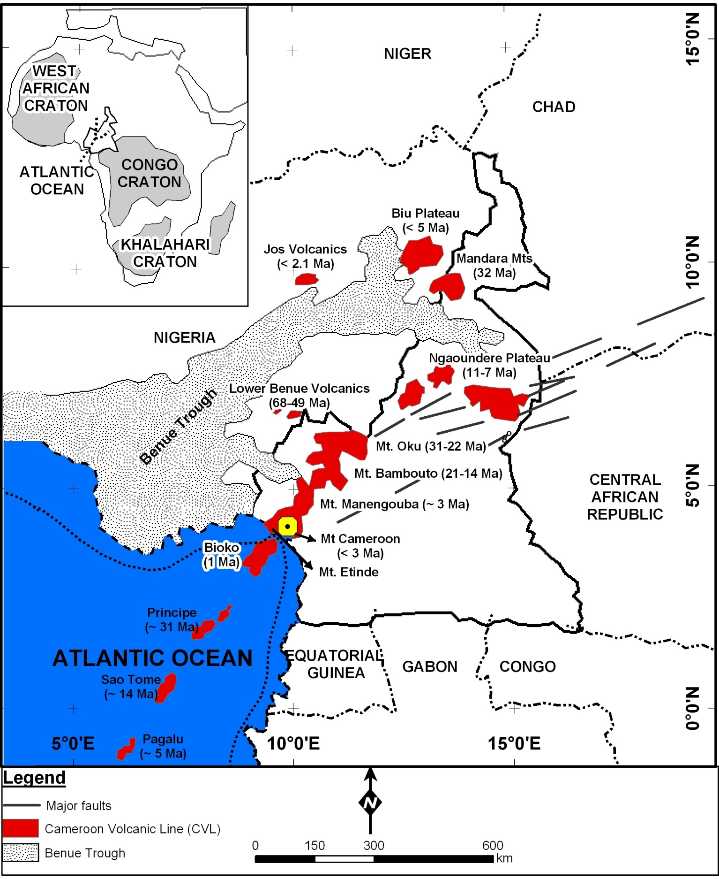
FIGURE 1: Fig. 1. Sketch map of Cameroon showing Mount Cameroon (MC) and the Cameroon Volcanic Line (CVL). Inset the CVL and Cameroon within the African Continent.

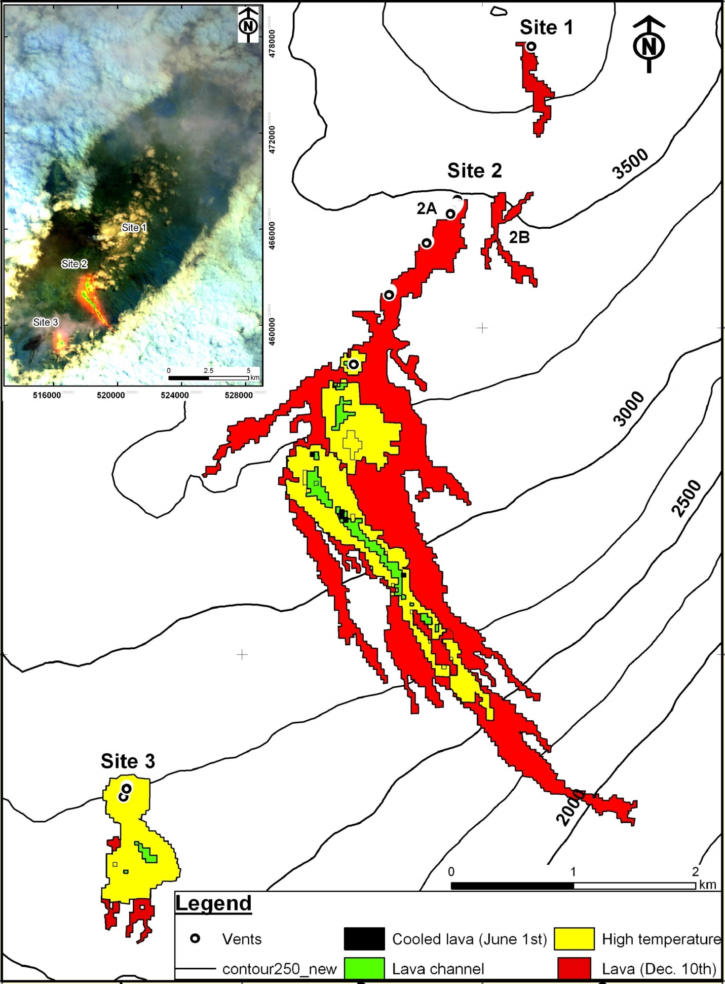
FIGURE 2: Fig. 2. Map of the 2000 lava flow fields showing pixels of the active flow (black, green and yellow) superimposed on the cooled lava flow (red). Inset false colour composite of bands 754.

Session 5 Volcano monitoring (remote sensing, ground based techniques…)/Surveillance volcanologique (télédétection, techniques de surveillance au sol…)
Poster

A permanent geodetic GNSS network to monitor ground deformation in the Virunga Volcanic province.

N. d'Oreye(1), A.G. Arjona(2), M. Bagalwa(3), F. Kervyn(4), N. Mashagiro(5), J.L.G. Pallero(6), J. Prieto(7), M. Syauswa(8).

(1) Dept. Geophys./Astrophys., National Museum of Natural History, Luxembourg, ndo@ecgs.lu
(2) European Center for Geodynamics and Seismology, Luxembourg
(3) Observatoire Volcanologique de Goma
(4) Earth Sciences Department, Royal Museum for Central Africa, Belgium
(5) Observatoire Volcanologique de Goma
(6) ETSI en Topografía, Geodesia y Cartografía. Universidad Politécnica de Madrid, Spain
(7) ETSI en Topografía, Geodesia y Cartografía. Universidad Politécnica de Madrid, Spain
(8) Observatoire Volcanologique de Goma

ABSTRACT/RÉSUMÉ
In 2009 the National Museum of Natural History of Luxembourg (NMNH) started the installation of a permanent geodetic Global Navigation Satellite System (GNSS) network for ground deformation monitoring in the North Kivu basin.

The network is composed of 8 GNSS stations tracking both GPS and GLONASS signals. They are located in Goma (OVG), Kibati (KBT), Kibumba (KBB), Rusayo (RSY), Bulengo (BLG), Tshubi (TSI), Bobandana (BOB) and Rubavu (RBV).
A 9th station lent by the University of Rochester was installed in Rumangabo (RGB) on May 2012. That station, as well as 5 others, was however dismounted shortly after for security reason when the war resumed in that region.

Each permanent GNSS station is equipped with a Leica GMX 902 GG or GR10 receiver and a Leica AX1202 or AS10 antenna fixed on a 2.5 m high geodetic concrete monument. These stations track both GPS and GLONASS satellites. Signals, sampled at 15 seconds, are radioed in real-time to the Goma Volcano Observatory (GVO). When direct line of sight between stations and GVO is not possible, no more than one repeater relays the signal. Only BOB and RGB are not radioed. Raw data are stored and pre-processed at the GVO, and automatically transmitted by Internet to NMNH in Luxembourg. The preliminary estimation of the baseline vectors is calculated in real-time at the GVO.

For data processing, we use only one reference station (NURK, installed 100 km to the East in Kigali, Rwanda), as other available references either suffer from data interruptions during the studied time period, have no official coordinates assigned and are not used in the IGS weekly solutions, or are located more than 1,000 km away from the study area. GNSS data are processed with the Bernese 5.0 software. Three types of processing are carried out:
1) Daily processing using Precise Point Positioning (PPP) in order to obtain good approximate coordinates for the network stations.
2) Daily network solutions considering reference station NURK as fixed.
3) Weekly (in terms of GPS week) network solutions by combination of the daily solutions. These computations are carried out in order to minimise the noise in the daily solutions. The repeatability of the coordinates in each weekly adjustment is of the order of 5-10 mm in each coordinate (east, north, up).
Data processing is performed both at NMNH and GVO.

Although the data suffered from various interruptions due to lightning damages or temporary dismounting for security reasons, these data successfully recorded e.g. ground deformations associated to the recent eruptions at Nyamulagira in 2010 and 2011/12.

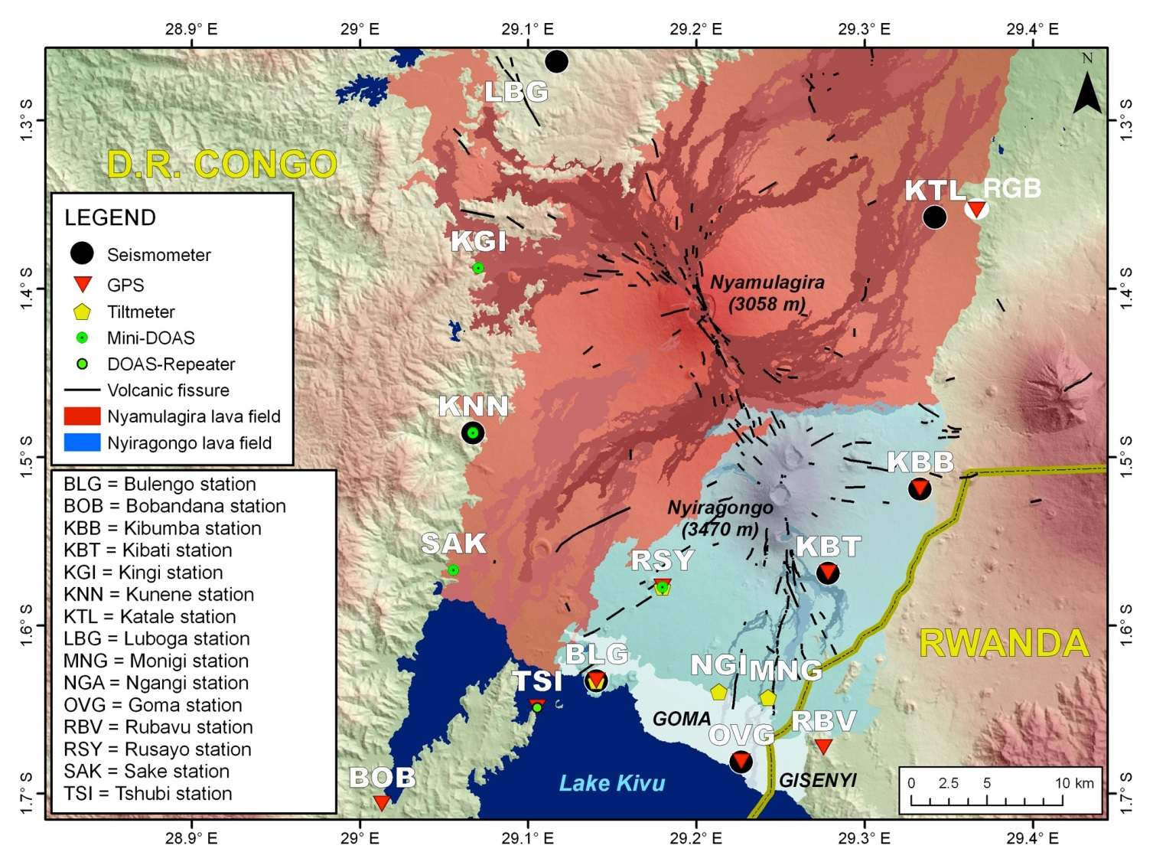
FIGURE 1: Location of the GVO monitoring networks. Permanent GNSS stations are marked with red triangles.

Session 5 Volcano monitoring (remote sensing, ground based techniques…)/Surveillance volcanologique (télédétection, techniques de surveillance au sol…)
Poster

Hazard implications of phreatomagmatism along the urbanised Lake Kivu Northern shoreline, D.R.Congo

S. Poppe(1), M. Rukeza(2), A. Fikiri(3), B. Smets(4)&(4'), M. Kervyn(5).

(1) Department of Geography, Earth System Science, Vrije Universiteit Brussel
(2) Observatoire Volcanologique de Goma (OVG)
(3) Observatoire Volcanologique de Goma (OVG)
(4) European Center for Geodynamics and Seismology (ECGS)
(4') Department of Geography, Earth System Science, Vrije Universiteit Brussel
(5) Department of Geography, Earth System Science, Vrije Universiteit Brussel

ABSTRACT/RÉSUMÉ
The Virunga Volcanic Province (VVP) is a transfer zone within the Eastern branch of the East-African rift, and hosts eight central volcanoes. The recently active Westernmost Nyamulagira volcano has erupted lava flows with a recurrence rate of ~2 years. The neighbouring Nyiragongo volcano hosts an active crater lava lake, drained in 2002 into a fissure and lava flow invading the city of Goma to the South, a densely populated area with ~one million inhabitants at present.
Many satellite volcanic cones are scattered within the lava fields of Nyamulagira and Nyiragongo, with multiple large cones distinctly present along the Lake Kivu Northern shoreline (Figure 1). We studied the stratigraphy of the best exposed cones in the field to support the volcanic hazard assessment of explosive eruptions in the Goma-Saké urban area.
Mont Goma cone is a dissected, asymmetric edifice constructed around at least three eruptive craters (Figure 1.A). A well-defined contact between consolidated hyalotuff and above-lying ash-and-lapilli tuff suggests distinct eruptive episodes, with an undefined time lag in between. Indicators of wet syn-depositional conditions and the occurrence of base surge deposits, testify the phreatomagmatic nature of the complex eruptive history.
Lac Vert (Figure 1.B), ~11 km to the North-East of Goma, is a maar crater with an ejecta rim of chaotic lithic breccia, overlain by bedded lithic breccia and finally by black laminated ash-and-lapilli tuff with minor cross-bedding. The sequence mirrors an eruptive evolution from phreatic excavation of volcanic country rock with the occurrence of base surge events and a final phase of magmatic activity with minor influence of external water.
To the South-East of Lac Vert at least six other tuff cones occupy the Lake Kivu shoreline (Figure 1.C), and are made up of massif to bedded hyalotuffs, with additional ash-and-lapilli tuffs. Within the same area, we identified at least two post-cone-building eruptive episodes, which formed freshy-looking, vesicular spatter cones and small-volume lava flows. These eruptions were associated with the opening of fissures in the surrounding cones.
Overall, a marked progression exists from phreatomagmatic tuff cones and small maar volcanoes close to the lake shoreline, to magmatic spatter-and-scoria cones at few kilometers away from the lake. These satellite cones are all concentrated within well-defined alignments related to the Nyiragongo and Nyamuragira rift zones, and concur spatially with the so-called ‘mazukus’ – gas emissions - and sublacustrine volcanic vent structures on the Lake Kivu floor. Based on the variations of the Lake Kivu level as assembled from the literature, at least 11 phreatomagmatic tuff cones and maar craters, identified along the actual Lake Kivu shoreline, were constructed during separate eruptions in the past 15,000 years.
Bedding structures in cone deposits suggest the occurrence of base surge events, with a plausible devastating impact on the area surrounding the eruptive vents. Due to the dense urbanization surrounding all observed phreatomagmatic deposits, the intermediary explosive nature of such eruptive events is a key element in the volcanic risk assessment of the Saké-Goma-Gisenyi urban area.

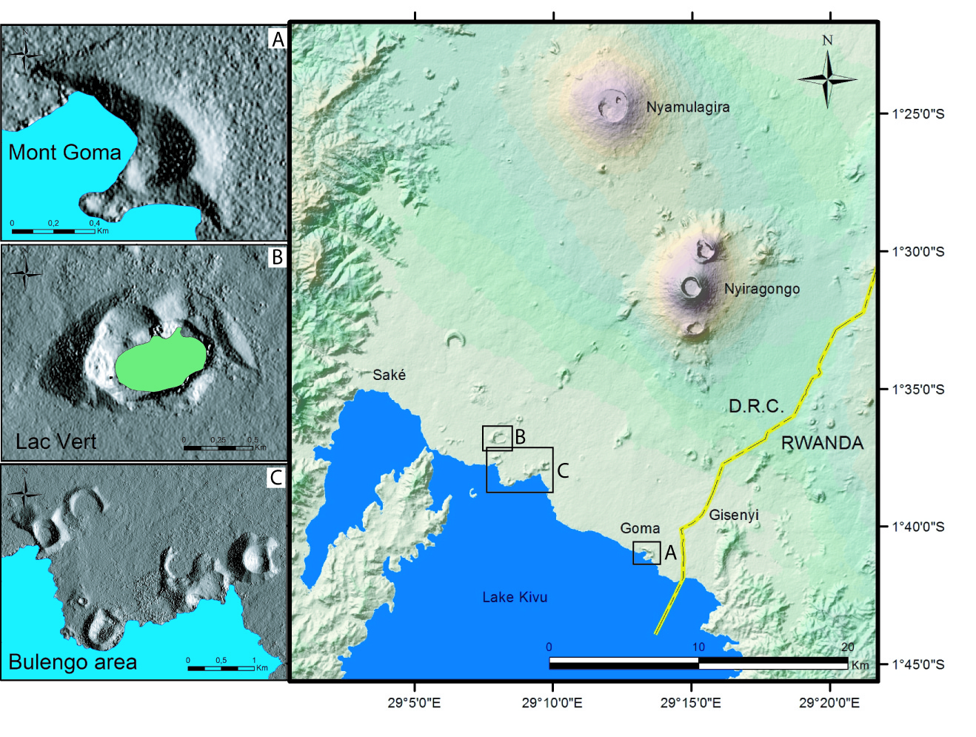
FIGURE 1: Figure 1: The Lake Kivu Northern shoreline with Nyiragongo and Nyamulagira volcanoes and hillshade DEM images of A. Mont Goma cone; B. Lac Vert maar; and C. the Bulengo area (6 tuff cones).

Session 5 Volcano monitoring (remote sensing, ground based techniques…)/Surveillance volcanologique (télédétection, techniques de surveillance au sol…)
Poster

Development of a stereographic time-lapse camera system to study and monitor the lava lake activity at Nyiragongo volcano (North Kivu, D.R. Congo)

B. Smets(1)&(1'), N. d'Oreye(2)&(2'), F. Kervyn(3).

(1) European Center for Geodynamics & Seismology, Luxembourg
(1') Vrije Universiteit Brussel, Belgium / Royal Museum for Central Africa, Belgium
(2) European Center for Geodynamics & Seismology, Luxembourg
(2') National Museum of Natural History, Luxembourg
(3) Royal Museum for Central Africa, Belgium

ABSTRACT/RÉSUMÉ
The semi-permanent active lava lake of Nyiragongo volcano (North Kivu, D.R. Congo) is the largest on Earth, with a diameter of about 200 m. This lava lake was drained during the two known historical flank eruptions in 1977 and 2002, feeding fast and disastrous lava flows. Since the discovery of the volcano by Europeans in 1894 and the first observation of the lava lake few decades later, the levels of the lava lake and the surrounding platforms in the main crater of Nyiragongo were roughly assessed during punctual visual observations from the top of the volcano. However, such observations are scarce and the access to the volcano has been limited by the recurrent unrests and civil wars that occurred in this region, especially during the last two decades. In addition, short-term (i.e. few minutes to few days) variations of the lava lake level were sometimes observed. These variations cannot be recorded by punctual observations.

We present here the development of an innovative technique, based on close-range photogrammetry, to study the Nyiragongo main crater and its lava lake. A stereo time-lapse camera (STLC) system has been developed and will allow the repeated 3D modelling of the lower part of the main crater. The main objective is to accurately estimate volume and surface level changes linked to the lava lake activity. The specificity of the system is presented. First tests were performed on a reduced model of the Nyiragongo main crater, in order to assess the resolution and accuracy that we can expect on the volcano. Coupled with the monitoring of other physical and geochemical parameters, such as temperature, gas, seismicity and ground deformation, and complemented by forthcoming field surveys, the system could provide scientists with high-resolution measurements to assess the main volcanic activity of Nyiragongo.

SESSION 6

Risk, vulnerability and society issues

Risques, vulnérabilité et sociétés

Session 6 Risk, vulnerability and society issues/Risques, vulnérabilité et sociétés
Talk / Oral

How to understand and to reduce hazard-centered risk prevention policies limitations?

P. Pigeon(1).

(1) Université de Savoie

ABSTRACT/RÉSUMÉ
The proposal aims at contributing to the issues the last part of the call raises: “There is today a growing awareness and attention on the interrelationships between geohazards issues and the societal challenges. AVCOR will contribute to determine how all these parameters need to be combined for supporting a global approach for an integrated development at a sub-continental scale”.

Our proposal will display how corrective works such as dikes transform hazards and vulnerability factors. Hazard-centered risk prevention policies using corrective works contribute to reduce hazard frequencies (such as floods, lahars, landslides, snowslides…) on the areas they intend to protect. Yet, they also favour human settlement intensification on such areas and, without willing it, they contribute to prepare future disasters . This is mainly why new policies question the absolute relevance of “protective“ works, and why these new policies are so much challenged today, especially by landowners. Such is the case in France with the so-called “dike risk” (Pigeon, 2013). But the 2010 Merapi volcanic eruption experience return (Picquout, 2013) proves, among other, that similar trends could be found elsewhere, in spite of hazards or cultural discrepancies.

Therefore, what could help us describing more in depth the paradoxical role hazard corrective works play? And how such understanding could contribute to disaster prevention?

Indeed, some tools and notions help understanding and representing this general trend towards unwanted preparation of disasters. Such is the case with Farmer’s curve, which belongs to power laws (Pigeon 2013), and resilience (Gunderson and Holling, 2002; Cummings, 2011; Lopez and Pigeon, 2011).

The outcome will draw attention on the necessity not to consider hazards and vulnerability as totally independent factors, but as risk parameters belonging to evolving systems. Representing local systems trends helps understanding corrective works limitations.

Practically, the main issue would be to increase the social acceptance of corrective measures limitations, and, therefore, the necessity to live with the impossibility to get rid of risk (but with the possibility to reduce event frequencies and damage intensities of future events). It helps understanding why disaster prevention needs to imply local societies in decision-making process, and this from the beginning up.

REFERENCES
Cumming, G.S. 2011. Spatial resilience in social-ecological systems. Dordrecht, Springer.
Gunderson L.H., Holling C.S. 2002. Panarchy. Understanding transformations in human and natural systems. Island Press, Washington.
Lopez, J and Pigeon, P. 2011. Co-evolution between structural mitigation measures and urbanization in France and Colombia: a comparative analysis of disaster risk management policies based on disaster databases. Habitat international, 35(4): 573-581.
Picquout, A. 2013. Impacts géographiques de l’éruption de 2010 du volcan Merapi, Java, Indonésie. Thèse Université de Paris 1, 335 p.
Pigeon, P. 2013. Flood risk and watershed management conflicts in France: upper catchment management of the river Rhone. In : Jeroen Warner, Arwin van Buuren and Jurian Edelenbos. Making space for the river. Governance experiences with multifunctional river flood management in the US and Europe. IWA publishing, London, chapter 11 : 149-162.

Session 6 Risk, vulnerability and society issues/Risques, vulnérabilité et sociétés
Talk / Oral

Inventory of institutions in charge of disasters management and risk prevention (Burundi, DRC, Rwanda)

C. Michellier(1)&(1'), F. Kervyn(2).

(1) Royal Museum for Central Africa
(1') IGEAT, Université Libre de Bruxelles
(2) Royal Museum for Central Africa

ABSTRACT/RÉSUMÉ
GeoRisCA (2012-2016) is a project funded by the Belgian Scientific Policy which aims at studying the geo-risk in the Kivu region (DRC, Rwanda, Burundi), in order to support risk management. Based on the analyses of seismic, volcanic and mass-movement hazards and the vulnerability assessment of the threatened elements, the global objective is to provide institutions in charge of disaster prevention and risk management with decision support tools.
From the beginning of the project, information and data were collected to make the inventory of existing management institutions in the three targeted countries (Burundi, DRC, Rwanda). This assessment was completed by meeting representatives of institutions in charge of disasters prevention and risk management. It was carried out in Bujumbura, Kigali, Bukavu and partly in Goma. It has allowed to highlight the levels of responses that can be provided, depending on the different stages of development of these insitutions of each country/province, which are themselves a result of various factors.
Finally, the goal of this analysis was not only to establish an inventory of these institutions, but also to assess their needs for risk management improvement and the contribution of GeoRisCA. Our local partnerships have highlighted the requirement and the will to develop together decision support tools, such as maps of the more at-risk areas. In complementarity, efficient lessons could also be learned from past experiences and actions conducted in neighboring countries/provinces in this field of disasters prevention and risk management.

Session 6 Risk, vulnerability and society issues/Risques, vulnérabilité et sociétés
Talk / Oral

Présentation du Plan Provincial de Contingence Catastrophes Naturelles et Accidnts Majeurs

J.M. Bwishe Habari(1).

(1) Protection Civile du Sud-Kivu

ABSTRACT/RÉSUMÉ
La présentation porte sur le Plan Provincial de Contingence Catastrophes Naturelles et Accidents Majeurs.
Ce Plan a été validé le 16/Juillet/2013 à Bukavu par le Conseil Provincial de Prévention et Gestion des catastrophes.
Je suis détenteur d'un Master en Droit International et Comparé de l'Environnement de l'Université de Limoges( France) et Enseignant à l'Institut Supérieur des Techniques de Développement( ISTD). Actuellement je suis le Secrétaire Technique de la Protection Civile du Sud-Kivu. Avant d'occuper cette fonction, j'avais été désigné comme Expert du Gouvernement Provincial du Sud-Kivu en charge des questions relatives a la prévention des risques et gestion des catastrophes. A ce titre je devais mener tous contacts et études dans et en dehors de la Province pour la création du service.
La rédaction du Plan de Contingence a été parmi les premières missions confiées à La Protection Civile pour une bonne préventiondes risques et une réponse coordonnée en cas de catastrophes.
Je souhaite partager cette expérience du Sud-Kivu, l'unique en République Démocrtatique du Congo avec les participants à la conférence. Désormais le Sud-Kivu est préparé pour mieux coordonner la réponse par rapport aux risques liés au volcan(déplacements des populations), au tremblement de terre, au gaz méthane, aux aléas climatiques et aux accidents majeurs. La conception et le programme de mise en oeuvre de e plan va énormement inspirer surtout les pas voisins avec qui nous partageons les mêmes aléas et catastrophes.

Session 6 Risk, vulnerability and society issues/Risques, vulnérabilité et sociétés
Talk / Oral

La réduction des risques des catastrophes au Burundi

E. Nibigira(1).

(1) Plateforme Nationale de Prévention des Risques et Gestion des catastrophes

ABSTRACT/RÉSUMÉ
1. Le contexte national en matière de Réduction des Risques des Catastrophes ; 2. Le Profil d’urgence au Burundi ; 3. Les outils stratégiques et légaux au niveau de la Plateforme Nationale de Prévention des Risques et Gestion des Catastrophes ; 4. La Structure de la Plateforme Nationale de prévention des Risques et Gestion des Catastrophes ; 5. Le Plan de réponse de la sécurité Civile ; 6. Les Mécanismes de coordination des opérations humanitaires après la catastrophe ; 7. Les défis ; 8. Les perspectives d’avenir

Session 6 Risk, vulnerability and society issues/Risques, vulnérabilité et sociétés
Talk / Oral

Science for Society in Central Africa: the geohazards contribution

F. Kervyn(1), GORISK, GeoRisCA, Vi-X and RGL-GEORISK teams.

(1) Royal Museum for Central Africa, Department of Earth Sciences, Tervuren, Belgium

ABSTRACT/RÉSUMÉ
The Kivu Basin region is one of the most densely populated areas of Africa where major geohazards concentrates and add more stress on populations already affected by endless and devastating conflicts. We are presenting a general overview and framework of three scientific projects focused on geohazards and the associated risks in the Kivu rift area. Vi-X is oriented towards the exploitation of high resolution X-SAR data and aims at producing for the Virunga Volcanic Province, high resolution Digital Elevation Models for Rift-Volcano-Structural interpretations. It also aims at the development of innovative InSAR techniques to monitor the Nyiragongo volcano’s lava lake. GeoRisCA is a project that aims at assessing the global risk of the region with regards to major geohazards by combining the hazards assessment with the vulnerability of the population and their risk perception. GeoRisCA is combining natural science with societal issues and represents as such an innovative approach in the region. Based on the experience acquired so far that demonstrates the need for local expertise, the RGL-GEORISK project was designed to develop capacities in various domains related to geohazard and risks management. It concentrates on the buildup of a pool of specialists who will later takeover with installation and maintenance of monitoring equipment, and the analysis and interpretation of the collected data. Indeed, doing good science requires good and capable scientists. Moreover, these projects are pieces of a more global puzzle initiative called GEOBSNET, which preconizes the development of a regional network of Geobservatories. GEOBSNET is presented as one approach to tackle the fact that geohazards do not respect political boundaries that actually corresponds to major geological structures. Fostering the coordination of research activities at a regional level, sharing geohazards data and monitoring networks, centralize and make available the relevant informations, are the most challenging objectives of GEOBSNET. Such an initiative may constitute a credible interface for international development cooperation programs, spatial agencies, joint reseach programs... The initiative has been presented to stakeholders in the region and shared with other research teams as for example the US MacArthur project whose seismic data acquired in Rwanda contribute to the analysis of tectonic and/or volcanic activity at Nyamulagira-Nyiragongo DRC volcanoes.

Session 6 Risk, vulnerability and society issues/Risques, vulnérabilité et sociétés
Talk / Oral

Assessing the vulnerability of sites in the East African Rift Valley to natural hazards: case study of Bujumbura, Burundi

L. Nibigira(1), H.B. Havenith(2), B. Dewals(3), P. Ozer(4).

(1) Environment and Geohazards, Department of Geology, University of Liege, Bât.B18 Allée du 6 août,4000 Liège-Belgique
(2) Environment and Geohazards, Department of Geology, University of Liege, Bât.B18 Allée du 6 août,4000 Liège-Belgique
(3) Hydraulics in Environmental and Civil Engineering, ArGEnCo Department, University of Liege
(4) Department of Environmental Sciences and Management, University of Liege

ABSTRACT/RÉSUMÉ
Due to the geomorphologic, structural and climatic context, the East African Rift Valley is prone to many natural hazards. The locally high density of the population contributes to related risk. As a result, the impacts on the habitat and infrastructures are constantly increasing. This work is based on a case study near the city of Bujumbura, which, for decades, has been affected by severe floods. Based on a study focusing on one of its rivers, the river Ntahangwa, this work tries to answer some questions related to the potential causes and ways of prevention and management of flood risk. The analysis is based on hydrological considerations while having a look at the possible mutual influences between these hydrological risks and geodynamic hazards. The methodology uses rainfall, geographic, demographic, topographic, and elevation data. Hydraulic modeling reveals the extent of the flood hazard according to its likelihood of occurrence and its sensitivity to geodynamic disturbances. This led us to propose solutions and related prevention/remediation measures. Considering the vulnerability of the population, it is clear that a change of people’s behavior is needed to reduce the total risk they’re exposed to, both with respect to the choice of construction areas and to all kinds of activities related to rivers exploitation.

KEYWORDS
flood hazard, vulnerability , geohazards , flow

Session 6 Risk, vulnerability and society issues/Risques, vulnérabilité et sociétés
Talk / Oral

Use of remote sensing for population estimation number determination

K. Karume(1), C. Schmidt, N. Karume, K. Kundert, E. Mukengere, B. Safina, R. Schomacher, D. Ganza, O. Azanga, C. Nfundiko.

(1) Observatoire Volcanologique de Goma

ABSTRACT/RÉSUMÉ
Ideally, in a country the population censuses are held regularly (five or ten-year intervals), population surveys, called "control surveys" are then conducted during the intercensal period. The latter, as well as the registers of civil status (information on the movements of the population), help determining a representative sample, called "scale model of the population." Random, stratified and weighted, it has the advantage of providing a good statistical database for any generalizations about the target population with relatively little risk of error. Bukavu and Goma cities, don’t comply with the classical scheme of data collection for two main reasons: - there are more than twenty years that real demographic censuses have been carried out in the country, the records of the 'civil status is poorly maintained and often incomplete - if any! - Especially during this post-conflict period. A study was can then be conducted to determine the number of people living in any given area under geohazard risk of these cities. Satellite images of 50 cm of resolution of July 2012 were used. A net of 200 x 200 meters was created to divide the satellite images in grids. Three classes were identified from the satellite image according to houses density: High density, medium density and low density zones. In each zone a point map was created by attributing to each house of the selected sample zones of the city a point. In average 307 houses in highly populated zones were identified, 178 medium density zones and 34 low density zones. The population of the city was obtained by taking the number of zones times an average of 8, 7 and 6 habitants per house respectively in high, medium and low density zones. A total of 805550 habitants was obtained for the all Bukavu city which is almost the same number of people estimated (830’000) by the Inspection Provinciale de la Santé which is the health office in charge of vaccination campaign in South-Kivu province. This method can be used whenever there is need to quickly estimate the number of the population in a region where there is no census data.

Session 6 Risk, vulnerability and society issues/Risques, vulnérabilité et sociétés
Talk / Oral

Precariousness and well-being in Goma: a personal narrative approach

T. Trefon(1).

(1) Musée Royal de l'Afrique Centrale

ABSTRACT/RÉSUMÉ
The city of Goma in eastern DRC is fraught with danger. Volcanic eruption epitomizes natural hazard; fighting between government forces and rebels is the overriding security risk. There are also environmental challenges such as the scarcity of vital natural resources, accompanied by societal problems resulting from a fragmented social landscape where an ‘every-man-for-himself’ sentiment prevails.
Natural hazards and social trauma go hand-in-hand in this city of approximately one million inhabitants. UN Secretary-General Ban Ki-moon and World Bank President Jim Yong Kim visited Goma in May 2013 proving how important Goma is on the international agenda. Humanitarian aid workers are omnipresent in Goma - and the Kivus in general - since the Rwandan genocide of 1994. Understanding people’s perceptions, their sense of agency and their response strategies is a prerequisite in designing appropriate policy strategies to reduce vulnerability and facilitate post-conflict reconstruction.
While the main objective of GeoRisCA is the assessment of natural risks in the Kivu region, understanding the vulnerability of local populations and their strategies to assure resilience and even the pursuit of well-being is also a priority for the project. Our contribution is a study of how people perceive life in this high-risk environment. It is based on a series of interviews with ordinary people from various walks of life. Gender, age, level of instruction and occupation were the main criteria for selecting our research subjects. Our main deliverable will be a collection of personal narratives in which people explain how they perceive natural hazards, security issues, economic expectations, mobility and political constraints. A market women who sells beans, a charcoal wholesaler, a civil servant, a police officer, a consultant with a career in the humanitarian sector, a motorbike taxi driver and a medical doctor are some of the individuals who have accepted to contribute to our collection of narratives. The recent history of Goma will be told in these narratives that combine universal sentiments and unique personal experiences.
As work is still in the early stages, this presentation will emphasize the pertinence of the approach and the methodology used. Fragments of our narratives will be presented as indicators of expected results.

Session 6 Risk, vulnerability and society issues/Risques, vulnérabilité et sociétés
Talk / Oral

Characterising volcanic hazards and risks

C. Vye-Brown(1), M. Auker(2), E. Cottrel(3), H. Delgado Granados(4), S. Loughlin(5), C. Mandeville(6), F. Nadim(7), C. Newhall(8), P. Papale(9), S. Sparks(10).

(1) British Geological Survey
(2) Bristol University
(3) Smithsonian Institution
(4) UNAM, Mexico
(5) British Geological Survey
(6) USGS
(7) Norwegian Geotechnical Institute
(8) Earth Observatory of Singapore
(9) INGV, Italy
(10) Bristol University

ABSTRACT/RÉSUMÉ
Characterisation and assessment of volcanic hazards, risk and impact is increasingly sought at the local to global scale to support mitigation, planning, and disaster risk reduction initiatives. We present a methodology to assess the physical threat posed by individual volcanoes through assessing potential volcanic eruption impacts, uncertainty, population and infrastructure exposure, and monitoring infrastructure. This methodology is being developed and applied to deliver the volcanoes summary for the next Global Assessment of Report (GAR). The GAR report is published by the United Nations Office for Disaster Risk Reduction (UNISDR). The report implements the Hyogo Framework for Action (HFA) that aims to substantially reduce disaster losses by 2015 by building the resilience of nations and communities to disasters. The GAR is a 4 year programme to evaluate risk and identify global challenges.
A task force has been created under the umbrella of the Global Volcano Model to deliver the volcanic risk component of the next report, GAR15, to be published in 2015 at the World Disaster Programme meeting. The volcano model will complement other models in the report on: earthquakes, floods, cyclones and extreme weather, tsunamis, exposure and risk. We will build on the methodology employed in the World Bank funded GFDRR report (Aspinall et al. 2011) to evaluate volcanic risk and are working in collaboration with volcanologists worldwide to build this model. This methodology is being modified by a GVM task force on volcanic indices. Volcano data from key databases, such as the database of Smithsonian's Global Volcanism Program and VOGRIPA, will be used to provide a synoptic assessment of global volcanism from a hazard and risk perspective. The community is encouraged to contribute information or analysis to this study through GVM. Progress towards gathering and analysing information for GAR15 will be presented.

REFERENCES
Aspinall, W., Auker, M., Crosweller, S., Hincks, T.K., Mahony, S., Nadim, F., J. Pooley Sparks, R.S.J. and Syre, E. (2011) Volcano Hazard and Exposure in Track II Countries and Risk Mitigation Measures - GFDRR Volcano Risk Study. Bristol University Cabot Institute and NGI Norway for the World Bank: NGI Report 20100806; 309pp, 3 May 2011.

Session 6 Risk, vulnerability and society issues/Risques, vulnérabilité et sociétés
Talk / Oral

BADEMO: Bayesian Decision Model for Volcanic Crises

R. Sobradelo(1), J. Marti(2), C. Kiburn(3).

(1) Institute of Earth Sciences Jaume Almera (CSIC-Barcelona)
(2) Institute of Earth Sciences Jaume Almera (CSIC-Barcelona)
(3) UCL Hazard Centre, University College of London

ABSTRACT/RÉSUMÉ
Understanding the potential evolution of a volcanic crisis is crucial to improving the design of effective mitigation strategies. This is especially the case for volcanoes close to densely-populated regions, where inappropriate decisions may trigger widespread loss of life, economic disruption and public distress. An outstanding goal for improving the management of volcanic crises, therefore, is to develop objective, real-time methodologies for evaluating how an emergency will develop. Here we propose a general and flexible Bayesian decision model (BADEMO) to use during volcanic crises management, to show how evaluations can be improved during the different stages of a volcanic emergency by applying Bayesian decision theory to an structured event tree formed by the different stages and phases of a volcanic crisis to assess the risk of each possible action.
BADEMO incorporates decision making at all the stages of a volcanic crisis. The model combines the multiple hazard and risk factors that decision makers need for a holistic analysis of a volcanic crisis. These factors include possible eruptive scenarios and their probabilities of occurrence, the evolution of the monitoring parameters, the evaluation of the population at risk, the cost of a false alarm, and the cost of a failed forecast. The combined results identify the most likely scenarios and provide the basis for establishing a range of recommended actions as an emergency evolves.

Session 6 Risk, vulnerability and society issues/Risques, vulnérabilité et sociétés
Talk / Oral

An attempted assessment of the human health impact of Nyiragongo and Nyamulagira volcanoes SO2-rich plume

C. Michellier(1)&(1'), L. Van Thournout(2), F. Kervyn(3), J. Wilondja(4), J.B. Kahindo(5), M. Dramaix(6).

(1) Geology department, Royal Museum of Central Africa, Belgium
(1') IGEAT, Université Libre de Bruxelles

(2) School of public health, Université Libre de Bruxelles
(3) Geology department, Royal Museum of Central Africa, Belgium
(4) Goma Volcano Observatory
(5) Goma Volcano Observatory
(6) School of public health, Université Libre de Bruxelles

ABSTRACT/RÉSUMÉ
Based on two different statistical approaches, we attempted to assess the human health impact of the volcanic plume of Nyiragongo and Nyamulagira volcanoes. Located in the east of the Democratic Republic of Congo (DRC), these two volcanoes are among the most active of the continent.
Nyiragongo, which last eruption in January 2002, hosts a permanent lava lake that produces a SO2-rich plume. On its side, Nyamulagira makes major contributions to these emissions during its frequent eruptive periods (~2-3 years; last occurred in November 2011). Up to date, an assessment of the permanent volcanic plume impact on the population health has not been undertaken. It was the objective of this study conducted at two different scales.
- 1999-2010 data were extracted from the Health Information System (HIS). Through temporal and spatial analyses (Poisson regression), acute respiratory infection (ARI) cases routinely registered in health centres located under the plume were studied. No strong relationship of the ARI cases number was identified neither with distance to volcanoes, nor with eruptive months. This first approach was completed with the analysis of the health data collected during the last 2011 Nyamulagira eruption.
- As a second step, a field survey was conducted in March 2012, following the last Nyamulagira eruption. The objective was to collect general population’s specific health information. Statistical analyses highlighted new correlation between respiratory infection and this specific eruption. Other impacts, linked either to health or to agriculture, were also underlined through our results, as well as through field observations.
This (on-going) study aimed at determining the magnitude of the impact of volcanic plumes on the population health, at different scale and through various types of data. This study could be extended to the border region of Rwanda, by analyzing the routine data from the local health centers. As a whole, this study should contributes to define the appropriate sanitation recommendations and lead to effective volcanic impact reduction on human health.

Session 6 Risk, vulnerability and society issues/Risques, vulnérabilité et sociétés
Poster

Lava chemistry and dual eruption at Oldoinyo Lengai volcano: basis of environmental squalor in north-eastern Tanzania

F. Mangasini(1).

(1) Department of Chemical and Mining Engineering, University of Dar Es Salaam

ABSTRACT/RÉSUMÉ
Oldoinyo Lengai is the youngest of the Neogene-Quaternary volcanoes in northern Tanzania erupted subsequent to faulting at 1.2Ma. It is the only locality on Earth emitting natrocarbonatite lavas. In this article, treaties review coupled with field investigations go a long way pointing how dynamic chemical composition of the nephelinitic magma sets Oldoinyo Lengai to cyclical change in eruptive behavior between effusion and explosive activity; and its effects to ecosystem obliteration.
Natrocarbonatites contain > 50 per cent carbonate minerals with almost no silica (SiO2). Whereas carbonatites usually occur as intrusive dikes, volcanic plugs or cone sheets; and are less common as liquid, at Oldoinyo Lengai these lavas are extremely fluid at only 550˚C and are composed of abundant phenocrysts of nyerereite (Na0.82K0.19)2(Ca,Sr,Ba)0.975(CO3)2 and gregoryite Na1.74K0.1(Ca,Sr,Ba)0.16CO3.
The petrogenesis of natrocarbonatite has been linked to liquid immiscibility from a nephelinitic melt. Two modes of eruption exist as a result. Quiescent behavior whereby natrocarbonatite liquids flows and H2O degas from the melts usually under low pressure. And short periods of explosive eruption dissecting the former. In historical times three major explosive paroxysms have occurred at Oldoinyo Lengai: 1917, 1940-41, and 1966-67. Whereas maxima lava outflows were reported in 1917 and 1960-1961.
Through these activities, Oldoinyo Lengai has been an agent of environmental change in north-eastern Tanzania. Through explosive eruptions, ash falls have been causes of defoliation, loss of vegetation, crop failures and an agent of change of desertification. Hobley (1918) explains on the 1917 ash eruption …“the ash was distributed to a distance of twenty-five to thirty miles…, and killed off the luxuriant vegetation that clothed the lower slopes of the mountain”.
In addition, explosions have been main contributors of sulfur volatiles (SO2) that enter the atmosphere through convective plumes. The pumping sulfur increases stratospheric H2SO4 aerosols, which burns animal hairs, scorches plants, corrodes metals and causes skin rashes. Concurrent to other particulate matters it has been the source of breathing diseases and difficulties to the surrounding populations.
Similarly, explosive eruptions at Oldoinyo Lengai have been the reasons for dynamic gas composition, atmospheric temperatures and intensity of solar radiation especially in periods of intense eruptions. These moments are similarly recognized for volcanotectonic deformations. Collapsed craters, land subsidence, faulting, fissures development as well as awe from frequent earthquakes and tremors are examples of environmental changes that arises with explosive activity. On the other hand, lavas emitted from effusive eruptions have been sources of environmental degradation through formation of gullies, filling up of natural landscapes and burying of vegetation; and productive soils. It leaves less doubt that activity at Oldoinyo Lengai as a result of continental rifting in the East African Rift System (EARS) spars unique challenges in environmental management.

REFERENCES
Hobley C.W. (1918) A volcanic eruption in East Africa. J East Afr Uganda Nat Hist Soc 13: 339-343

Session 6 Risk, vulnerability and society issues/Risques, vulnérabilité et sociétés
Poster

Urban development of Goma city: increasing risk?

C. Michellier(1)&(1'), E. Hanson(2), F. Kervyn(3), E. Wolff(4).

(1) IGEAT, Université Libre de Bruxelles
(1') Royal Museum for Central Africa
(2) IGEAT, Université Libre de Bruxelles
(3) Royal Museum for Central Africa
(4) IGEAT, Université Libre de Bruxelles

ABSTRACT/RÉSUMÉ
The cities of Goma (Democratic Republic of Congo) and Rubavu (Rwanda) are located at the bottom of the Nyiragongo volcano, one of the most active African volcanoes. During its last eruption in January 2002, about 150 persons died and more than 10% of Goma city was destroyed by the lava flow. Other volcanic hazards, such as the presence of high CO2 concentrations in certain places along Lake Kivu shore (mazuku), are also threatening the population living in these cities. GeoRisCA project (2012-2016), funded by the Belgian Scientific and Policy, aims at assessing risk due to geo-hazards. In this framework, the development of this urban site is studied as a major vulnerability component, which might contribute to risk increasing. The specific objective of our approach is to identify the urban growth tracks of the city, and to highlight areas which could be more at risk, because of volcanic hazards (i.e. if another eruption occurs; location of permanent mazuku). In other to reach this objective, Landsat images have been analysed to identify the land cover changes over a 25-year period. On one hand, we observed that urban growth has been particularly strong in Goma city, towards west, especially between 1989 and 2001. The phenomena is much more limited in space in Rubavu but a population densification has occurred. On the other hand, the knowledge regarding the various volcanic hazards is recent and in constant evolution. Although the development of prevention program and specific on-site warning indicators, the proportion of the population and the areas at-risk have heavily increased over the past 25 years. This phenomena is due to several elements; the most evident being the uncontrolled population increasing. The output of such a study highlights areas which are more vulnerable and thus more at-risk to the studied geo-hazards. Maps established on these results could become a tool to urban planning, as well as to risk prevention and disaster management policies (e.g. input for a contingency plan to locate safe places, which could be used as gathering point in case of an emergency).

